Why enzymes?
Catalysts increase the rate of otherwise slow or imperceptible reactions without undergoing any net change in their structure. The early development of the concept of catalysis in the 19th century went hand in hand with the discovery of powerful catalysts from biological sources. These were called enzymes and were later found to be proteins. They mediate all synthetic and degradative reactions carried out by living organisms. They are very efficient catalysts, often far superior to conventional chemical catalysts, for which reason they are being employed increasingly in today's high-technological society, as a highly significant part of biotechnological expansion. Their utilization has created a billion dollar business including a wide diversity of industrial processes, consumer products, and the burgeoning field of biosensors. Further applications are being discovered constantly.
Enzymes have a number of distinct advantages over conventional chemical catalysts. Foremost amongst these are their specificity and selectivity not only for particular reactions but also in their discrimination between similar parts of molecules (regiospecificity) or optical isomers (stereospecificity). They catalyse only the reactions of very narrow ranges of reactants (substrates), which may consist of a small number of closely related classes of compounds (e.g. trypsin catalyses the hydrolysis of some peptides and esters in addition to most proteins), a single class of compounds (e.g. hexokinase catalyses the transfer of a phosphate group from ATP to several hexoses), or a single compound (e.g. glucose oxidase oxidises only glucose amongst the naturally occurring sugars). This means that the chosen reaction can be catalysed to the exclusion of side-reactions, eliminating undesirable by-products. Thus, higher productivities may be achieved, reducing material costs. As a bonus, the product is generated in an uncontaminated state so reducing purification costs and the downstream environmental burden. Often a smaller number of steps may be required to produce the desired end-product. In addition, certain stereospecific reactions (e.g. the conversion of glucose into fructose) cannot be achieved by classical chemical methods without a large expenditure of time and effort. Enzymes work under generally mild processing conditions of temperature, pressure and pH. This decreases the energy requirements, reduces the capital costs due to corrosion-resistant process equipment and further reduces unwanted side-reactions. The high reaction velocities and straightforward catalytic regulation achieved in enzyme-catalysed reactions allow an increase in productivity with reduced manufacturing costs due to wages and overheads.
There are some disadvantages in the use of enzymes which cannot be ignored but which are currently being addressed and overcome. In particular, the high cost of enzyme isolation and purification still discourages their use, especially in areas which currently have an established alternative procedure. The generally unstable nature of enzymes, when removed from their natural environment, is also a major drawback to their more extensive use.

Enzyme nomenclature
All enzymes contain a protein backbone. In some enzymes this is the only component in the structure. However there are additional non-protein moieties usually present which may or may not participate in the catalytic activity of the enzyme. Covalently attached carbohydrate groups are commonly encountered structural features which often have no direct bearing on the catalytic activity, although they may well effect an enzyme's stability and solubility. Other factors often found are metal ions (cofactors) and low molecular weight organic molecules (coenzymes). These may be loosely or tightly bound by noncovalent or covalent forces. They are often important constituents contributing to both the activity and stability of the enzymes. This requirement for cofactors and coenzymes must be recognised if the enzymes are to be used efficiently and is particularly relevant in continuous processes where there may be a tendency for them to become separated from an enzyme's protein moiety.
Enzymes are classified according the report of a Nomenclature Committee appointed by the International Union of Biochemistry (1984). This enzyme commission assigned each enzyme a recommended name and a 4-part distinguishing number. It should be appreciated that some alternative names remain in such common usage that they will be used, where appropriate, in this text. The enzyme commission (EC) numbers divide enzymes into six main groups according to the type of reaction catalysed:
(1) Oxidoreductases which involve redox reactions in which hydrogen or oxygen atoms or electrons are transferred between molecules. This extensive class includes the dehydrogenases (hydride transfer), oxidases (electron transfer to molecular oxygen), oxygenases (oxygen transfer from molecular oxygen) and peroxidases (electron transfer to peroxide). For example: glucose oxidase (EC 1.1.3.4, systematic name, β-D-glucose:oxygen 1-oxidoreductase).
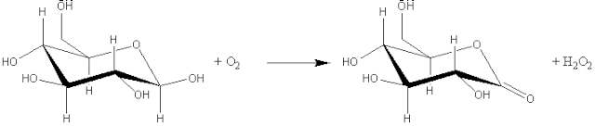
[1.1]
β-D-glucose + oxygen D-glucono-1,5-lactone + hydrogen peroxide
(2) Transferases which catalyse the transfer of an atom or group of atoms (e.g. acyl-, alkyl- and glycosyl-), between two molecules, but excluding such transfers as are classified in the other groups (e.g. oxidoreductases and hydrolases). For example: aspartate aminotransferase (EC 2.6.1.1, systematic name, L-aspartate:2-oxoglutarate aminotransferase; also called glutamic-oxaloacetic transaminase or simply GOT).
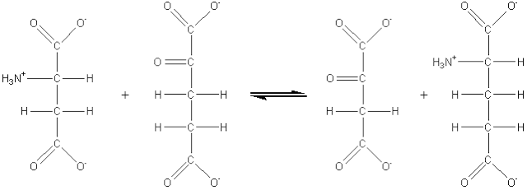
[1.2]
L-aspartate + 2-oxoglutarate oxaloacetate + L-glutamate
(3) Hydrolases which involve hydrolytic reactions and their reversal. This is presently the most commonly encountered class of enzymes within the field of enzyme technology and includes the esterases, glycosidases, lipases and proteases. For example: chymosin (EC 3.4.23.4, no systematic name declared; also called rennin).
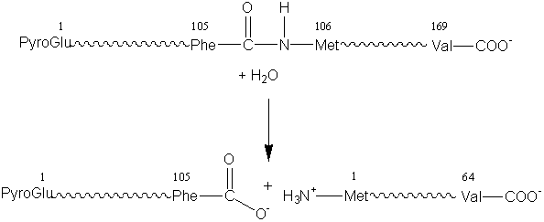
[1.3]
κ-casein + water para-κ-casein + caseino macropeptide
(4) Lyases which involve elimination reactions in which a group of atoms is removed from the substrate. This includes the aldolases, decarboxylases, dehydratases and some pectinases but does not include hydrolases. For example: histidine ammonia-lyase (EC 4.3.1.3, systematic name, L-histidine ammonia-lyase; also called histidase).
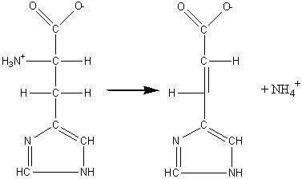
[1.4]
L-histidine urocanate + ammonia
(5) Isomerases which catalyse molecular isomerisations and includes the epimerases, racemases and intramolecular transferases. For example: xylose isomerase (EC 5.3.1.5, systematic name, D-xylose ketol-isomerase; commonly called glucose isomerase).
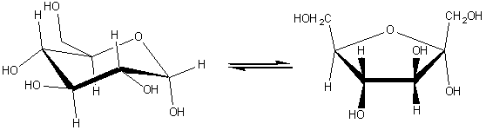[1.5]
α-D-glucopyranose α-D-fructofuranose
(6) Ligases, also known as synthetases, form a relatively small group of enzymes which involve the formation of a covalent bond joining two molecules together, coupled with the hydrolysis of a nucleoside triphosphate. For example: glutathione synthase (EC 6.3.2.3, systematic name, γ-L-glutamyl-L-cysteine:glycine ligase (ADP-forming); also called glutathione synthetase).
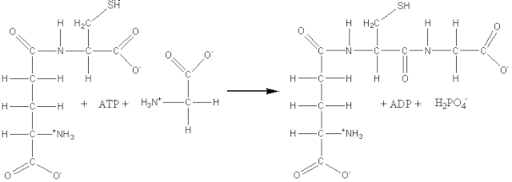
[1.6]
ATP + γ-L-glutamyl-L-cysteine + glycine ADP + phosphate + glutathione

Enzyme units

The amount of enzyme present or used in a process is difficult to determine in absolute terms (e.g. grams), as its purity is often low and a proportion may be in an inactive, or partially active, state. More relevant parameters are the activity of the enzyme preparation and the activities of any contaminating enzymes. These activities are usually measured in terms of the activity unit (U) which is defined as the amount which will catalyse the transformation of 1 micromole of the substrate per minute under standard conditions. Typically, this represents 10⁻⁶ - 10⁻¹¹ Kg for pure enzymes and 10⁻⁴ - 10⁻⁷ Kg for industrial enzyme preparations. Another unit of enzyme activity has been recommended. This is the katal (kat) which is defined as the amount which will catalyse the transformation of one mole of substance per second (1 kat = 60 000 000 U). It is an impracticable unit and has not yet received widespread acceptance. Sometimes non-standard activity units are used, such as Soxhet, Anson and Kilo Novo units, which are based on physical changes such as lowering viscosity and supposedly better understood by industry. Rightfully, such units are gradually falling into disuse. The activity is a measure of enzyme content that is clearly of major interest when the enzyme is to be used in a process. For this reason, enzymes are usually marketed in terms of activity rather than weight. The specific activity (e.g. U Kg⁻¹) is a parameter of interest, some utility as an index of purity but lesser importance. There is a major problem with these definitions of activity; the rather vague notion of "standard conditions". These are meant to refer to optimal conditions, especially with regard to pH, ionic strength, temperature, substrate concentration and the presence and concentration of cofactors and coenzymes. However, these so-termed optimal conditions vary both between laboratories and between suppliers. They also depend on the particular application in which the enzyme is to be used. Additionally, preparations of the same notional specific activity may differ with respect to stability and be capable of very different total catalytic productivity (this is the total substrate converted to product during the lifetime of the catalyst, under specified conditions). Conditions for maximum initial activity are not necessarily those for maximum stability. Great care has to be taken over the consideration of these factors when the most efficient catalyst for a particular purpose is to be chosen

The mechanism of enzyme catalysis

In order for a reaction to occur, reactant molecules must contain sufficient energy to cross a potential energy barrier, the activation energy. All molecules possess varying amounts of energy depending, for example, on their recent collision history but, generally, only a few have sufficient energy for reaction. The lower the potential energy barrier to reaction, the more reactants have sufficient energy and, hence, the faster the reaction will occur. All catalysts, including enzymes, function by forming a transition state, with the reactants, of lower free energy than would be found in the uncatalysed reaction (Figure 1.1). Even quite modest reductions in this potential energy barrier may produce large increases in the rate of reaction (e.g. the activation energy for the uncatalysed breakdown of hydrogen peroxide to oxygen and water is 76 kJ M⁻¹ whereas, in the presence of the enzyme catalase, this is reduced to 30 kJ M⁻¹ and the rate of reaction is increased by a factor of 10⁸, sufficient to convert a reaction time measured in years into one measured in seconds).

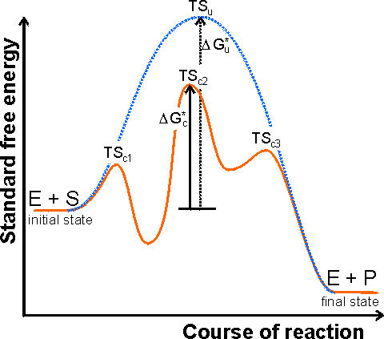
Figure 1.1. A schematic diagram showing the free energy profile of the course of an enzyme catalysed reaction involving the formation of enzyme-substrate (ES) and enzyme-product (EP) complexes, i.e.
The catalysed reaction pathway goes through the transition states TS_{c1}, TS_{c2} and TS_{c3}, with standard free energy of activation ΔG_{c}*, whereas the uncatalysed reaction goes through the transition state TS_{u} with standard free energy of activation ΔG_{u}*. In this example the rate limiting step would be the conversion of ES into EP. Reactions involving several substrates and products, or more intermediates, are even more complicated. The Michaelis-Menten reaction scheme [1.7] would give a similar profile but without the EP-complex free energy trough. The schematic profile for the uncatalysed reaction is shown as the dashed line. It should be noted that the catalytic effect only concerns the lowering of the standard free energy of activation from ΔG_{u}* to ΔG_{c}* and has no effect on the overall free energy change (i.e.. the difference between the initial and final states) or the related equilibrium constant.

There are a number of mechanisms by which this activation energy decrease may be achieved. The most important of these involves the enzyme initially binding the substrate(s), in the correct orientation to react, close to the catalytic groups on the active enzyme complex and any other substrates. In this way the binding energy is used partially in order to reduce the contribution of the considerable activation entropy, due to the loss of the reactants' (and catalytic groups') translational and rotational entropy, towards the total activation energy. Other contributing factors are the introduction of strain into the reactants (allowing more binding energy to be available for the transition state), provision of an alternative reactive pathway and the desolvation of reacting and catalysing ionic groups.
The energies available to enzymes for binding their substrates are determined primarily by the complementarity of structures (i.e. a good 3-dimensional fit plus optimal non-covalent ionic and/or hydrogen bonding forces). The specificity depends upon minimal steric repulsion, the absence of unsolvated or unpaired charges, and the presence of sufficient hydrogen bonds. These binding energies are capable of being quite large. As examples, antibody-antigen dissociation constants are characteristically near 10⁻⁸ M (free energy of binding is 46 kJ M⁻¹), ATP binds to myosin with a dissociation constant of 10⁻¹³ M (free energy of binding is 75 kJ M⁻¹) and biotin binds to avidin, a protein found in egg white, with a dissociation constant of 10⁻¹⁵ M (free energy of binding is 86 kJ M⁻¹). However, enzymes do not use this potential binding energy simply in order to bind the substrate(s) and form stable long-lasting complexes. If this were to be the case, the formation of the transition state between ES and EP would involve an extremely large free energy change due to the breaking of these strong binding forces, and the rate of formation of products would be very slow. They must use this binding energy for reducing the free energy of the transition state. This is generally achieved by increasing the binding to the transition state rather than the reactants and, in the process, introducing an energetic strain into the system and allowing more favourable interactions between the enzyme's catalytic groups and the reactants.

Simple kinetics of enzyme action

It is established that enzymes form a bound complex to their reactants (i.e. substrates) during the course of their catalysis and prior to the release of products. This can be simply illustrated, using the mechanism based on that of Michaelis and Menten for a one-substrate reaction, by the reaction sequence:
Enzyme + Substrate(Enzyme-substrate complex) Enzyme + Product
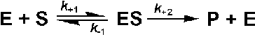 [1.7]
where k₊₁, k₋₁ and k₊₂ are the respective rate constants, typically having values of 10⁵ - 10⁸ M⁻¹ s⁻¹, 1 - 10⁴ s⁻¹ and 1 - 10⁵ s⁻¹ respectively; the sign of the subscripts indicating the direction in which the rate constant is acting. For the sake of simplicity the reverse reaction concerning the conversion of product to substrate is not included in this scheme. This is allowable (1) at the beginning of the reaction when there is no, or little, product present, or (2) when the reaction is effectively irreversible. Reversible reactions are dealt with in more detail later in this chapter. The rate of reaction (v) is the rate at which the product is formed.
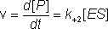 (1.1)
where [ ] indicates the molar concentration of the material enclosed (i.e. [ES] is the concentration of the enzyme-substrate complex). The rate of change of the concentration of the enzyme-substrate complex equals the rate of its formation minus the rate of its breakdown, forwards to give product or backwards to regenerate substrate.
therefore:
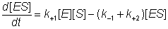 (1.2)
During the course of the reaction, the total enzyme at the beginning of the reaction ([E]₀, at zero time) is present either as the free enzyme ([E]) or the ES complex ([ES]).
i.e. [E]₀ = [E] + [ES] (1.3)
therefore:
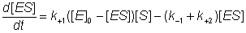 (1.4)
Gathering terms together,
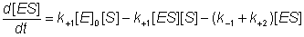
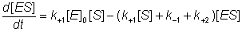
this gives:
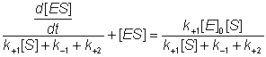 (1.5)
The differential equation 1.5 is difficult to handle, but may be greatly simplified if it can be assumed that the left hand side is equal to [ES] alone. This assumption is valid under the sufficient but unnecessarily restrictive steady state approximation that the rate of formation of ES equals its rate of disappearance by product formation and reversion to substrate (i.e. d[ES]/dt is zero). It is additionally valid when the condition:
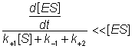 (1.6)
is valid. This occurs during a substantial part of the reaction time-course over a wide range of kinetic rate constants and substrate concentrations and at low to moderate enzyme concentrations. The variation in [ES], d[ES]/dt, [S] and [P] with the time-course of the reaction is shown in Figure 1.2, where it may be seen that the simplified equation is valid throughout most of the reaction.

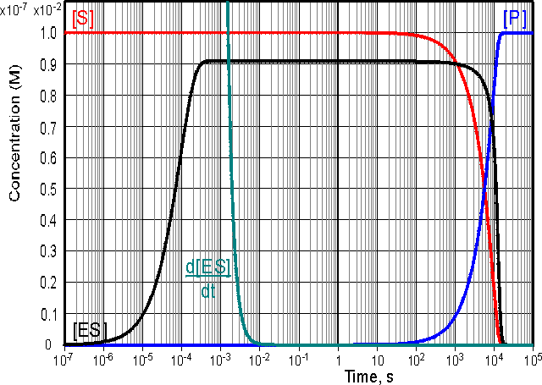
Figure 1.2. Computer simulation of the progress curves of d[ES]/dt (0 - 10⁻⁷ M scale), [ES] (0 - 10⁻⁷ M scale), [S] (0 - 10⁻² M scale) and [P] (0 - 10⁻² M scale) for a reaction obeying simple Michaelis-Menten kinetics with k₊₁ = 10⁶ M⁻¹ s⁻¹, k₋₁ = 1000 s⁻¹, k₊₂ = 10 s⁻¹, [E]₀ = 10⁻⁷ M and [S]₀ = 0.01 M. The simulation shows three distinct phases to the reaction time-course, an initial transient phase which lasts for about a millisecond followed by a longer steady state phase of about 30 minutes when [ES] stays constant but only a small proportion of the substrate reacts. This is followed by the final phase, taking about 6 hours during which the substrate is completely converted to product.
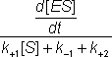is much less than [ES] during both of the latter two phases.

The Michaelis-Menten equation (below) is simply derived from equations 1.1 and 1.5, by substituting K_{m} for 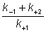. K_{m} is known as the Michaelis constant with a value typically in the range 10⁻¹ - 10⁻⁵ M. When k₊₂<<k₋₁, K_{m} equals the dissociation constant (k₋₁/k₊₁) of the enzyme substrate complex.
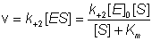 (1.7)
or, more simply
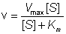 (1.8)
where V_{max} is the maximum rate of reaction, which occurs when the enzyme is completely saturated with substrate (i.e. when [S] is very much greater than K_{m}, V_{max} equals k₊₂[E]₀ , as the maximum value [ES] can have is [E]₀ when [E]₀ is less than [S]₀). Equation 1.8 may be rearranged to show the dependence of the rate of reaction on the ratio of [S] to K_{m},
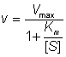 (1.9)
and the rectangular hyperbolic nature of the relationship, having asymptotes at v = V_{max} and [S] = -K_{m},
(V_{max}-v)(K_{m}+[S])=V_{max}K_{m} (1.10)
The substrate concentration in these equations is the actual concentration at the time and, in a closed system, will only be approximately equal to the initial substrate concentration ([S]₀) during the early phase of the reaction. Hence, it is usual to use these equations to relate the initial rate of reaction to the initial, and easily predetermined, substrate concentration (Figure 1.3). This also avoids any problem that may occur through product inhibition or reaction reversibility (see later).

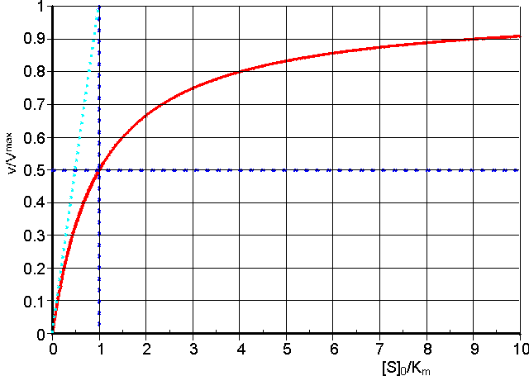
Figure 1.3. A normalised plot of the initial rate (v₀) against initial substrate concentration ([S]₀) for a reaction obeying the Michaelis-Menten kinetics (equation 1.8). The plot has been normalised in order to make it more generally applicable by plotting the relative initial rate of reaction (v₀/V_{max}) against the initial substrate concentration relative to the Michaelis constant ([S]₀/K_{m}, more commonly referred to as β, the dimensionless substrate concentration). The curve is a rectangular hyperbola with asymptotes at v₀ = V_{max} and [S]₀ = -K_{m}. The tangent to the curve at the origin goes through the point (v₀ = V_{max}),([S]₀ = K_{m}). The ratio V_{max}/K_{m} is an important kinetic parameter which describes the relative specificity of a fixed amount of the enzyme for its substrate (more precisely defined in terms of k_{cat}/K_{m}). The substrate concentration, which gives a rate of half the maximum reaction velocity, is equal to the K_{m}.

It has been established that few enzymes follow the Michaelis-Menten equation over a wide range of experimental conditions. However, it remains by far the most generally applicable equation for describing enzymic reactions. Indeed it can be realistically applied to a number of reactions which have a far more complex mechanism than the one described here. In these cases K_{m} remains an important quantity, characteristic of the enzyme and substrate, corresponding to the substrate concentration needed for half the enzyme molecules to bind to the substrate (and, therefore, causing the reaction to proceed at half its maximum rate) but the precise kinetic meaning derived earlier may not hold and may be misleading. In these cases the K_{m} is likely to equal a much more complex relationship between the many rate constants involved in the reaction scheme. It remains independent of the enzyme and substrate concentrations and indicates the extent of binding between the enzyme and its substrate for a given substrate concentration, a lower K_{m} indicating a greater extent of binding. V_{max} clearly depends on the enzyme concentration and for some, but not all, enzymes may be largely independent of the specific substrate used. K_{m} and V_{max} may both be influenced by the charge and conformation of the protein and substrate(s) which are determined by pH, temperature, ionic strength and other factors. It is often preferable to substitute k_{cat} for k₊₂ , where V_{max} = k_{cat}[E]₀, as the precise meaning of k₊₂, above, may also be misleading. k_{cat} is also known as the turnover number as it represents the maximum number of substrate molecules that the enzyme can 'turn over' to product in a set time (e.g. the turnover numbers of α-amylase, glucoamylase and glucose isomerase are 500 s⁻¹, 160 s⁻¹ and 3 s⁻¹ respectively; an enzyme with a relative molecular mass of 60000 and specific activity 1 U mg⁻¹ has a turnover number of 1 s⁻¹). The ratio k_{cat}/K_{m} determines the relative rate of reaction at low substrate concentrations, and is known as the specificity constant. It is also the apparent 2nd order rate constant at low substrate concentrations (see Figure 1.3), where
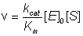 (1.11)
Many applications of enzymes involve open systems, where the substrate concentration remains constant, due to replenishment, throughout the reaction time-course. This is, of course, the situation that often prevails in vivo. Under these circumstances, the Michaelis-Menten equation is obeyed over an even wider range of enzyme concentrations than allowed in closed systems, and is commonly used to model immobilised enzyme kinetic systems (see Chapter 3).
Enzymes have evolved by maximising k_{cat}/K_{m} (i.e. the specificity constant for the substrate) whilst keeping K_{m} approximately identical to the naturally encountered substrate concentration. This allows the enzyme to operate efficiently and yet exercise some control over the rate of reaction.
The specificity constant is limited by the rate at which the reactants encounter one another under the influence of diffusion. For a single-substrate reaction the rate of encounter between the substrate and enzyme is about 10⁸ - 10⁹ M⁻¹ s⁻¹. The specificity constant of some enzymes approach this value although the range of determined values is very broad (e.g. k_{cat}/K_{m} for catalase is 4 x 10⁷ M⁻¹ s⁻¹, whereas it is 25 M⁻¹ s⁻¹ for glucose isomerase, and for other enzymes varies from less than 1 M⁻¹ s⁻¹ to greater than 10⁸ M⁻¹ s⁻¹).

Effect of pH and ionic strength

Enzymes are amphoteric molecules containing a large number of acid and basic groups, mainly situated on their surface. The charges on these groups will vary, according to their acid dissociation constants, with the pH of their environment (Table 1.1). This will effect the total net charge of the enzymes and the distribution of charge on their exterior surfaces, in addition to the reactivity of the catalytically active groups. These effects are especially important in the neighbourhood of the active sites. Taken together, the changes in charges with pH affect the activity, structural stability and solubility of the enzyme.

Table 1.1. pK_{a}sª and heats of ionisation^{b} of the ionising groups commonly found in enzymes.
Group | Usual pK_{a} range | Approximate charge at pH 7 | Heats of ionisation  (kJ mole⁻¹)
Carboxyl (C-terminal, glutamic acid, aspartic acid) | 3 - 6 | -1.0 | ± 5
Ammonio (N-terminal) (lysine) | 7 - 9 | +1.0 | +45
Ammonio (N-terminal) (lysine) | 9 - 11 | +1.0 | +45
Imidazolyl (histidine) | 5 - 8 | +0.5 | +30
Guanidyl (arginine) | 11 - 13 | +1.0 | +50
Phenolic (tyrosine) | 9 - 12 | 0.0 | +25
Thiol (cysteine) | 8 - 11 | 0.0 | +25
ª The pK_{a} (defined as -Log₁₀(K_{a})) is the pH at which half the groups are ionised. Note the similarity between the K_{a} of an acid and the K_{m} of an enzyme, which is the substrate concentration at which half the enzyme molecules have bound substrate. (Back)
^{b} By convention, the heat (enthalpy) of ionisation is positive when heat is withdrawn from the surrounding solution (i.e. the reaction is endothermic) by the dissociation of the hydrogen ions. (Back)

There will be a pH, characteristic of each enzyme, at which the net charge on the molecule is zero. This is called the isoelectric point (pI), at which the enzyme generally has minimum solubility in aqueous solutions. In a similar manner to the effect on enzymes, the charge and charge distribution on the substrate(s), product(s) and coenzymes (where applicable) will also be affected by pH changes. Increasing hydrogen ion concentration will, additionally, increase the successful competition of hydrogen ions for any metal cationic binding sites on the enzyme, reducing the bound metal cation concentration. Decreasing hydrogen ion concentration, on the other hand, leads to increasing hydroxyl ion concentration which compete against the enzymes' ligands for divalent and trivalent cations causing their conversion to hydroxides and, at high hydroxyl concentrations, their complete removal from the enzyme. The temperature also has a marked effect on ionisations, the extent of which depends on the heats of ionisation of the particular groups concerned (Table 1.1). The relationship between the change in the pK_{a} and the change in temperature is given by a derivative of the Gibbs-Helmholtz equation:
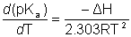 (1.12)
where T is the absolute temperature (K), R is the gas law constant (8.314 J M⁻¹ K⁻¹), ΔH is the heat of ionisation and the numeric constant (2.303) is the natural logarithm of 10, as pK_{a}'s are based on logarithms with base 10. This variation is sufficient to shift the pI of enzymes by up to one unit towards lower pH on increasing the temperature by 50°C.
These charge variations, plus any consequent structural alterations, may be reflected in changes in the binding of the substrate, the catalytic efficiency and the amount of active enzyme. Both V_{max} and K_{m} will be affected due to the resultant modifications to the kinetic rate constants k₊₁, k₋₁ and k_{cat} (k₊₂ in the Michaelis-Menten mechanism), and the variation in the concentration of active enzyme. The effect of pH on the V_{max} of an enzyme catalysed reaction may be explained using the, generally true, assumption that only one charged form of the enzyme is optimally catalytic and therefore the maximum concentration of the enzyme-substrate intermediate cannot be greater than the concentration of this species. In simple terms, assume EH⁻ is the only active form of the enzyme,
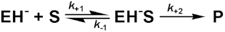 [1.8]
The concentration of EH⁻ is determined by the two dissociations
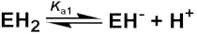 [1.9]
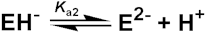 [1.10]
with
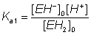 (1.13)
and
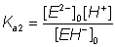 (1.14)
However,
(1.15)
therefore:
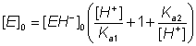 (1.16)
As the rate of reaction is given by k₊₂[EH⁻S] and this is maximal when [EH⁻S] is maximal (i.e.. when [EH⁻S] = [EH⁻]₀):
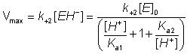 (1.17)
The V_{max} will be greatest when
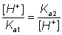 (1.18)
therefore:
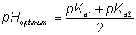 (1.19)
This derivation has involved a number of simplifications on the real situation; it ignores the effect of the ionisation of substrates, products and enzyme-substrate complexes and it assumes EH⁻ is a single ionised species when it may contain a mixture of differently ionised groups but with identical overall charge, although the process of binding substrate will tend to fix the required ionic species. It does, however, produce a variation of maximum rate with pH which gives the commonly encountered 'bell-shaped' curve (Figure 1.4). Where the actual reaction scheme is more complex, there may be a more complex relationship between V_{max} and pH. In particular, there may be a change in the rate determining step with pH. It should be recognised that K_{m} may change with pH in an independent manner to the V_{max} as it usually involves other, or additional, ionisable groups. It is clear that at lower non-saturating substrate concentrations the activity changes with pH may or may not reflect the changes in V_{max}. It should also be noted from the foregoing discussion that the variation of activity with pH depends on the reaction direction under consideration. The pH_{optimum} may well be different in the forward direction from that shown by the reverse reaction. This is particularly noticeable when reactions which liberate or utilise protons are considered (e.g. dehydrogenases) where there may well be greater than 2 pH units difference between the pH_{optimum} shown by the rates of forward and reverse reactions.

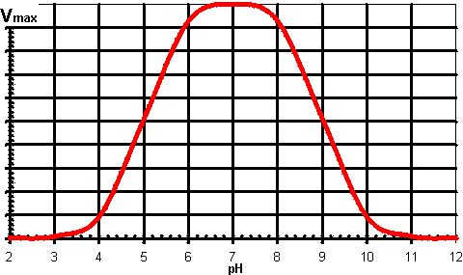
Figure 1.4. A generally applicable schematic diagram of the variation in the rate of an enzyme catalysed reaction (V_{max}) with the pH of the solution. The centre (optimum pH) and breadth of this 'bell-shaped' curve depend upon the acid dissociation constants of the relevant groups in the enzyme. It should be noted that some enzymes have pH-activity profiles that show little similarity to this diagram.

The variation of activity with pH, within a range of 2-3 units each side of the pI, is normally a reversible process. Extremes of pH will, however, cause a time- and temperature-dependent, essentially irreversible, denaturation. In alkaline solution (pH > 8), there may be partial destruction of cystine residues due to base catalysed β-elimination reactions whereas, in acid solutions (pH < 4), hydrolysis of the labile peptide bonds, sometimes found next to aspartic acid residues, may occur. The importance of the knowledge concerning the variation of activity with pH cannot be over-emphasised. However, a number of other factors may mean that the optimum pH in the V_{max}-pH diagram may not be the pH of choice in a technological process involving enzymes. These include the variation of solubility of substrate(s) and product(s), changes in the position of equilibrium for a reaction, suppression of the ionisation of a product to facilitate its partition and recovery into an organic solvent, and the reduction in susceptibility to oxidation or microbial contamination. The major such factor is the effect of pH on enzyme stability. This relationship is further complicated by the variation in the effect of the pH with both the duration of the process and the temperature or temperature-time profile. The important parameter derived from these influences is the productivity of the enzyme (i.e. how much substrate it is capable of converting to product). The variation of productivity with pH may be similar to that of the V_{max}-pH relationship but changes in the substrate stream composition and contact time may also make some contribution. Generally, the variation must be determined under the industrial process conditions. It is possible to alter the pH-activity profiles of enzymes. The ionisation of the carboxylic acids involves the separation of the released groups of opposite charge. This process is encouraged within solutions of higher polarity and reduced by less polar solutions. Thus, reducing the dielectric constant of an aqueous solution by the addition of a co-solvent of low polarity (e.g. dioxan, ethanol), or by immobilisation (see Chapter 3), increases the pK_{a} of carboxylic acid groups. This method is sometimes useful but not generally applicable to enzyme catalysed reactions as it may cause a drastic change on an enzyme's productivity due to denaturation (but see Chapter 7). The pK_{a} of basic groups are not similarly affected as there is no separation of charges when basic groups ionise. However, protonated basic groups which are stabilised by neighbouring negatively charged groups will be stabilised (i.e. have lowered pK_{a}) by solutions of lower polarity. Changes in the ionic strength (Ι) of the solution may also have some effect. The ionic strength is defined as half of the total sum of the concentration (c_{i}) of every ionic species (i) in the solution times the square of its charge (z_{i}); i.e. . Ι = 0.5Σ(c_{i}z_{i}²).
For example, the ionic strength of a 0.1 M solution of CaCl₂ is 0.5 x (0.1 x 2² + 0.2 x 1²) = 0.3 M.
At higher solution ionic strength, charge separation is encouraged with a concomitant lowering of the carboxylic acid pK_{a}s. These changes, extensive as they may be, have little effect on the overall charge on the enzyme molecule at neutral pH and are, therefore, only likely to exert a small influence on the enzyme's isoelectric point. Chemical derivatisation methods are available for converting surface charges from positive to negative and vice-versa. It is found that a single change in charge has little effect on the pH-activity profile, unless it is at the active site. However if all lysines are converted to carboxylates (e.g. by reaction with succinic anhydride) or if all the carboxylates are converted to amines (e.g. by coupling to ethylene diamine by means of a carbodiimide, see Chapter 3) the profile can be shifted about a pH unit towards higher or lower pH, respectively. The cause of these shifts is primarily the stabilisation or destabilisation of the charges at the active site during the reaction, and the effects are most noticeable at low ionic strength. Some, more powerful, methods for shifting the pH-activity profile are specific to immobilised enzymes and described in Chapter 3.
The ionic strength of the solution is an important parameter affecting enzyme activity. This is especially noticeable where catalysis depends on the movement of charged molecules relative to each other. Thus both the binding of charged substrates to enzymes and the movement of charged groups within the catalytic 'active' site will be influenced by the ionic composition of the medium. If the rate of the reaction depends upon the approach of charged moieties the following approximate relationship may hold,
(1.20)
where k is the actual rate constant, k₀ is the rate constant at zero ionic strength, z_{A} and z_{B} are the electrostatic charges on the reacting species, and I is the ionic strength of the solution. If the charges are opposite then there is a decrease in the reaction rate with increasing ionic strength whereas if the charges are identical, an increase in the reaction rate will occur (e.g. the rate controlling step in the catalytic mechanism of chymotrypsin involves the approach of two positively charged groups, ⁵⁷histidine⁺ and ¹⁴⁵arginine⁺ causing a significant increase in k_{cat} on increasing the ionic strength of the solution). Even if a more complex relationship between the rate constants and the ionic strength holds, it is clearly important to control the ionic strength of solutions in parallel with the control of pH.

Effect of temperature and pressure

Rates of all reactions, including those catalysed by enzymes, rise with increase in temperature in accordance with the Arrhenius equation.
(1.21)
where k is the kinetic rate constant for the reaction, A is the Arrhenius constant, also known as the frequency factor, ΔG* is the standard free energy of activation (kJ M⁻¹) which depends on entropic and enthalpic factors, R is the gas law constant and T is the absolute temperature. Typical standard free energies of activation (15 - 70 kJ M⁻¹) give rise to increases in rate by factors between 1.2 and 2.5 for every 10°C rise in temperature. This factor for the increase in the rate of reaction for every 10°C rise in temperature is commonly denoted by the term Q₁₀ (i.e. in this case, Q₁₀ is within the range 1.2 - 2.5). All the rate constants contributing to the catalytic mechanism will vary independently, causing changes in both K_{m} and V_{max}. It follows that, in an exothermic reaction, the reverse reaction (having a higher activation energy) increases more rapidly with temperature than the forward reaction. This, not only alters the equilibrium constant (see equation 1.12), but also reduces the optimum temperature for maximum conversion as the reaction progresses. The reverse holds for endothermic reactions such as that of glucose isomerase (see reaction [1.5]) where the ratio of fructose to glucose, at equilibrium, increases from 1.00 at 55°C to 1.17 at 80°C.
In general, it would be preferable to use enzymes at high temperatures in order to make use of this increased rate of reaction plus the protection it affords against microbial contamination. Enzymes, however, are proteins and undergo essentially irreversible denaturation (i.e.. conformational alteration entailing a loss of biological activity) at temperatures above those to which they are ordinarily exposed in their natural environment. These denaturing reactions have standard free energies of activation of about 200 - 300 kJ mole⁻¹ (Q₁₀ in the range 6 - 36) which means that, above a critical temperature, there is a rapid rate of loss of activity (Figure 1.5). The actual loss of activity is the product of this rate and the duration of incubation (Figure 1.6). It may be due to covalent changes such as the deamination of asparagine residues or non-covalent changes such as the rearrangement of the protein chain. Inactivation by heat denaturation has a profound effect on the enzymes productivity (Figure 1.7).

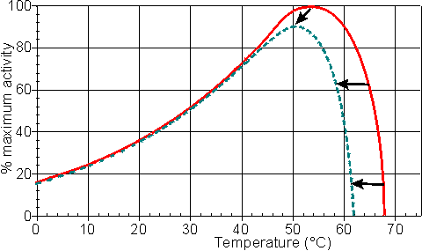
Figure 1.5. A schematic diagram showing the effect of the temperature on the activity of an enzyme catalysed reaction. —— short incubation period; ----- long incubation period. Note that the temperature at which there appears to be maximum activity varies with the incubation time.

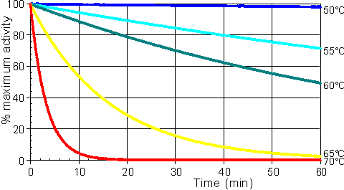
Figure 1.6. A schematic diagram showing the effect of the temperature on the stability of an enzyme catalysed reaction. The curves show the percentage activity remaining as the incubation period increases. From the top they represent equal increases in the incubation temperature (50°C, 55°C, 60°C, 65°C and 70°C).

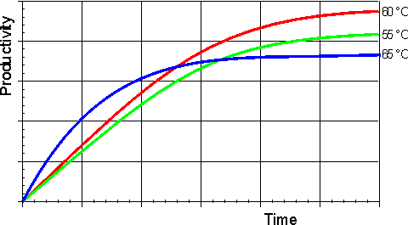
Figure 1.7. A schematic diagram showing the effect of the temperature on the productivity of an enzyme catalysed reaction. —— 55°C; —— 60°C; —— 65°C. The optimum productivity is seen to vary with the process time, which may be determined by other additional factors (e.g. overhead costs). It is often difficult to get precise control of the temperature of an enzyme catalysed process and, under these circumstances, it may be seen that it is prudent to err on the low temperature side.

The thermal denaturation of an enzyme may be modelled by the following serial deactivation scheme:

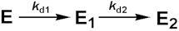 [1.11]
where k_{d1} and k_{d2} are the first-order deactivation rate coefficients, E is the native enzyme which may, or may not, be an equilibrium mixture of a number of species, distinct in structure or activity, and E₁ and E₂ are enzyme molecules of average specific activity relative to E of A₁ and A₂. A₁ may be greater or less than unity (i.e. E₁ may have higher or lower activity than E) whereas A₂ is normally very small or zero. This model allows for the rare cases involving free enzyme (e.g. tyrosinase) and the somewhat commoner cases involving immobilised enzyme (see Chapter 3) where there is a small initial activation or period of grace involving negligible discernible loss of activity during short incubation periods but prior to later deactivation. Assuming, at the beginning of the reaction:
(1.22)
and:
(1.23)
At time t,
(1.24)
It follows from the reaction scheme [1.11],
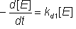 (1.25)
Integrating equation 1.25 using the boundary condition in equation 1.22 gives:
(1.26)
From the reaction scheme [1.11],
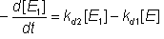 (1.27)
Substituting for [E] from equation 1.26,
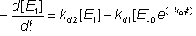 (1.28)
Integrating equation 1.27 using the boundary condition in equation 1.23 gives:
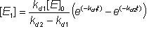 (1.29)
If the term 'fractional activity' (A^{f}) is introduced where,
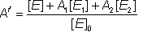 (1.30)
then, substituting for [E₂] from equation 1.24, gives:
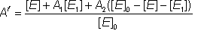 (1.31)
therefore:
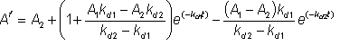 (1.32)
When both A₁ and A₂ are zero, the simple first order deactivation rate expression results
(1.33)
The half-life (t_{1/2}) of an enzyme is the time it takes for the activity to reduce to a half of the original activity (i,e. A^{f} = 0.5). If the enzyme inactivation obeys equation 1.33, the half-life may be simply derived,
(1.34)
therefore:
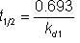 (1.35)
In this simple case, the half-life of the enzyme is shown to be inversely proportional to the rate of denaturation.
Many enzyme preparations, both free and immobilised, appear to follow this series-type deactivation scheme. However because reliable and reproducible data is difficult to obtain, inactivation data should, in general, be assumed to be rather error-prone. It is not surprising that such data can be made to fit a model involving four determined parameters (A₁, A₂, k_{d1} and k_{d2}). Despite this possible reservation, equations 1.32 and 1.33 remain quite useful and the theory possesses the definite advantage of simplicity. In some cases the series-type deactivation may be due to structural microheterogeneity, where the enzyme preparation consists of a heterogeneous mixture of a large number of closely related structural forms. These may have been formed during the past history of the enzyme during preparation and storage due to a number of minor reactions, such as deamidation of one or two asparagine or glutamine residues, limited proteolysis or disulphide interchange. Alternatively it may be due to quaternary structure equilibria or the presence of distinct genetic variants. In any case, the larger the variability the more apparent will be the series-type inactivation kinetics. The practical effect of this is that usually k_{d1} is apparently much larger than k_{d2} and A₁ is less than unity.
In order to minimise loss of activity on storage, even moderate temperatures should be avoided. Most enzymes are stable for months if refrigerated (0 - 4°C). Cooling below 0°C, in the presence of additives (e.g. glycerol) which prevent freezing, can generally increase this storage stability even further. Freezing enzyme solutions is best avoided as it often causes denaturation due to the stress and pH variation caused by ice-crystal formation. The first order deactivation constants are often significantly lower in the case of enzyme-substrate, enzyme-inhibitor and enzyme-product complexes which helps to explain the substantial stabilising effects of suitable ligands, especially at concentrations where little free enzyme exists (e.g. [S] >> K_{m}). Other factors, such as the presence of thiol anti-oxidants, may improve the thermal stability in particular cases.
It has been found that the heat denaturation of enzymes is primarily due to the proteins' interactions with the aqueous environment. They are generally more stable in concentrated, rather than dilute, solutions. In a dry or predominantly dehydrated state, they remain active for considerable periods even at temperatures above 100°C. This property has great technological significance and is currently being exploited by the use of organic solvents (see Chapter 7).
Pressure changes will also affect enzyme catalysed reactions. Clearly any reaction involving dissolved gases (e.g. oxygenases and decarboxylases) will be particularly affected by the increased gas solubility at high pressures. The equilibrium position of the reaction will also be shifted due to any difference in molar volumes between the reactants and products. However an additional, if rather small, influence is due to the volume changes which occur during enzymic binding and catalysis. Some enzyme-reactant mixtures may undergo reductions in volume amounting to up to 50 ml mole⁻¹ during reaction due to conformational restrictions and changes in their hydration. This, in turn, may lead to a doubling of the k_{cat}, and/or a halving in the K_{m} for a 1000 fold increase in pressure. The relative effects on k_{cat} and K_{m} depend upon the relative volume changes during binding and the formation of the reaction transition states.

Reversible reactions

A reversible enzymic reaction (e.g. the conversion of glucose to fructose, catalysed by glucose isomerase) may be represented by the following scheme where the reaction goes through the reversible stages of enzyme-substrate (ES) complex formation, conversion to enzyme-product (EP) complex and finally desorption of the product. No step is completely rate controlling.
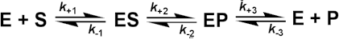 [1.12]
Pairs of symmetrical equations may be obtained for the change in the concentration of the intermediates with time:
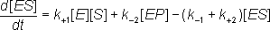 (1.36)
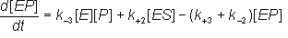 (1.37)
Assuming that there is no denaturation, the total enzyme concentration must remain constant and:
(1.38a)
therefore:
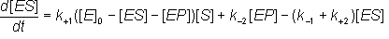 (1.38b)
gathering terms in [ES]
(1.39a)
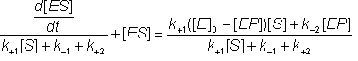 (1.39b)
and,
(1.38c)
gathering terms in [EP]
(1.40a)
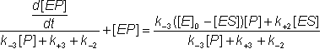 (1.40b)
Under similar conditions to those discussed earlier for the Michaelis-Menten mechanism (e.g. under the steady-state assumptions when both d[ES]/dt and d[EP]/dt are zero, or more exactly when
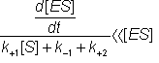 (1.41)
and
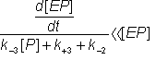 (1.42)
are both true. The following equations may be derived from equation 1.39b using the approximation, given by equations 1.41 and collecting terms.
(1.43a)
(1.43b)
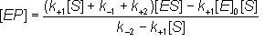 (1.43c)
Also, the following equations (symmetrical to the above) may be derived from equation 1.40b by using the approximation, given by equation 1.42, and collecting terms.
(1.44a)
(1.44b)
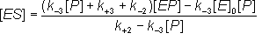 (1.44c)
Substituting for [ES] from equation 1.44c into equation 1.43a
(1.43d)
(1.43e)
(1.43f)
Removing identical terms from both sides of the equation:
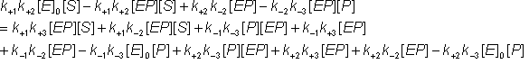 (1.43g)
Gathering all the terms in [EP]:
(1.43h)
(1.43i)
Also, substituting for [EP] from equation 1.43c into equation 1.44a
(1.44d)
(1.44e)
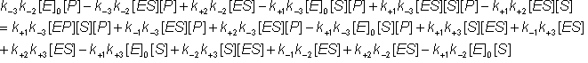 (1.44f)
Removing identical terms from both sides of the equation:
(1.44g)
Gathering all the terms in [ES]:
(1.44h)
(1.44i)
The net rate of reaction (i.e.. rate at which substrate is converted to product less the rate at which product is converted to substrate) may be denoted by v where,
(1.45)
Substituting from equations 1.43i and 1.44i
(1.46a)
Simplifying:
(1.46b)
Therefore,
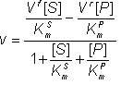 (1.47)
where:
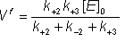 (1.48)
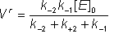 (1.49)
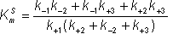 (1.50)
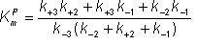 (1.51)
At equilibrium:
(1.52)
and, because the numerator of equation 1.47 must equal zero,
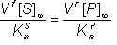 (1.53)
where [S]∞ and [P]∞ are the equilibrium concentrations of substrate and product (at infinite time). But by definition,
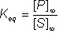 (1.54)
Substituting from equation 1.53
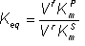 (1.55)
This is the Haldane relationship.
Therefore:
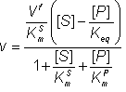 (1.56)
If K_{m}^{S} and K_{m}^{P} are approximately equal (e.g. the commercial immobilised glucose isomerase, Sweetase, has K_{m}(glucose) of 840 mM and K_{m}(fructose) of 830 mM at 70°C), and noting that the total amount of substrate and product at any time must equal the sum of the substrate and product at the start of the reaction:
(1.57)
Therefore:
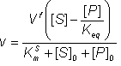 (1.58)
Therefore:
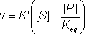 (1.59)
where:
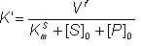 (1.60)
K' is not a true kinetic constant as it is only constant if the initial substrate plus product concentration is kept constant.
Also,
(1.61)
Substituting from equation 1.54,
(1.62)
Let [S#] equal the concentration difference between the actual concentration of substrate and the equilibrium concentration.
(1.63)
Therefore:
(1.64)
Substituting in equation 1.47
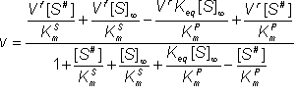 (1.65)
Rearranging equation 1.55,
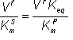 (1.66)
Therefore:
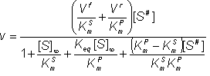 (1.67)

Therefore:
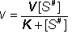 (1.68)
Where
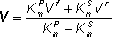 (1.69)
Therefore:
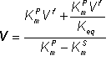 (1.70)
Therefore:
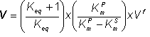 (1.71)
and:
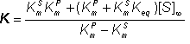 (1.72)
As in the case of K' in equation 1.59, K is not a true kinetic constant as it varies with [S]∞ and hence the sum of [S]₀ and [P]₀. It is only constant if the initial substrate plus product concentration is kept constant. By a similar but symmetrical argument, the net reverse rate of reaction,
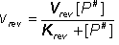 (1.73)
with constants defined as above but by symmetrically exchanging K_{m}^{P} with K_{m}^{S}, and V^{r} with V^{f}.
Both equations (1.59) and (1.68) are useful when modelling reversible reactions, particularly the technologically important reaction catalysed by glucose isomerase. They may be developed further to give productivity-time estimates and for use in the comparison of different reactor configurations (see Chapters 3 and 5).
Although an enzyme can never change the equilibrium position of a catalysed reaction, as it has no effect on the standard free energy change involved, it can favour reaction in one direction rather than its reverse. It achieves this by binding strongly, as enzyme-reactant complexes, the reactants in this preferred direction but only binding the product(s) weakly. The enzyme is bound up with the reactant(s), encouraging their reaction, leaving little free to catalyse the reaction in the reverse direction. It is unlikely, therefore, that the same enzyme preparation would be optimum for catalysing a reversible reaction in both directions.

Enzyme inhibition

A number of substances may cause a reduction in the rate of an enzyme catalysed reaction. Some of these (e.g. urea) are non-specific protein denaturants. Others, which generally act in a fairly specific manner, are known as inhibitors. Loss of activity may be either reversible, where activity may be restored by the removal of the inhibitor, or irreversible, where the loss of activity is time dependent and cannot be recovered during the timescale of interest. If the inhibited enzyme is totally inactive, irreversible inhibition behaves as a time-dependent loss of enzyme concentration (i.e.. lower V_{max}), in other cases, involving incomplete inactivation, there may be time-dependent changes in both K_{m} and V_{max}. Heavy metal ions (e.g. mercury and lead) should generally be prevented from coming into contact with enzymes as they usually cause such irreversible inhibition by binding strongly to the amino acid backbone.
More important for most enzyme-catalysed processes is the effect of reversible inhibitors. These are generally discussed in terms of a simple extension to the Michaelis-Menten reaction scheme.
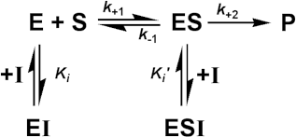 [1.13]
where I represents the reversible inhibitor and the inhibitory (dissociation) constants K_{i} and K_{i}' are given by
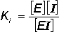 (1.74)
and,
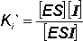 (1.75)
For the present purposes, it is assumed that neither EI nor ESI may react to form product. Equilibrium between EI and ESI is allowed, but makes no net contribution to the rate equation as it must be equivalent to the equilibrium established through:
[1.14]
Binding of inhibitors may change with the pH of the solution, as discussed earlier for substrate binding, and result in the independent variation of both K_{i} and K_{i}' with pH.
In order to simplify the analysis substantially, it is necessary that the rate of product formation (k₊₂) is slow relative to the establishment of the equilibria between the species.
Therefore:
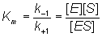 (1.76)
also:
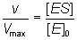 (1.77)
where:
(1.78)
therefore:
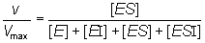 (1.79)
Substituting from equations (1.74), ( 1.75) and (1.76), followed by simplification, gives:
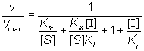 (1.80)
therefore:
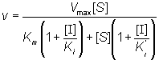 (1.81)
If the total enzyme concentration is much less than the total inhibitor concentration (i.e. [E]₀<< [I]₀), then:
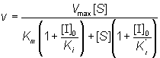 (1.82)
This is the equation used generally for mixed inhibition involving both EI and ESI complexes (Figure 1.8a). A number of simplified cases exist.

Competitive inhibition
K_{i}' is much greater than the total inhibitor concentration and the ESI complex is not formed. This occurs when both the substrate and inhibitor compete for binding to the active site of the enzyme. The inhibition is most noticeable at low substrate concentrations but can be overcome at sufficiently high substrate concentrations as the V_{max} remains unaffected (Figure 1.8b). The rate equation is given by:
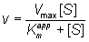 (1.83)
where K_{m}^{app} is the apparent K_{m} for the reaction, and is given by:
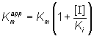 (1.84)
Normally the competitive inhibitor bears some structural similarity to the substrate, and often is a reaction product (product inhibition, e.g. inhibition of lactase by galactose), which may cause a substantial loss of productivity when high degrees of conversion are required. The rate equation for product inhibition is derived from equations (1.83) and (1.84).
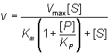 (1.85)
A similar effect is observed with competing substrates, quite a common state of affairs in industrial conversions, and especially relevant to macromolecular hydrolyses where a number of different substrates may coexist, all with different kinetic parameters. The reaction involving two co-substrates may be modelled by the scheme.
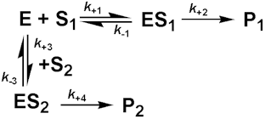 [1.15]
Both substrates compete for the same catalytic site and, therefore, their binding is mutually exclusive and they behave as competitive inhibitors of each others reactions. If the rates of product formation are much slower than attainment of the equilibria (i.e. k₊₂ and k₊₄ are very much less than k₋₁ and k₋₃ respectively), the rate of formation of P₁ is given by:
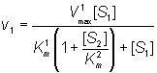 (1.86)
and the rate of formation of P₂ is given by
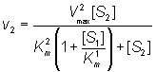 (1.87)
If the substrate concentrations are both small relative to their K_{m} values:
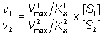 (1.88)
Therefore, in a competitive situation using the same enzyme and with both substrates at the same concentration:
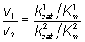 (1.89)
where and in this simplified case. The relative rates of reaction are in the ratio of their specificity constants. If both reactions produce the same product (e.g. some hydrolyses):
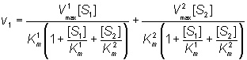 (1.90)
therefore:
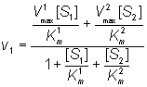 (1.91)

Uncompetitive inhibition
K_{i} is much greater than the total inhibitor concentration and the EI complex is not formed. This occurs when the inhibitor binds to a site which only becomes available after the substrate (S₁) has bound to the active site of the enzyme. This inhibition is most commonly encountered in multi-substrate reactions where the inhibitor is competitive with respect to one substrate (e.g. S₂) but uncompetitive with respect to another (e.g. S₁), where the reaction scheme may be represented by
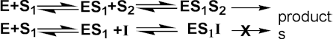 [1.16]
The inhibition is most noticeable at high substrate concentrations (i.e. S₁ in the scheme above) and cannot be overcome as both the V_{max} and K_{m} are equally reduced (Figure 1.8c). The rate equation is:
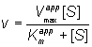 (1.92)
where V_{max}^{app} and K_{m}^{app} are the apparent V_{max} and K_{m} given by:
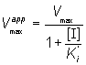 (1.93)
and
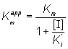 (1.94)
In this case the specificity constant remains unaffected by the inhibition. Normally the uncompetitive inhibitor also bears some structural similarity to one of the substrates and, again, is often a reaction product.

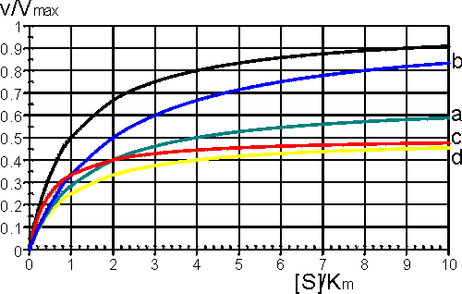
Figure 1.8. A schematic diagram showing the effect of reversible inhibitors on the rate of enzyme-catalysed reactions. —— no inhibition, (a) —— mixed inhibition ([I] = K_{i} = 0.5 K_{i}'); lower V_{max}^{app} (= 0.67 V_{max}), higher K_{m}^{app} (= 2 K_{m}). (b) —— competitive inhibition ([I] = K_{i}); V_{max}^{app} unchanged (= V_{max}), higher K_{m}^{app} (= 2 K_{m}). (c) —— uncompetitive inhibition ([I] = K_{i}'); lower V_{max}^{app} (= 0.5 V_{max}) and K_{m}^{app} (= 0.5 K_{m}). (d) —— noncompetitive inhibition ([I] = K_{i} = K_{i}'); lower V_{max}^{app} (= 0.5 V_{max}), unchanged K_{m}^{app} (= K_{m}).

A special case of uncompetitive inhibition is substrate inhibition which occurs at high substrate concentrations in about 20% of all known enzymes (e.g. invertase is inhibited by sucrose). It is primarily caused by more than one substrate molecule binding to an active site meant for just one, often by different parts of the substrate molecules binding to different subsites within the substrate binding site. If the resultant complex is inactive this type of inhibition causes a reduction in the rate of reaction, at high substrate concentrations. It may be modelled by the following scheme
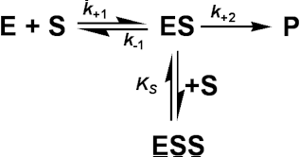 [1.17]
where:
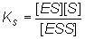 (1.95)
The assumption is made that ESS may not react to form product. It follows from equation (1.82) that:
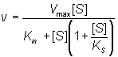 (1.96)
Even quite high values for K_{S} lead to a levelling off of the rate of reaction at high substrate concentrations, and lower K_{S} values cause substantial inhibition (Figure 1.9).

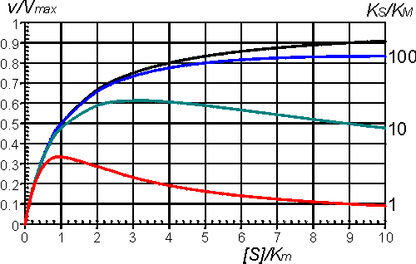
Figure 1.9. The effect of substrate inhibition on the rate of an enzyme-catalysed reaction. A comparison is made between the inhibition caused by increasing K_{S} relative to K_{m}. —— no inhibition, K_{S}/K_{m} >> 100; —— K_{S}/K_{m} = 100; —— K_{S}/K_{m} = 10; —— K_{S}/K_{m} = 1. By the nature of the binding causing this inhibition, it is unlikely that K_{S}/K_{m} < 1.

Noncompetitive inhibition
Both the EI and ESI complexes are formed equally well (i.e. K_{i} equals K_{i}'). This occurs when the inhibitor binds at a site away from the substrate binding site, causing a reduction in the catalytic rate. It is quite rarely found as a special case of mixed inhibition. The fractional inhibition is identical at all substrate concentrations and cannot be overcome by increasing substrate concentration due to the reduction in V_{max} (Figure 1.8d). The rate equation is given by:
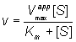 (1.97)
where V_{max}^{app} is given by:
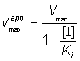 (1.98)
The diminution in the rate of reaction with pH, described earlier, may be considered as a special case of noncompetitive inhibition; the inhibitor being the hydrogen ion on the acid side of the optimum or the hydroxide ion on the alkaline side.

Determination of V_{max} and K_{m}

It is important to have as thorough knowledge as is possible of the performance characteristics of enzymes, if they are to be used most efficiently. The kinetic parameters V_{max}, K_{m} and k_{cat}/K_{m} should, therefore, be determined. There are two approaches to this problem using either the reaction progress curve (integral method) or the initial rates of reaction (differential method). Use of either method depends on prior knowledge of the mechanism for the reaction and, at least approximately, the optimum conditions for the reaction. If the mechanism is known and complex then the data must be reconciled to the appropriate model (hypothesis), usually by use of a computer-aided analysis involving a weighted least-squares fit. Many such computer programs are currently available and, if not, the programming skill involved is usually fairly low. If the mechanism is not known, initial attempts are usually made to fit the data to the Michaelis-Menten kinetic model. Combining equations (1.1) and (1.8),
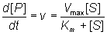 (1.99)
which, on integration, using the boundary condition that the product is absent at time zero and by substituting [S] by ([S]₀ - [P]), becomes
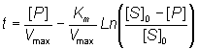 (1.100)
If the fractional conversion (X) is introduced, where
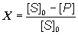 (1.101)
then equation (1.100) may be simplified to give:
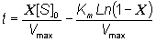 (1.102)
Use of equation (1.99) involves the determination of the initial rate of reaction over a wide range of substrate concentrations. The initial rates are used, so that [S] = [S]₀, the predetermined and accurately known substrate concentration at the start of the reaction. Its use also ensures that there is no effect of reaction reversibility or product inhibition which may affect the integral method based on equation (1.102). Equation (1.99) can be utilised directly using a computer program, involving a weighted least-squares fit, where the parameters for determining the hyperbolic relationship between the initial rate of reaction and initial substrate concentration (i.e.. K_{m} and V_{max}) are chosen in order to minimise the errors between the data and the model, and the assumption is made that the errors inherent in the practically determined data are normally distributed about their mean (error-free) value.
Alternatively the direct linear plot may be used (Figure 1.10). This is a powerful non-parametric statistical method which depends upon the assumption that any errors in the experimentally derived data are as likely to be positive (i.e. too high) as negative (i.e. too low). It is common practice to show the data obtained by the above statistical methods on one of three linearised plots, derived from equation (1.99) (Figure 1.11). Of these, the double reciprocal plot is preferred to test for the qualitative correctness of a proposed mechanism, and the Eadie-Hofstee plot is preferred for discovering deviations from linearity.

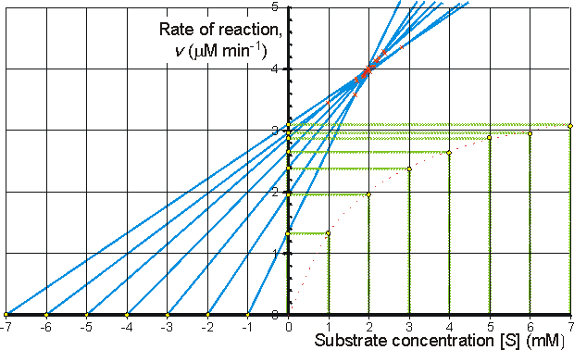
Figure 1.10. The direct linear plot. A plot of the initial rate of reaction against the initial substrate concentration also showing the way estimates can be directly made of the K_{m} and V_{max}. Every pair of data points may be utilised to give a separate estimate of these parameters (i.e. n(n-1)/2 estimates from n data points with differing [S]₀). These estimates are determined from the intersections of lines passing through the (x,y) points (-[S]₀,0) and (0,v); each intersection forming a separate estimate of K_{m} and V_{max}. The intersections are separately ranked in order of increasing value of both K_{m} and V_{max} and the median values taken as the best estimates for these parameters. The error in these estimates can be simply determined from sub-ranges of these estimates, the width of the sub-range dependent on the accuracy required for the error and the number of data points in the analysis. In this example there are 7 data points and, therefore, 21 estimates for both K_{m} and V_{max}. The ranked list of the estimates for K_{m} (mM) is 0.98,1.65, 1.68, 1.70, 1.85, 1.87, 1.89, 1.91, 1.94, 1.96, 1.98, 1.99, 2.03, 2.06, 1.12, 2.16, 2.21, 2.25, 2.38, 2.40, 2.81, with a median value of 1.98 mM. The K_{m} must lie between the 4th (1.70 mM) and 18th (2.25 mM) estimate at a confidence level of 97% (Cornish-Bowden et al., 1978). The list of the estimates for V_{max} (mM.min⁻¹) is ranked separately as 3.45, 3.59, 3.80, 3.85, 3.87, 3.89, 3.91, 3.94, 3.96, 3.96, 3.98, 4.01, 4.03, 4.05, 4.13, 4.14, 4.18, 4.26, 4.29, 4.35, with a median value of 3.98 mM.min⁻¹. The V_{max} must lie between the 4th (3.85 mM.min⁻¹) and 18th (4.18 mM.min⁻¹) estimate at a confidence level of 97%. It can be seen that outlying estimates have little or no influence on the results. This is a major advantage over the least-squared statistical procedures where rogue data points cause heavily biased effects.

Figure 1.11. Three ways in which the hyperbolic relationship between the initial rate of reaction and the initial substrate concentration
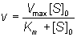
can be rearranged to give linear plots. The examples are drawn using K_{m} = 2 mM and V_{max} = 4 μM min⁻¹.
(a) Lineweaver-Burk (double-reciprocal) plot of 1/v against 1/[S]₀ giving intercepts at 1/V_{max} and -1/K_{m}
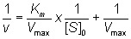 (1.103)
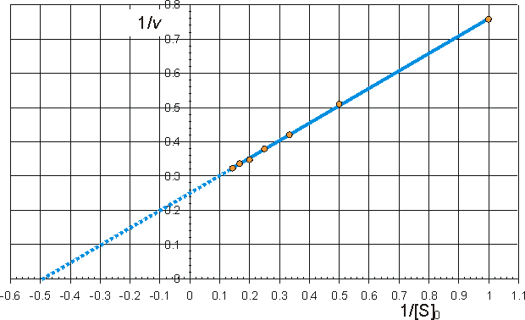
(b) Eadie-Hofstee plot of v against v/[S]₀ giving intercepts at V_{max} and V_{max}/K_{m}
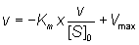 (1.104)
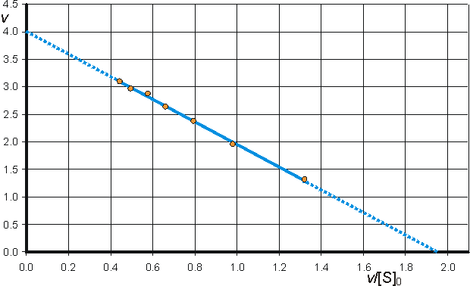
c) Hanes-Woolf (half-reciprocal) plot of [S]₀/v against [S]₀ giving intercepts at K_{m}/V_{max} and K_{m}.
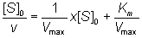 (1.105)
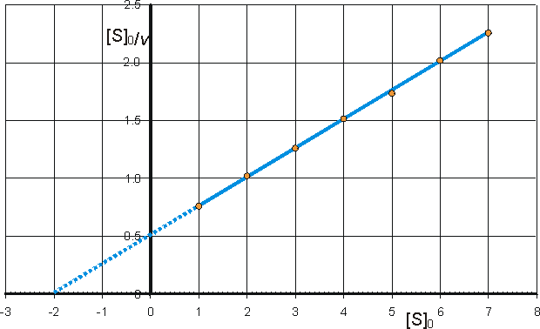

The progress curve of the reaction (Figure 1.12) can be used to determine the specificity constant (k_{cat}/K_{m}) by making use of the relationship between time of reaction and fractional conversion (see equation (1.102). This has the advantage over the use of the initial rates (above) in that fewer determinations need to be made, possibly only one progress curve is necessary, and sometimes the initial rate of reaction is rather difficult to determine due to its rapid decline. If only the early part of the progress curve, or its derivative, is utilised in the analysis, this procedure may even be used in cases where there is competitive inhibition by the product, or where the reaction is reversible.

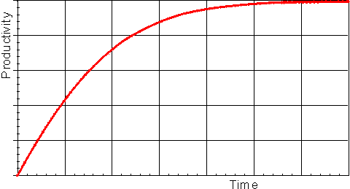
Figure 1.12. A schematic plot showing the amount of product formed (productivity) against the time of reaction, in a closed system. The specificity constant may be determined by a weighted least-squared fit of the data to the relationship given by equation (1.102).

The type of inhibition and the inhibition constants may be determined from the effect of differing concentrations of inhibitor on the apparent K_{m}, V_{max} and k_{cat}/K_{m}, although some more specialised plots do exist (e.g. Cornish-Bowden, 1974).

Summary and Bibliography of Chapter 1

- Enzymes are specific catalysts of vast range and utility.
- Their activity is governed by their structure and physical environment.
- Care should be taken over the interpretation of reported units of enzymic activity and the conditions necessary for maximum productivity.
- Enzymes may lose their catalytic activity reversibly or irreversibly due to denaturation or inhibition, dependent upon the conditions
- The values of the K_{m}, V_{max}, specificity constants, pH_{optimum} and rate of thermal denaturation are all of relevance and utility to enzyme technology

References and Bibliography

- Bender, M.L., Kezdy, J.F. & Gunter, C.R. (1964). The anatomy of an enzymatic catalysis: α-Chymotrypsin. Journal of the American Chemical Society, 86, 3714-21.
- Chaplin, M.F. (1986). Protein structure and enzyme activity. Oxford, UK: IRL Press Ltd. (This is a CAL/simulation software package suitable for IBM or BBC micocomputers)
- Cornish-Bowden, A. (1974). A simple graphical method for determining the inhibition constants of mixed, uncompetitive and non-competitive inhibitors. Biochemical Journal, 137, 143-4.
- Cornish-Bowden, A. (1976). Principles of enzyme kinetics. London: Butterworth.
- Cornish-Bowden, A. & Endrenyi, L. (1986). Robust regression of enzyme kinetic data. Biochemical Journal, 234, 21-9.
- Cornish-Bowden, A., Porter, W.R. & Trager, W.F. (1978). Evaluation of distribution-free confidence limits for enzyme kinetic parameters. Journal of Theoretical Biology, 74, 163-75.
- Crompton, I.E. & Waley, S.G. (1986). The determination of specificity constants in enzyme-catalysed reactions. Biochemical Journal, 239, 221-4.Eisenthal, R. & Cornish-Bowden, A. (1974). The direct linear plot. Biochemical Journal, 139, 715-20.
- Fersht, A. (1985). Enzyme structure and mechanism, 2nd edn, New York: W.H.Freeman & Co.Henderson, P.J.F. (1978). Statistical analysis of enzyme kinetic data. Techniques in the life sciences, Biochemistry vol. B1/11, Techniques in protein and enzyme biochemistry - part 2. pp B113/1-41, Amsterdam: Elsevier/North-Holland Biomedical Press.
- Henley, J.P. & Sadana, A. (1985). Categorization of enzyme deactivations using a series-type mechanism. Enzyme and Microbial Technology, 7, 50-60.
- Hill, C.M., Waight R.D. & Bardsley, W.G. (1977). Does any enzyme follow the Michaelis-Menten equation? Molecular and Cellullar Biochemistry, 15, 173-8.
- Koshland, D.E. Jr. (1962). The comparison of non-enzymic and enzymic reaction velocities. Journal of Theoretical Biology, 2, 75-86.
- Michaelis, L. & Menten, M.L. (1913). The kinetics of invertin action. Biochemische Zeitschrift, 49, 333-69.

