Chapter 7: Recent advances in enzyme technology

Enzymic reactions in biphasic liquid systems

It would often be useful if enzyme catalysed reactions could be performed in solvents other than water, as this is not the ideal medium for the majority of organic reactions. Many reactants (e.g. molecular oxygen, steroids and lipids) are more soluble in organic solvents than in water and some products may be quite labile in an aqueous environment. Accomplishing reactions with such substrates (e.g. the aerobic oxidation of oestrogens catalysed by fungal laccase) in non-aqueous media allows a much increased volumetric activity to be achieved. Microbial contamination, by contrast, is much less of a problem in such solvents, and the consequent absence of microbial proteases may lead to an apparent stabilisation in the biocatalyst.
Some polymerising reactions, for example the polymerisation of phenols catalysed by peroxidase, will produce a higher molecular weight product when carried out in a solution more able to dissolve the products (i.e. oligomers) initially formed. Under normal physiological conditions, hydrolytic enzymes catalyse the degradation of polymers; i.e. hydrolases are transferases normally transferring a moiety to the acceptor, water. Water is normally present in a vast molar excess over other potential acceptor molecules so no reaction occurs other than hydrolysis. Also, the normal 'concentration' of water (about 55.5 M) is much greater than its typical K_{m} (about 50 mM) and the rate of hydrolysis will not be affected as the reaction proceeds. By greatly reducing the water activity in these systems they can be used to transfer to other acceptors. Examples of this can be found in the transesterification reactions of esterases and lipases, described more fully later, and the (undesirable) formation of isomaltose from glucose catalysed by glucoamylase.
Restriction of the enzyme to the aqueous phase effectively immobilises the enzyme and allows its straightforward separation, using phase separators developed for the established chemical process industry, from product-containing organic phase. The main asset of these systems, however, is their ability to shift the thermodynamic equilibria of the reactions. As was pointed out in Chapter 1, enzymes do not change the equilibrium constants (K_{eq}) of reactions. Although changes in the physical conditions (i.e. temperature, pH and pressure) do affect the K_{eq} of a reaction, usually this effect is relatively slight over the physical range allowed by stability of the biocatalysts. Use of a biphasic aqueous-organic system, however, may result in substantial changes in the practically useful 'apparent' K_{eq}. The use of enzymes within organic solvents normally results in a two phase system as all water-soluble enzymes possess a significant amount of strongly bound water, even when in an apparently dry state. This is shown schematically in Figure 7.1.

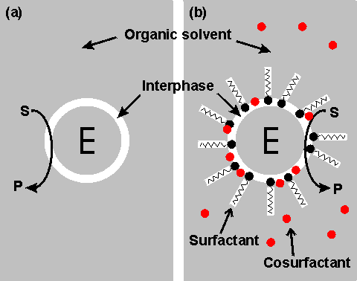
Figure 7.1. Schematic diagram showing two configurations for an enzyme within an organic solvent. (a) almost-anhydrous enzyme suspended in the organic solvent. The enzyme (E) is surrounded by a thin interphase consisting of water or water plus immobilisation support. (b) enzyme dissolved in a reversed micellar medium. The micelles are formed by the surfactant molecules with assistance from the cosurfactant (if present). The surfactant (e.g. cetyltrimethylammonium bromide (CTAB), bis(2-ethylhexyl) sodium sulphosuccinate (AOT), phosphatidylcholine, tetraethyleneglycoldodecylether) is only found at the interphase boundary, whereas the water-immiscible cosurfactant (e.g. butanol, hexanol, octanol), added to vary the properties of this interphase, is generally less polar and more soluble in the organic continuous phase. Both preparations (a) and (b) give optically transparent solutions.

The stabilisation of enzymes in biphasic aqueous-organic systems

It should become clear from the later discussion that there may be a substantial advantage to be gained from the use of biphasic systems in many enzyme-catalysed reactions. One major factor must first be addressed; the stability of the enzyme in these systems. A distinction should be drawn between the more water-soluble hydrophilic enzymes and the more hydrophobic enzymes often associated with lipid and membranes (e.g. lipases). The active integrity and stability of hydrophilic enzymes appears to depend on the presence of a thin layer of water, just a few molecules thick, within the microenvironment. This amount of water is miniscule (between 50 and 500 molecules of water for each enzyme molecule) and the enzyme may effectively be operating in an almost anhydrous state. Some hydrophobic lipases retain activity even if fewer molecules of water remain; presumably just sufficient to stabilise the conformation of the active site. The pH of such minute pools of water, containing no free hydrogen ions, is impossible to measure, or control, directly. However, it appears that the enzyme 'remembers' the pH of its last aqueous solution and functions as though at that pH. If the enzyme-bound water is stripped out or diluted by the use of the more water-soluble, or miscible, organic solvents then the enzyme is usually inactivated. However, under conditions where this does not occur, the limited amount of water available, and the associated reduction in the water activity, considerably reduces the rate of thermoinactivation. This has a stabilising effect on most enzymes; porcine pancreatic lipase, for example, has a half-life of greater than 12 hours at 100°C in 0.02% water in tributyrin, whereas this drops to 12 minutes at a 0.8% water content and inactivation is almost instantaneous in 100% water. Additionally, the freezing point of the water is reduced which allows the use of particularly heat-labile enzymes at very low temperatures. The lowering of the water activity tends to produce a more rigid enzyme molecule which may affect both its K_{m} and V_{max}. In extreme cases, this may result in a change in the catalytic properties. Porcine pancreatic lipase demonstrates this effect. When used in biphasic systems of low water activity, it no longer catalyses transesterification reactions involving the bulky tertiary alcohols.
The most important factor in the balance between stabilisation and inactivation, due to organic phase, is the solvent polarity. Solvents of lower polarity (i.e. greater hydrophobicity) are less able to disrupt the structure of the necessary tightly bound water molecules. The best measure of polarity is the logarithm of the partition coefficient (LogP) of the organic liquid between n-octanol and water; the higher the LogP, the more non-polar (hydrophobic) is the solvent (Table 7.1).
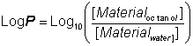 (7.1)

Table 7.1. LogP values of the more commonly used organic solvents.
Solvent | LogP | Solvent | LogP
Butanone | 0.3 | 1,1,1-trichloroethane | 2.8
Ethyl acetate | 0.7 | Carbon tetrachloride | 2.8
Butanol | 0.8 | Dibutyl ether | 2.9
Diethyl ether | 0.8 | Cyclohexane | 3.1
Methylene chloride | 1.4 | Hexane | 3.5
Butyl acetate | 1.7 | Petroleum ether (60-80) | 3.5
Di-isopropyl ether | 2.0 | Petroleum ether (80-100) | 3.8
Benzene | 2.0 | Dipentyl ether | 3.9
Chloroform | 2.2 | Heptane | 4.0
Tetrachloroethylene | 2.3 | Petroleum ether (100-120) | 4.3
Toluene | 2.7 | Hexadecane | 8.7
LogP values increase by about 0.52 for every methylene group (-CH₂-) added in an homologous series. Thus, the LogP of hexanol is that of butanol (0.8) plus 2 x 0.52 (i.e. approximately 1.8).

There appears to be a clear correlation between the activity of biocatalysts in two-phase systems and the LogP (Figure 7.2). The S-shape of this relationship suggests that enzymes are generally inactivated by solvents with logP < 2 but are little affected by solvents with LogP > 4. There is some variation in the effects between different enzymes and different solvents which makes activity prediction, in the LogP range of 2 - 4, rather imprecise. This range includes some of the most utilised organic phases (e.g. chloroform), which may be suitable for some applications but cause harmful inactivation in others. The solubility of the reactant(s) and product(s) may considerably reduce the range of LogP that are available for a particular application; many basically nonpolar molecules possessing some polar structural regions which cause their lack of solubility in strongly hydrophobic solvents. The choice of organic phase will also depend on additional factors such as cost, ease of recovery, fire and fume hazards and specific inhibitory effects. The S-shaped curve can be shifted to the left by immobilising the enzyme within a highly hydrophilic support (Figure 7.2). A simple way of achieving this is to impregnate a beaded hydrophilic polymer (e.g. Sephadex, agarose) with the enzyme followed by suspension of the wet beads directly in the organic phase. These shifts are very important as they greatly increase the choice of suitable organic phase. Such impregnated beads have the additional advantages that
- they protect the contained enzyme from liquid-liquid interfacial denaturation at higher rates of stirring;
- they enable more facile recovery of the biocatalyst;
- they may be used with low molecular weight hydrophilic coenzymes (e.g. NAD(P)⁺) with the assistance of a coenzyme regenerating process; the coenzyme being effectively immobilised within the aqueous pools; and
- they allow the efficient and continuous use of biphasic PBRs, so long as the moving organic phase remains saturated with water.

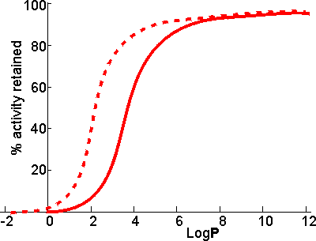
Figure 7.2. Schematic diagram showing the dependence of the activity of immobilised enzymes, in biphasic systems, on the LogP of the organic phase. ——— free enzyme; -------- enzyme immobilised within a strongly hydrophilic support.

Biphasic systems may be further stabilised by the use of deuterated water (D₂O). This reduces the rate of thermal inactivation, although it does cause an increase in the pK_{a}s of ionising groups by about 0.4 with the associated changes in the pH-activity and pH-stability relationships. The higher cost of the deuterated water is offset, to a certain extent, by the small amount necessary in these systems and the ease with which it may be recovered at the end of a catalytic process.
Even where the organic solvent has very low LogP and is miscible, the effect of the expected loss in enzymic activity may be offset by changes in the equilibrium constant. Thus it has been proposed that glucose isomerase be used in aqueous ethanol to produce high fructose corn syrup. The equilibrium fraction of fructose can be raised by about 10% to 55% at 30°C in 80% v/v ethanol. This is economically valid even though the enzymic activity drops by about 10% compared to that in the absence of ethanol.

Equilibria in biphasic aqueous-organic systems
Much of the theory outlining the effect of biphasic systems on the apparent equilibria was outlined by Karel Martinek and his co-workers at Lomonosov Moscow State University. Consider the simple reaction scheme, involving the equilibrium between reactant (A) and product (B) with K_{w} representing the equilibrium constant (K_{eq}) in water:
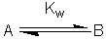 [7.1]
If this reaction is carried out in a biphasic system consisting of a mixture of an aqueous and an organic solvent, both A and B will be partitioned between the two solvents (with partition coefficients, P_{A} and P_{B}) and a separate equilibrium (K_{org}) will be established between A and B in the organic phase.
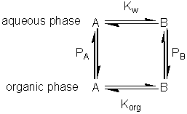 [7.2]
where:
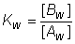 (7.2)
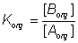 (7.3)
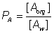 (7.4)
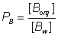 (7.5)
Because of the cyclic nature of these equilibria only three of these parameters are independent 'variables' (i.e. K_{org} depends on K_{w}, P_{A} and P_{B}). It should be noticed from the following discussion that K_{org} plays no further part, although similar derivations could be made involving K_{org}, P_{A} and P_{B} rather than K_{w}, P_{A} and P_{B}. The apparent equilibrium constant (K_{biphasic}) of this system may be defined as
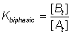 (7.6)
where the subscripts t, org and w refer to the total solution, the organic and water phases respectively. If V represents the volumes involved, it follows that
(7.7)
(7.8)
(7.9)
Substituting from equations 7.7 and 7.8 into equation 7.6,
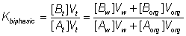 (7.10)
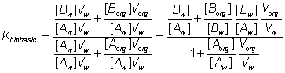 (7.11)
Substituting the partition coefficients from equations 7.3 and 7.4 gives the simplified relationship,
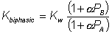 (7.12)
i.e. α is the ratio of the volumes of the organic and water phases.
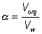 (7.13)
The apparent equilibrium constant (K_{biphasic}) varies with the relative volumes of the aqueous and organic phases; increasing when the substrate is partitioned more efficiently out of the organic phase and into the aqueous phase relative to the behaviour of the product (i.e. P_{A} < P_{B}), and decreasing when the reverse occurs (Figure 7.3A). If there are sufficient differences in the partition coefficients and both substrate and product are relatively non-polar then substantial shifts in the equilibria occur even at high relative water contents. A substantial increase in the apparent equilibrium constant may be achieved, when both the substrate and product have partition coefficients less than unity, when the ratio of the partition coefficients is suitable (Figure 7.3B). Clearly if α is very small K_{biphasic} tends to K_{w}, the equilibrium constant in aqueous solution. However, if α is sufficiently large, equation 7.12 simplifies to
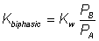 (7.14)
Therefore, substituting from equations 7.2 - 7.5,
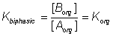(7.15)
Therefore K_{biphasic} tends to K_{org}, the equilibrium constant of the reaction in the pure organic liquid.

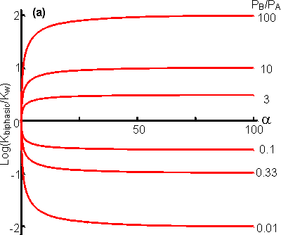
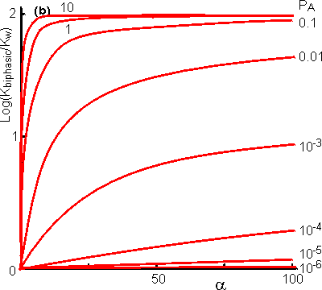
Figure 7.3. The variation in the apparent equilibrium constants of a one-substrate one-product reaction (A B) with the relative component composition of a biphasic aqueous-organic system. (A) shows the effect of the ratio of the partition coefficients, P_{B}/P_{A}. The curves have been generated using equation 7.12 and the following values for the partition coefficients, from the top downwards; P_{A} = 0.2, P_{B} = 20; P_{A} = 0.2, P_{B} = 2; P_{A} = 0.2, P_{B} = 0.6; P_{A} = 0.6, P_{B} = 0.2; P_{A} = 2, P_{B} = 0.2; P_{A} = 20, P_{B} = 0.2. (B) shows the effect of the polarity of A and B, keeping the ratio of the partition coefficients constant (P_{B}/P_{A} = 100). The following values for the partition coefficients have been used, from the top downwards; P_{B} = 100, P_{B} = 10, P_{B} = 1, P_{B} = 0.1, P_{B} = 0.01, P_{B} = 0.001, P_{B} = 0.0001.

Many reactions are bimolecular, and these are influenced in a more complex way by the biphasic system. The processes may be represented in a manner similar to that used for monomolecular reactions;
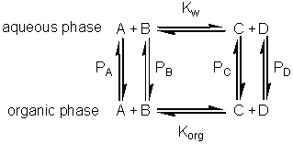 [7.3]
Using similar reasoning to that outlined above, the following expression may be obtained for the apparent equilibrium constantes
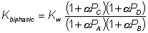 (7.16)
As in the case of monomolecular reactions, when the relative water content is very low (i.e. α is high) the apparent equilibrium constant tends to K_{org}. However, the equation (7.16) is quadratic in terms of α and at intermediate values may produce a maximum or minimum value for the apparent equilibrium constant that is several decades different from either K_{w} or K_{org} (i.e. the apparent equilibrium constant may be greater than the equilibrium constant of the same reaction in either of the pure phases, see Figure 7.4). Under some circumstances this may enable the reaction productivity in the biphasic system to be much greater than that attainable in either pure phase.

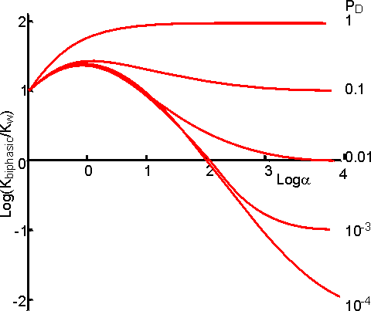
Figure 7.4. The variation in the apparent equilibrium constants of a two-substrate two-product reaction (A + B C + D) with the relative component composition of a biphasic aqueous-organic system. In all cases the partition coefficients are P_{A} = 1, P_{B} = 1 and P_{C} = 100. The following values for the partition coefficient (P_{D}) have been used, from the top downwards; 1, 0.1, 0.01, 0.001 and 0.0001.

A special and relevant case of the bimolecular reaction scheme is where one of the reactants is water (e.g. use of the hydrolases). These reactions may be written in a way corresponding to reaction scheme [7.3].
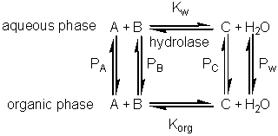 [7.4]
The normal direction for the reaction in aqueous solution is the hydrolytic process from right to left. However, the apparent equilibrium constant may be shifted in biphasic solutions, as outlined above, and allow the hydrolase to act in a synthetic (i.e. left to right in reaction scheme [7.4]), rather than hydrolytic, manner. Such reactions significantly extend the processes available to the enzyme technologist, as synthetic reactions are generally much more difficult to achieve by classical organic chemistry than hydrolytic reactions, particularly when a regiospecificity is required as, then, there is a choice of reactive groups in the substrates. Two factors affect the yield of the product (C) in such reactions: (1) the shift in apparent equilibrium constant (K_{biphasic}); and (2) the concentration of water ([(H₂O)_{t}]), as one of the participating reactants. [(H₂O)_{t}] may be obtained from the material balance,
(7.17)
where [(H₂O)_{w}] is the molar concentration of pure water (= 1000/18 = 55.5 M). Substituting P_{w} for [(H₂O)org]/[(H₂O)w],
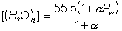 (7.18)
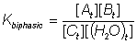 (7.19)
Substituting for K_{biphasic} from equation 7.16 (with P_{D} set to equal P_{w}) and rearranging, the terms in (1 + αP_{w}) cancel to give
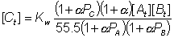 (7.20)
This represents a fairly complex relationship but a few generalisations may be made. If the product (C) is less polar than either reactant (A or B) then the yield generally increases with the relative concentration of the organic phase (α) to reach a plateau. If the reverse occurs, then there will be a plateau at low yield and high α in the α-yield diagram. Both minima and maxima may occur, dependent on the parameters. Figure 7.5 shows the variation of the apparent equilibrium constant and the yield for the enzymic synthesis of an ester from its acid and alcohol in a biphasic system. From this it can be seen that the use of a biphasic system can increase the yield of such reactions from zero to nearly 100%. In order to achieve high conversions, the water produced must be removed from the two-phase system. If it is not removed, there is a continual drop in α which reduces the extent of the favourable equilibrium. There are no simple ways in which this water may be removed but reactors which allow the constant addition of fresh catalyst and organic phase reduce the size of the problem.

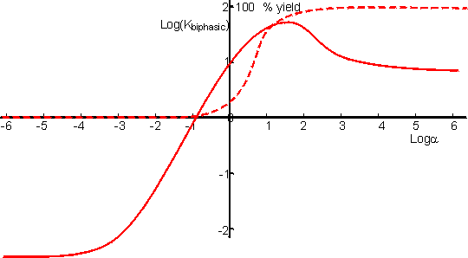
Figure 7.5. The variation in the apparent equilibrium constant and percentage yield of a reverse hydrolytic reaction (A + B C + H₂O) with the relative component composition of a biphasic aqueous-organic system. The reaction portrayed is the synthesis of N-benzoyl-L-phenylalanine ethyl ester, from N-benzoyl-L-phenylalanine and ethyl alcohol, catalysed by α-chymotrypsin in a biphasic chloroform-water system (pH 7). ——— apparent equilibrium constant; ------- % yield (semi-logarithmic plot). The curves were calculated assuming K_{w} = 0.002, P_{A} = 0.11 (N-benzoyl-L-phenylalanine at pH 7), P_{B} = 0.01 (ethyl alcohol), P_{C} = 4100 (N-benzoyl-L-phenylalanine ethyl ester), and an equimolar mixture of reactants.

Use of biphasic solvent systems also affect the ionisation of acid and basic groups. Consider the ionisation of an acid HA, where only the unionised form is soluble in the organic phase and the ionic species are only soluble in the aqueous phase,
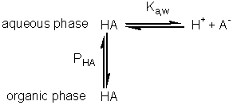 [7.5]
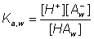 (7.21)
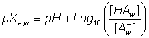 (7.22)
The hydrogen ion concentration, as determined, is characteristic of the aqueous phase,
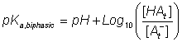 (7.23)
A consideration of material mass balances for A⁻ and HA gives
(7.24)
(7.25)
Substituting for pH from equation 7.22 into equation 7.23 gives
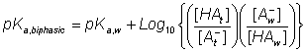 (7.26)
Substituting from equations 7.24 and 7.25 this simplifies to give
(7.27)
Similarly, for the protonation of a base
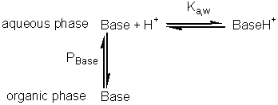 [7.6]
(7.28)
A qualitative assessment of reaction schemes [7.5] and [7.6] shows that increasing the partition coefficient for the uncharged acid or base will pull the reaction away from the formation of the ionised species. It follows from equations 7.27 and 7.28 that the apparent pK_{a}s of acids increase in biphasic systems whereas those of bases decrease. These changes may well be several pH units, dependent on the partition coefficients and the relative fraction of organic solvent present. The shifts in pK_{a} are in addition to any increase in the pK_{a} due to the lower dielectric constant of the aqueous phase, as outlined in Chapter 1. This is likely to be particularly relevant under almost anhydrous conditions (i.e. where α is high) which tend to 'freeze' the hydrogen ions lowering their activity. The utility of the shift in the pK_{a} can be shown using ester synthesis catalysed by α-chymotrypsin as an example.
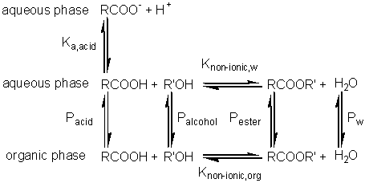 [7.7]
where RCOOH and RCOO⁻ represent the un-ionised and ionised forms of N-benzoyl-L-phenylalanine, RCOOR' represents N-benzoyl-L-phenylalanine ethyl ester and R'OH represents ethyl alcohol.Although the non-ionic reaction in aqueous solution is evenly balanced (K_{nonionic,w} = 7), the overall reaction proceeds towards the left, in water at neutral pH, due to the pull exerted by the acid's ionisation (pK_{a} = 3.4). In biphasic chloroform-water solution (α = 20, P_{HA} = 100), the K_{a} shifts by three decades to give a pK_{a} close to 7. This, together with a shift in the equilibrium constant due to the partition effects, outlined earlier, produces an overall shift in the equilibrium constant of about five decades at the optimal pH (7.5) of the enzyme (Figure 7.6). Use of the biphasic system allows reactions to be performed at a pH that is both thermodynamically favourable to the reaction direction required and at the optimum for the enzyme's catalytic efficiency.

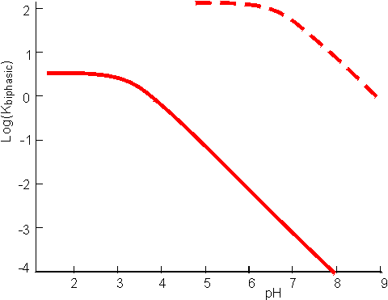
Figure 7.6. pH dependence of the apparent equilibrium constant for the synthesis of N-benzoyl-L-phenylalanine ethyl ester, as given by the reaction scheme [7.7]. ——— reaction in aqueous solution only (i.e. α = 0); ---------- reaction in a biphasic chloroform-water system (α = 20). The shift upwards is due to the more significant partition of the ester into the organic phase relative to the reactants, whereas the shift in the pH dependence to higher pH is due to the change in the apparent pK_{a} of the acid.

Enzyme kinetics in biphasic aqueous-organic systems

Although the equilibrium position of reactions may be shifted in biphasic systems, this is of no practical consequence unless the reaction actually occurs. The enzyme must be able to convert the reactants to products. For this to proceed, even in the presence of fully active enzymes, there must be some reactant present in the aqueous microenvironment surrounding the enzyme. Reactants may have fairly low aqueous solubilities under the normal conditions associated with such biphasic processes. The aqueous phase remains effectively unstirred, even when the organic phase is well-stirred, during the reaction so that the thickness of the 'unstirred layer' (δ) is equal to the thickness of the aqueous layer surrounding the enzyme. Where δ is large, the rate of reaction is likely to be controlled by the passage of reactants through this aqueous layer as the concentration gradients will be very shallow due to the low solubilities of the reactants in water. However, δ is often very thin, however, especially where the enzyme is freely soluble, causing the reactions to be effectively diffusionally controlled by the passage of the reactants from the more concentrated organic phase through the interphase boundary to very low concentrations within the microenvironment of the enzyme. Clearly, the thickness of the aqueous layer around an immobilised enzyme will be of great importance in determining the degree of diffusional resistance involved, and hence the lowering of the reaction rate. As with all immobilised enzymes, the volumetric surface area (A/V) is an important parameter governing the overall flux of the substrate to the biocatalytic surface, the effectiveness of the enzyme and the productivity. Whereas in reactions involving a single liquid phase this surface area is the area presented by the exterior of the particles to the bulk of the liquid, in most practical biphasic liquid systems it is the interfacial area between the two liquid phases that is relevant. Under normal operating conditions this interfacial area will depend upon the volume of the aqueous droplet surrounding and enclosing the enzymic biocatalyst. As the relative volume of the organic phase increases the volumetric surface area will decrease, so reducing the maximum volumetric productivity. This will be of particular importance where α needs to be very high in order to shift the reaction equilibrium. Clearly this will reduce the reaction rate due to the reduction in the amount of enzyme that can be present, due to its associated water, and the associated reduction in the interfacial area. Where the catalysed reaction generates water, this should not generally be allowed to accumulate as it not only has a detrimental effect on the equilibrium constant but will also slow down the rate of reaction.
There are some rules which allow the optimisation of the two-phase system for enzyme-catalysed reactions. They depend upon the concept of LogP being extended to cover the substrates, products and the interphase (see Figure 7.1).
- The difference between the LogP values of the substrate(s) and the interphase should be as small as possible whereas that of the substrate(s) should be much lower than that of the organic phase. These conditions encourage high concentrations of substrate(s) within the interphase and, hence, the transfer of the substrate from the organic phase into the aqueous phase.
- The difference between the LogP values of the product(s) and the organic phase should be as small as possible whereas that of the product(s) should be much greater than that of the interphase. These conditions encourage the transfer of the product from the aqueous phase through the interphase into the organic phase, after reaction.
The LogP of the interphase can be varied independently of the organic phase by suitable choice of surfactants and cosurfactants. The precise structure of this interphase may be much more complex than outlined in Figure 7.1. In particular, when there is excess water and surfactant present, the surfactant may form multiple concentric membranes, consisting of surfactant bilayers, around the aqueous core. This presents another reason for the removal of the water produced by use of hydrolases (used as synthetases) in biphasic systems. Control over the amount of water surrounding the enzyme is often possible by means of molecular sieves (e.g. potassium aluminium silicate), which absorb water. Removal of water dissolved in the organic phase can easily be achieved by their use and this leads to the depletion of water from the aqueous biocatalytic pools by its partition. If the organic phase has a high boiling point the removal of water may be simply achieved by vacuum distillation; e.g. in the esterification of fatty acids and fatty alcohols catalysed by lipase and used in wax manufacture.

Use of aqueous two-phase systems

Aqueous 2-phase systems (see Chapter 2) offer the opportunity to shift reaction equilibria towards product formation by ensuring that enzyme and substrate partition into one phase whilst the product enters, and may be removed from, the other. The theory developed (earlier) for aqueous/organic biphasic systems is equally applicable to these systems. An example of such an extractive bioconversion is a method for the conversion of starch to glucose using bacterial α-amylase and glucoamylase. Starch substrate partitions almost entirely into the lower, more hydrophilic, dextran-rich phase of a system comprising 3% polyethylene glycol (PEG 20,000) and 5% crude unfractionated dextran. The enzymes also partition largely to the bottom phase but the glucose, produced by the hydrolysis, distributes itself more evenly between the phases. A small proportion of the glucoamylase enters the upper phase and will convert any oligosaccharide entering that phase to glucose. Concentrations of up to 140 g l⁻¹ glucose may be reached in the upper phase.
Such a system offers some of the advantages of an immobilised enzyme process without some of the disadvantages. The enzymes are largely retained and are stabilised by the presence of the polymers yet catalysis is in homogeneous solution (within the phase) so no diffusion limitations to mass transfer exist. Drawbacks include the need to separate the product from the upper phase polymers and gradual loss of enzymes which enter the upper phase. Enzyme loss could be reduced, without introducing diffusion limitations, by linking them to hydrophilic polymers so as to form soluble complexes.

Practical examples of the use of enzymes 'in reverse'

It has long been known that if proteases are supplied with high concentrations of soluble proteins, peptides or amino acids, polymers (plasteins) are produced with apparently random, if rather hydrophobic, structures. This reaction has been used, for example, to produce bland-tasting, colourless plasteins from brightly coloured, unpleasant tasting, algal biomass and for the introduction of extra methionine into low quality soy protein. However in general, the non-specific use of proteases in the synthesis of new structures has not found commercial use. However, proteases have come into use as alternatives to chemical methods for the synthesis of peptides of known and predetermined structure because their specificity allows reactions to proceed stereospecifically and without costly protection of side-chains.
A method for the synthesis of the high intensity sweetener aspartame exemplifies the power of proteases (in this case, thermolysin). Aspartame is the dipeptide of L-aspartic acid with the methyl ester of L-phenylalanine (α-L-aspartyl-L- phenylalanyl-O-methyl ester). The chemical synthesis of aspartame requires protection of both the β-carboxyl group and the α-amino group of the L-aspartic acid. Even then, it produces aspartame in low yield and at high cost. If the β-carboxyl group is not protected, a cost saving is achieved but about 30% of the β-isomer is formed and has, subsequently, to be removed. When thermolysin is used to catalyse aspartame production the regiospecificity of the enzyme eliminates the need to protect this β-carboxyl group but the α-amino group must still be protected (usually by means of reaction with benzyl chloroformate to form the benzyloxycarbonyl derivative, i.e. BOC-L-aspartic acid) to prevent the synthesis of poly-L-aspartic acid. More economical racemic amino acids can also be used as only the desired isomer of aspartame will be formed.
If stoichiometric quantities of BOC-L-aspartic acid and L-phenylalanine methyl ester are reacted in the presence of thermolysin, an equilibrium reaction mixture is produced giving relatively small yields of BOC-aspartame. However, if two equivalents of the phenylalanine methyl ester are used, an insoluble addition complex forms in high yield at concentrations above 1 M. The loss of product from the liquid phase due to this precipitation greatly increases the overall yield of this process. Later, the BOC-aspartame may be released from this adduct by simply altering the pH. The stereospecificity of the thermolysin determines that only the L-isomer of phenylalanine methyl ester reacts but the addition product is formed equally well from both the D- and L-isomers. This fortuitous state of affairs allows the use of racemic phenylalanine methyl ester, the L-isomer being converted to the aspartame derivative and the D-isomer forming the insoluble complex shifting the equilibrium to product formation. D-phenylalanine ethyl ester released from the addition complex may be isomerised enzymically to reform the racemic mixture. The BOC-aspartame may be deprotected by a simple hydrogenation process to form aspartame.
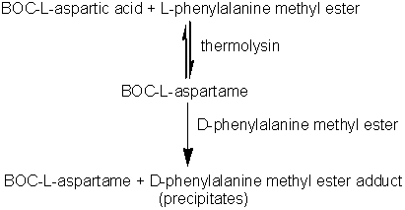 [7.8]
Immobilised thermolysin cannot be used in this process as it has been found to co-precipitate with the insoluble adduct. However, this may be circumvented by its use within a liquid/liquid biphasic system.

Table 7.2 The specificity of some specific industrial proteases, involving acyl intermediates.
Enzyme | Preferred cleavage sitesª  (N-terminal C-terminal)
Bromelain | -LysZ; -ArgZ; -PheZ; -TyrZ
Chymotrypsin | -TrpZ; -TyrZ; -PheZ; -LeuZ
Papain | -Phe-AAZ; -Val-AAZ; -Leu-AAZ; -Ile-AAZ
Pepsin | -Phe(or Tyr,Leu)Trp(or Phe,Tyr)-
Thermolysin | -AALeu-; -AAPhe-; -AAIle-; -AAVal-
Trypsin | -ArgZ; -LysZ
ª AA represents any amino acid residue and Z represents amino acid residues, esters or amides. The cleavage sites () are those preferred by the pure enzyme; crude preparations may have much broader specificities.

The synthesis of aspartame is a very simple example of how proteases may be used in peptide synthesis. Most proteases show specificity in their cleavage sites (Table 7.2) and may be used to synthesise specific peptide linkages. Factors that favour peptide synthesis are correct choice of pH, the selection of protecting residues for amino and carboxyl groups that favour product precipitation and the use of liquid/liquid biphasic systems, all of which act by controlling the equilibrium of the reaction. An alternative strategy is kinetically controlled synthesis where the rate of peptide product synthesis (k_{P}) is high compared with the rate of peptide hydrolysis (k_{H}). This may be ensured by providing an amino acid or peptide which is a more powerful nucleophile than water in accepting a peptide unit from an enzyme-peptide intermediate. This kinetically controlled reaction may be represented as
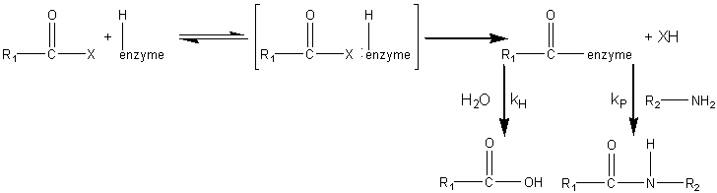 [7.9]
where X represents an alcohol, amine or other activating group, i.e. the reactant is an ester, amide (peptide) or activated carboxylic acid. The relative rate of peptide formation compared with hydrolysis depends on the the ratio k_{P}/k_{H}, the ratio of the K_{m} values for water and amine, and the relative concentrations of the (unprotonated) amine and water (see equation 1.91). Thus, where necessary, the reaction yield may be improved by lowering the water activity. It has been found that the yields may be increased by reducing the temperature to 4°C, perhaps by a disproportionate effect on the K_{m} values. The amine and enzyme concentrations should be as high as possible for such kinetically controlled reactions and only those enzymes which utilise a covalently-linked enzyme-peptide intermediates can be used (see Table 7.2). Also, the reaction is stopped well before equilibrium is reached as, under such thermodynamic control, the product peptide will be converted back though the enzyme intermediate to the carboxylic acid, a process made almost irreversible by its ionisation in solutions of pH above its pK_{a}, as shown in reaction scheme [7.10].
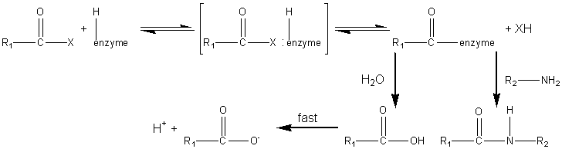 [7.10]
Peptides may be lengthened either by the addition of single amino acid residues or by the condensation of peptide fragments. The size of the peptide required as the final product may determine the type of synthesis used; condensation of fragments may be performed in kinetically controlled processes whereas stepwise elongation is best achieved using biphasic solid/liquid (i.e. precipitation) or liquid/liquid thermodynamically controlled processes.
In general, few proteases are required for such synthetic purposes. As they are quite costly, especially at the high activities necessary for kinetic control, they may be immobilised in order to enable their repeated use. Many examples of enzymic peptide synthesis may be sited. The conversion of porcine insulin to human insulin requires the replacement of the C-terminal alanine (β30) residue by a threonine. This can be achieved by a single transpeptidation step catalysed by trypsin using an carboxyl-protected threonine in an aqueous solution with an organic co-solvent. The protective group can be simply removed later by mild hydrolysis and the product purified by silica gel chromatography (see scheme [7.11]).
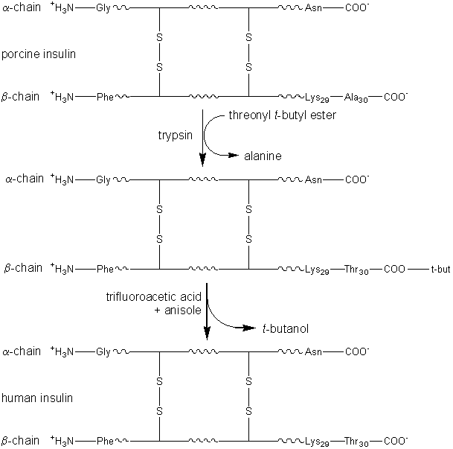 [7.11]

Glycosidases used in synthetic reactions

This is a comparatively neglected topic probably because polysaccharides can be obtained readily from plant or microbial sources, because polysaccharide function is not so specifically related to its structure, and because the theory describing the functional significance of oligosaccharides is still being developed. As there is an abundance of knowledge about glycosidases and their specificities, there is no fundamental reason why they should not be used to synthesise oligosaccharides. There are few examples in the literature of oligosaccharides being constructed using enzymes such as dextransucrase (EC 2.4.1.5), levansucrase (EC 2.4.1.10), cyclomaltodextrin glucanotransferase (EC 2.4.1.19) and β-galactosidase (EC 3.2.1.23) to build up glucose, fructose or galactose residues on suitable acceptors. Fructosyltransferases (e.g. inulosucrase, EC 2.4.1.9) have been used to synthesise compounds such as sucrose-6-acetate, xylosucrose (β-D-fructofuranosyl-(2,1)-α-D-xylopyranoside) and the low cariogenic sweetener, 'neosugar' which consists of a mixture of glucose, sucrose and β-2,1 linked fructans with terminal non-reducing glucose residues (typical composition before chromatographic refinement: 2% fructose, 26% glucose, 11% sucrose, 30% 1-kestose (β-D-fructofuranosyl-(2,1)-β-D-fructofuranosyl- (2,1)-α-D-glucopyranose), 25% nystose (β-D-fructofuranosyl- (2,1)-β-D-fructofuranosyl-(2,1)-β-D-fructofuranosyl-(2,1)-α-D- glucopyranose) and 6% higher oligosaccharides).
sucrose + glucose-6-acetate sucrose-6-acetate + glucose [7.12]
sucrose + xylose xylosucrose + glucose [7.13]
sucrose + sucrose 1-kestose + glucose [7.14]
1-kestose + sucrose nystose + glucose [7.15]
As shown in reaction scheme [7.16], dextransucrase can be used to produce dextran (a polymer of α-1,6 linked glucose residues) from sucrose. Dextran is used in gel chromatographic media, such as Sephadex, in the aqueous 2-phase systems already described, and as a blood plasma extender. For any of these uses it is undesirable to have cells remaining in the dextran so the dextransucrase, produced extracellularly by Leuconostoc mesenteroides is purified before use. The size of dextran molecules produced may be controlled by including small concentrations of sugars such as maltose which compete with sucrose as acceptors for glucose residues from the donor sucrose molecules.
sucrose + dextran (G_{n}) fructose + dextran (G_{n+1}) [7.16]
Thermodynamically controlled synthesis of oligosaccharides, catalysed by glycosidases, is possible by use of high substrate concentrations and a 'molecular trap' to remove the products. For example, β-galactosidase may be used to synthesise N-acetyllactosamine (β-D-galactopyranosyl-(1,6)-2-acetamido- 2-deoxy-D-glucose) using a carbon-celite column to remove it, as formed.
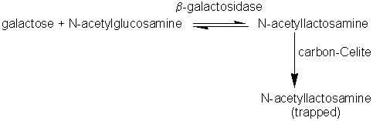 [7.17]
There seems to have been no systematic attempt to construct hetero-oligosaccharides in a stepwise movement yet thermodynamically or kinetically controlled reactions could be used just as in peptide synthesis.

Interesterification of lipids

There is no opportunity or established need to build up polymers or oligomers using lipases or esterases yet it is possible and commercially advantageous to use these enzymes as transferases in transesterifications (carboxyl group exchange between esters), acidolyses (carboxyl group exchange between esters and carboxylic acids) and alcoholyses (alcohol exchange between esters and alcohols). Certain triglycerides, cocoa butter being the outstanding example, have high value because of their physical properties and comparative rarity. There is a commercial pull, therefore, to fund routes to the production of high value triglycerides from more plentiful, cheaper raw materials. This may be done using lipases (e.g. ex.Rhizopus or ex. Mucor Miehei) acting as transacylases.
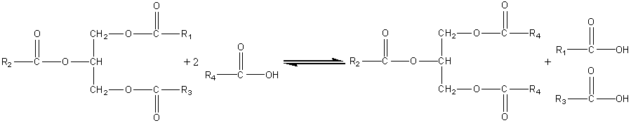 [7.18]
This acidolysis reaction may be used for increasing the value of rapeseed oil by exchanging linoleic acid for linolenic acid residues and increasing the value of palm oil and sunflower oil by increasing their content of oleic acid residues. Cocoa butter is a relatively expensive fat, used in confectionery, because of its sharp melting point between room temperature and body temperature; chocolate literally melts in the mouth. This is due to the fairly small variation in the structure of the constituent triglycerides; 80% have palmitic acid or stearic acid in the 1 and 3 positions with oleic acid in the central 2 position. For the production of cocoa butter substitute from palm oil, a process which increases the value of the product three-fold, the acidolysis utilises stearic acid (i.e. R₄ is C₁₇H₃₅) in hexane containing just sufficient water to activate the lipase. Olive oil may be similarly improved by exchanging its 1,3-oleic acid residues for palmityl groups. The products may be recovered by recrystallisation from aqueous acetone. Such reactions may also be used for the resolution of racemic mixtures of carboxylic acids or alcohols, the lipase generally being specific for only one out of a pair of optical isomers.
The secret of success has been the selection of lipases with the correct specificity and the selection of reaction conditions that favour transacylation rather than hydrolysis. Because the hydrolytic activity of industrial lipases is 10 - 15 times the transacylation activity, it is advantageous to minimise the water content of the reaction system and use the aqueous/organic biphasic systems described earlier.An example of lipase being used in an alcoholysis reaction is the biphasic production of isoamyl acetate, a natural aroma.
lipase
CH₃CH₂OCOCH₃ + (CH₃)₂CHCH₂CH₂OH (CH₃)₂CHCH₂CH₂OCOCH₃ + CH₃CH₂OH [7.19]
Ethyl acetate + isoamylalcohol isoamyl acetate + ethanol

Summary and Bibliography of Chapter 7

- Reaction equilibria can be shifted by use of biphasic systems. This may be utilised by enzyme technologists so long as their enzymes are stable within such systems.
- LogP is the best measure of the polarity of a solution for use in enzymic reactions.
- Kinetic control may be preferred to thermodynamic control in some enzymic syntheses.

References and Bibliography
- Carrea, G., Riva, S., Bovara, R. & Pasta, P. (1988). Enzymatic oxidoreduction of steroids in two-phase systems: effects of organic solvents on enzyme kinetics and evaluation of the performance of different reactors. Enzyme and Microbial Technology, 10, 333-340.
- Deetz, J.S. & Rozzell, J.D. (1988). Enzyme-catalysed reactions in non-aqueous media. Trends in Biotechnology, 6, 15-19.
- Klibanov, A.M. (1986). Enzymes that work in organic solvents. CHEMTECH, 16, 354-359.
- Laane, C., Boeren, S., Vos, K. & Veeger, C. (1987). Rules for optimization of biocatalysts in organic solvents. Biotechnology and Bioengineering , 30, 81-87.
- Lilly, M.D. (1982). Two-liquid-phase biocatalytic reactions. Journal of Chemical Technology and Biotechnology, 32, 162-169.
- Luisi, P.L. & Laane, C. (1986). Solubilization of enzymes in apolar solvents via reverse micelles. Trends in Biotechnology, 4, 153-160.
- Martinek, K. & Semenov, A.N. (1981). Enzymic synthesis in biphasic aqueous-organic systems. 2. Shift in ionic equilibria. Biochimica et Biophysica Acta, 658ES70, 90-101.
- Martinek, K., Semenov, A.N. & Berezin, I.V. (1981). Enzymic synthesis in biphasic aqueous-organic systems. 1. Chemical equilibrium shift. Biochimica et Biophysica Acta, 658, 76-89.
- Morihara, K. (1987). Using proteases in peptide synthesis. Trends in Biotechnology, 5, 164-170.
- Nilsson, K.G.I. (1988). Enzymatic synthesis of oligosaccharides. Trends in Biotechnology, 6, 256-264.
- Rekker, R.F. & de Kort, H.M. (1979). The hydrophobic fragmental constant; an extension to a 1000 data point set. European Journal of Medicinal Chemistry , 14, 479-488.
- Visuri, K. & Klibanov, A.M. (1987). Enzymic production of high fructose corn syrup (HFCS). containing 55% fructose in aqueous ethanol. Biotechnology and Biopengineering, 30, 917-920.
- Zaks, A., Empie, M. & Gross, A. (1988).Potentially commercial enzymatic processes for the fine and specialty chemical industries. Trends in Biotechnology, 6, 272-275.
- Zaks, A. & Klibanov, A.M. (1984). Enzymic catalysis in organic media at 100°C. Science, 224, 1249-1251.
- Zaks, A. & Klibanov, A.M. (1985). Enzyme-catalyzed processess in organic solvents. Proceedings of the National Academy of Sciences, 82, 3192-3196.

