Chapter 5: Immobilised enzymes and their uses

Enzyme reactors

An enzyme reactor consists of a vessel, or series of vessels, used to perform a desired conversion by enzymic means. A number of important types of such reactor are shown diagrammatically in Figure 5.1. There are several important factors that determine the choice of reactor for a particular process. In general, the choice depends on the cost of a predetermined productivity within the product's specifications. This must be inclusive of the costs associated with substrate(s), downstream processing, labour, depreciation, overheads and process development, in addition to the more obvious costs concerned with building and running the enzyme reactor. Other contributing factors are the form of the enzyme of choice (i.e. free or immobilised), the kinetics of the reaction and the chemical and physical properties of an immobilisation support including whether it is particulate, membranous or fibrous, and its density, compressibility, robustness, particle size and regenerability. Attention must also be paid to the scale of operation, the possible need for pH and temperature control, the supply and removal of gases and the stability of the enzyme, substrate and product. These factors will be discussed in more detail with respect to the different types of reactor.
Batch reactors generally consist of a tank containing a stirrer (stirred tank reactor, STR). The tank is normally fitted with fixed baffles that improve the stirring efficiency. A batch reactor is one in which all of the product is removed, as rapidly as is practically possible, after a fixed time. Generally this means that the enzyme and substrate molecules have identical residence times within the reactor, although in some circumstances there may be a need for further additions of enzyme and/or substrate (i.e. fed -batch operation). The operating costs of batch reactors are higher than for continuous processes due to the necessity for the reactors to be emptied and refilled both regularly and often. This procedure is not only expensive in itself but means that there are considerable periods when such reactors are not productive; it also makes uneven demands on both labour and services. STRs can be used for processes involving non-immobilised enzymes, if the consequences of these contaminating the product are not severe. Batch reactors also suffer from pronounced batch-to-batch variations, as the reaction conditions change with time, and may be difficult to scale-up, due to the changing power requirements for efficient fixing. They do, however, have a number of advantageous features. Primary amongst these is their simplicity both in use and in process development. For this reason they are preferred for small-scale production of highly priced products, especially where the same equipment is to be used for a number of different conversions. They offer a closely controllable environment that is useful for slow reactions, where the composition may be accurately monitored, and conditions (e.g. temperature, pH, coenzyme concentrations) varied throughout the reaction. They are also of use when continuous operation of a process proves to be difficult due to the viscous or intractable nature of the reaction mix.

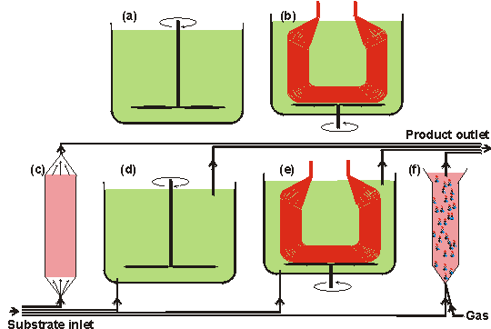
Figure 5.1. Diagrams of various important enzyme reactor types.
- Stirred tank batch reactor (STR), which contains all of the enzyme and substrates) until the conversion is complete;
- batch membrane reactor (MR), where the enzyme is held within membrane tubes which allow the substrate to diffuse in and the product to diffuse out. This reactor may often be used in a semicontinuous manner, using the same enzyme solution for several batches;
- packed bed reactor (PBR), also called plug -flow reactor (PFR), containing a settled bed of immobilised enzyme particles;
- continuous flow stirred tank reactor (CSTR) which is a continuously operated version of (a); (e) continuous flow membrane reactor (CMR) which is a continuously operated version of (b);
- fluidised bed reactor (FBR), where the flow of gas and/or substrate keeps the immobilised enzyme particles in a fluidised state.
All reactors would additionally have heating/cooling coils (interior in reactors (a), and (d), and exterior, generally, in reactors (b), (c), (e) and (f)) and the stirred reactors may contain baffles in order to increase (reactors (a), (b), (d) and (e) or decrease (reactor (f)) the stirring efficiency. The continuous reactors ((c) -(f)) may all be used in a recycle mode where some, or most, of the product stream is mixed with the incoming substrate stream. All reactors may use immobilised enzymes. In addition, reactors (a), (b) and (e) (plus reactors (d) and (f), if semipermeable membranes are used on their outlets) may be used with the soluble enzyme.

The expected productivity of a batch reactor may be calculated by, assuming the validity of the non -reversible Michaelis -Menten reaction scheme with no diffusional control, inhibition or denaturation (see reaction scheme [1.7] and equation (1.7). The rate of reaction (v) may be expressed in terms of the volume of substrate solution within the reactor (Vol_{S}) and the time (t):
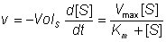 (5.1)
Therefore:
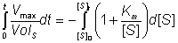 (5.2)
On integrating using the boundary condition that [S] = [S]₀ at time (t) = 0:
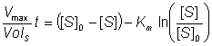 (5.3)
Let the fractional conversion be X, where:
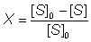 (5.4)
Therefore;
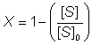 (5.4a)
and
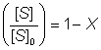 (5.4b)
Also
(5.4c)
Therefore substituting using (5.4c) and (5.4b) in (5.3):
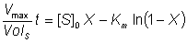 (5.5)
The change in fractional conversion and concentrations of substrate and product with time in a batch reactor is shown in Figure 5.2(a).

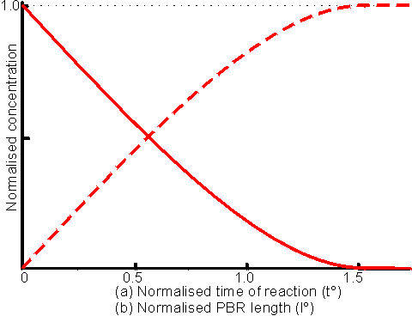
Figure 5.2. This figure shows two related behaviours.
(a) The change in substrate and product concentrations with time, in a batch reactor. The reaction S P is assumed, with the initial condition [S]₀/K_{m} = 10. The concentrations of substrate (——— and product (-----------) are both normalised with respect to [S]₀. The normalised time (i.e. t° = t V_{max}/[S]₀) is relative to the time (t° = 1) that would be required to convert all the substrate if the enzyme acted at V_{max} throughout, the actual time for complete conversion being longer due to the reduction in the substrate concentration at the reaction progresses. The dashed line also indicates the variation of the fractional conversion (X) with t°.
(b) The change in substrate and product concentrations with reactor length for a PBR. The reaction S P is assumed with the initial condition, [S]₀/K_{m} = 10. The concentrations of substrate (———) and product (-----------) are both normalised with respect to [S]". The normalised reactor length (i.e. I° = lV_{max}/F, where V_{max} is the maximum velocity for unit reactor length and I is the reactor length) is relative to the length (i.e. when I° = 1) that contains sufficient enzyme to convert all the substrate at the given flow rate if the enzyme acted at its maximum velocity throughout; the actual reactor length necessary for complete conversion being longer due to the reduction in the substrate concentration as the reaction progresses. P may be considered as the relative position within a PBR or the reactor's absolute length.

Membrane reactors

The main requirement for a membrane reactor (MR) is a semipermeable membrane which allows the free passage of the product molecules but contains the enzyme molecules. A cheap example of such a membrane is the dialysis membrane used for removing low molecular weight species from protein preparations. The usual choice for a membrane reactor is a hollow-fibre reactor consisting of a preformed module containing hundreds of thin tubular fibres each having a diameter of about 200 μm and a membrane thickness of about 50 μm. Membrane reactors may be used in either batch or continuous mode and allow the easy separation of the enzyme from the product. They are normally used with soluble enzymes, avoiding the costs and problems associated with other methods of immobilisation and some of the diffusion limitations of immobilised enzymes. If the substrate is able to diffuse through the membrane, it may be introduced to either side of the membrane with respect to the enzyme, otherwise it must be within the same compartment as the enzyme, a configuration that imposes a severe restriction on the flow rate through the reactor, if used in continuous mode. Due to the ease with which membrane reactor systems may be established, they are often used for production on a small scale (g to kg), especially where a multi-enzyme pathway or coenzyme regeneration is needed. They allow the easy replacement of the enzyme in processes involving particularly labile enzymes and can also be used for biphasic reactions (see Chapter 7). The major disadvantage of these reactors concerns the cost of the membranes and their need to be replaced at regular intervals.
The kinetics of membrane reactors are similar to those of the batch STR, in batch mode, or the CSTR, in continuous mode (see later). Deviations from these models occur primarily in configurations where the substrate stream is on the side of the membrane opposite to the enzyme and the reaction is severely limited by its diffusion through the membrane and the products' diffusion in the reverse direction. Under these circumstances the reaction may be even more severely affected by product inhibition or the limitations of reversibility than is indicated by these models.

Continuous flow reactors

The advantages of immobilised enzymes as processing catalysts are most markedly appreciated in continuous flow reactors. In these, the average residence time of the substrate molecules within the reactor is far shorter than that of the immobilised-enzyme catalyst. This results in a far greater productivity from a fixed amount of enzyme than is achieved in batch processes. It also allows the reactor to handle substrates of low solubility by permitting the use of large volumes containing low concentrations of substrate. The constant reaction conditions may be expected to result in a purer and more reproducible product. There are two extremes of process kinetics in relation to continuous flow reactors;
- the ideal continuous flow stirred tank reactor (CSTR), in which the reacting stream is completely and rapidly mixed with the whole of the reactor contents and the enzyme contacts low substrate and high product concentrations;. and
- the ideal continuously operated packed bed reactor (PBR), where no mixing takes place and the enzyme contacts high substrate and low product concentrations.
The properties of the continuously operated fluidised bed reactor (FBR) lie, generally, somewhere between these extremes. An ordered series of CSTRs or FBRs may approximate, in use where the outlet of one reactor forms the inlet to the next reactor, to an equivalent PBR.
The transport of momentum, heat and mass in these continuous reactors are important factors contributing to the resultant productivity. They are due to fluid flow and molecular and turbulent motions, and often described by means of a number of empirical relationships, involving dimensionless numbers. The most important of these is the Reynolds number (Re), which relates the inertial force due to the flow of solution to the viscous force resisting that flow. Low Re indicates streamlined flow whereas higher Re indicates progressively more turbulence, there being a critical value for Re, dependent on the configuration of the system, at which there is a transition from streamlined flow to turbulent flow. Re is defined in terms of Lf_{m}/ η or Lf/ν, where L is the characteristic length of the system, f_{m} is the mass flow rate (g m⁻² s⁻¹), f is the fluid velocity (m s⁻¹), η is the dynamic viscosity (g m⁻¹s⁻¹) and ν is the kinematic viscosity (m² s⁻¹). Examples of the characteristic lengths in these definitions of Re are the particle diameter for flow past spherical particles, and the tube diameter for flow within hollow tubes. The value of the (characteristic length of the system) x (fluid velocity) for a stirred tank system may be taken as the (stirrer speed) x (stirrer diameter)². Re is, therefore, higher at high flow rates and low viscosities. Another dimensionless number which is of use in describing and comparing continuous enzyme reactors is the Le Goff number (Lf), which expresses the efficiency with which the energy dissipated in producing the fluid flow is used to transport material (and heat) to the catalytic surface. Low values for Lf indicate a relatively high energetic and financial cost, in achieving contact between the catalytically active immobilised-enzyme surface and the substrate stream, and the consequent reduction in any external diffusion limitations. The Lf is higher for low pressure drops through the reactor, high flow rates and high conversions. The relationship between the Lf and the Re is shown schematically for a PBR and a CSTR in Figure 5.3, where it may be seen that the PBR is more efficient at fairly low Re but far less so at higher Re, reflecting the necessity for stirring the CSTR even at low flow rates and the increased backpressure in PBRs at high flow rates.

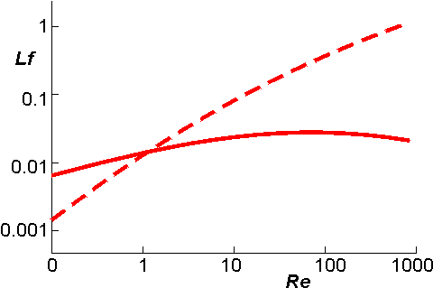
Figure 5.3. A diagram comparing the variation of Re with Lf for a PBR (———) and a CSTR (-----------). An FBR behaves similarly to the CSTR.

Packed bed reactors

The most important characteristic of a PBR is that material flows through the reactor as a plug; they are also called plug flow reactors (PFR). Ideally, all of the substrate stream flows at the same velocity, parallel to the reactor axis with no back -mixing. All material present at any given reactor cross -section has had an identical residence time. The longitudinal position within the PBR is, therefore, proportional to the time spent within the reactor; all product emerging with the same residence time and all substrate molecule having an equal opportunity for reaction. The conversion efficiency of a PBR, with respect to its length, behaves in a manner similar to that of a well -stirred batch reactor with respect to its reaction time (Figure 5.2(b)) Each volume element behaves as a batch reactor as it passes through the PBR. Any required degree of reaction may be achieved by use of an idea PBR of suitable length.
The flow rate (F) is equivalent to Vol_{S}/t for a batch reactor. Therefore equation (5.5) may be converted to represent an ideal PBR, given the assumption, not often realised in practice, that there are no diffusion limitations:
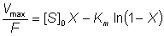 (5.6)
In order to produce ideal plug -flow within PBRs, a turbulent flow regime is preferred to laminar flow, as this causes improved mixing and heat transfer normal to the flow and reduced axial back-mixing. Achievement of high enough Re may, however, be difficult due to unacceptably high feed rates. Consequent upon the plug -flow characteristic of the PBR is that the substrate concentration is maximised, and the product concentration minimised, relative to the final conversion at every point within the reactor; the effectiveness factor being high on entry to the reactor and low close to the exit. This means that PBRs are the preferred reactors, all other factors being equal, for processes involving product inhibition, substrate activation and reaction reversibility. At low Re the flow rate is proportional to the pressure drop across the PBR. This pressure drop is, in turn, generally found to be proportional to the bed height, the linear flow rate and dynamic viscosity of the substrate stream and (1 - ε)²/ε³ (where ε is the porosity of the reactor; i.e. the fraction of the PBR volume taken up by the liquid phase), but inversely proportional to the cross-sectional area of the immobilised enzyme pellets. In general PBRs are used with fairly rigid immobilised-enzyme catalysts (1 -3 mm diameter), because excessive increases in this flow rate may distort compressible or physically weak particles. Particle deformation results in reduced catalytic surface area of particles contacting the substrate-containing solution, poor external mass transfer characteristics and a restriction to the flow, causing increased pressure drop. A vicious circle of increased back-pressure, particle deformation and restricted flow may eventually result in no flow at all through the PBR.
PBRs behave as deep-bed filters with respect to the substrate stream. It is necessary to use a guard bed if plugging of the reactor by small particles is more rapid than the biocatalysts' deactivation. They are also easily fouled by colloidal or precipitating material. The design of PBRs does not allow for control of pH, by addition of acids or bases, or for easy temperature control where there is excessive heat output, a problem that may be particularly noticeable in wide reactors (> 15 cm diameter). Deviations from ideal plug-flow are due to back-mixing within the reactors, the resulting product streams having a distribution of residence times. In an extreme case, back-mixing may result in the kinetic behaviour of the reactor approximating to that of the CSTR (see below), and the consequent difficulty in achieving a high degree of conversion. These deviations are caused by channelling, where some substrate passes through the reactor more rapidly, and hold-up, which involves stagnant areas with negligible flow rate. Channels may form in the reactor bed due to excessive pressure drop, irregular packing or uneven application of the substrate stream, causing flow rate differences across the bed. The use of a uniformly sized catalyst in a reactor with an upwardly flowing substrate stream reduces the chance and severity of non-ideal behaviour.

Continuous flow stirred tank reactors

This reactor consists of a well -stirred tank containing the enzyme, which is normally immobilised. The substrate stream is continuously pumped into the reactor at the same time as the product stream is removed. If the reactor is behaving in an ideal manner, there is total back-mixing and the product stream is identical with the liquid phase within the reactor and invariant with respect to time. Some molecules of substrate may be removed rapidly from the reactor, whereas others may remain for substantial periods. The distribution of residence times for molecules in the substrate stream is shown in Figure 5.4.
The CSTR is an easily constructed, versatile and cheap reactor, which allows simple catalyst charging and replacement. Its well -mixed nature permits straightforward control over the temperature and pH of the reaction and the supply or removal of gases. CSTRs tend to be rather large as the: need to be efficiently mixed. Their volumes are usually about five to ten time the volume of the contained immobilised enzyme. This, however, has the advantage that there is very little resistance to the flow of the substrate stream, which may contain colloidal or insoluble substrates, so long as the insoluble particles are not able to sweep the immobilised enzyme from the reactor. The mechanical nature of the stirring limits the supports for the immobilised enzymes to materials which do not easily disintegrate to give 'fines' which may enter the product stream. However, fairly small particle (down to about 10 μm diameter) may be used, if they are sufficiently dense to stay within the reactor. This minimises problems due to diffusional resistance.
An ideal CSTR has complete back -mixing resulting in a minimisation of the substrate concentration, and a maximisation of the product concentration, relative to the final conversion, at every point within the reactor the effectiveness factor being uniform throughout. Thus, CSTRs are the preferred reactors, everything else being equal, for processes involving substrate inhibition or product activation. They are also useful where the substrate stream contains an enzyme inhibitor, as it is diluted within the reactor. This effect is most noticeable if the inhibitor concentration is greater than the inhibition constant and [S]₀/K_{m} is low for competitive inhibition or high for uncompetitive inhibition, when the inhibitor dilution has more effect than the substrate dilution. Deviations from ideal CSTR behaviour occur when there is a less effective mixing regime and may generally be overcome by increasing the stirrer speed, decreasing the solution viscosity or biocatalyst concentration or by more effective reactor baffling.
The rate of reaction within a CSTR can be derived from a simple mass balance to be the flow rate (F) times the difference in substrate concentration between the reactor inlet and outlet. Hence:
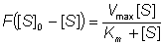 (5.7)
Therefore:
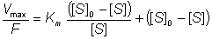 (5.8)
from equation (5.4):
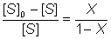 (5.9)
Therefore:
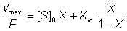 (5.10)
This equation should be compared with that for the PBR (equation (5.6)). Together these equations can be used for comparing the productivities of the two reactors (Figures 5.5 and 5.6).

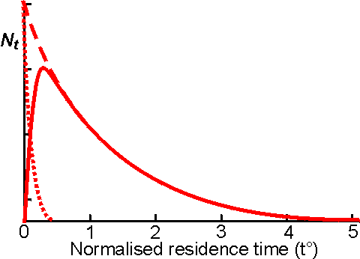
Figure 5.4. The residence time distribution of a CSTR. The relative number of molecules resident within the reactor for a particular time N, is plotted against the normalised residence time (i.e. tF/V, where V is the reactor volume, and F is the flow rate; it is the time relative to that required for one reactor volume to pass through the reactor). The residence time distribution of non -reacting media molecules ( ----------- which obeys the relationship 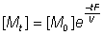, where [M] is the concentration of media molecules, giving a half-life for remaining in the reactor of 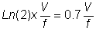, product (——— ) and substrate (·········) are shown. The reaction S P is assumed, and substrate molecules that have long residence times are converted into product, the average residence time of the product being greater than that for the substrate. The composition of the product stream is identical with that of the liquid phase within the reactor. This composition may be calculated from the relative areas under the curves and, in this case, represents a 90% conversion. Under continuous operating conditions (operating time > 4V/F), the mean residence time within the reactor is V/F. However, it may be noted from the graph that only a few molecules have a residence time close to this value (only 7% between 0.9V/F and 1.1 V/F) whereas 20% of the molecules have residence times of less than 0.1 V/F or greater than 2.3V/F. It should be noted that 100% of the molecules in an equivalent ideal PBR might be expected to have residence times equal to their mean residence time.

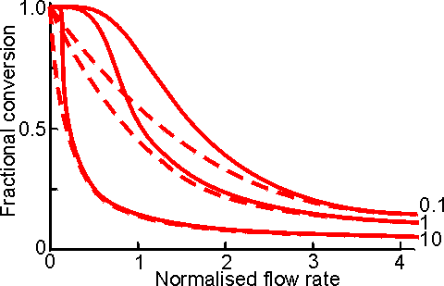
Figure 5.5. Comparison of the changes in fractional conversion with flow rate between the PBR (———) and CSTR (-----------) at different values of [S]₀/K_{m} (10,1 and 0.1, higher [S]₀/K_{m} giving the higher curves). The flow rate is normalised with respect to the reactor's volumetric enzyme content ( = FK_{m}/V_{max}. It can be seen that there is little difference between the two reactors at faster flow rates and lower conversions, especially at high values of [S]₀/K_{m}.

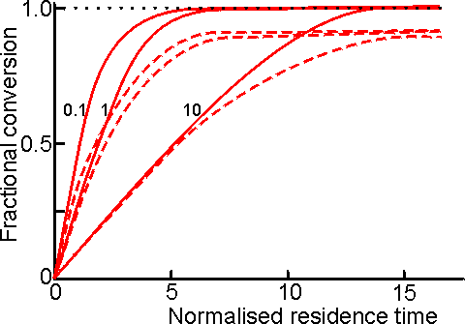
Figure 5.6. Comparison of the changes in fractional conversion with residence time between the PBR (———) and CSTR (-----------) at different values of [S]₀/K_{m} (10, 1 and 0.1; higher [S]₀/K_{m} values giving the lower curves). The residence time is the reciprocal of the normalised flow rate (see Figure 5.5). If the flow rate is unchanged then the 'normalised residence time' may be thought of as the reactor volume needed to produce the required degree of conversion.

Equations describing the behaviour of CSTRs and PBRs utilising reversible reactions or undergoing product or substrate inhibition can be derived in a similar manner, using equations (1.68), (1.85) and (1.96) rather than (1.8):
Substrate -inhibited PBR:
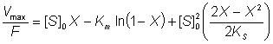 (5.11)
Substrate -inhibited CSTR:
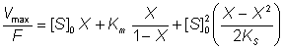 (5.12)
Product -inhibited PBR:
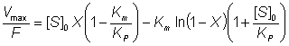 (5.13)
Product -inhibited CSTR:
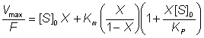 (5.14)
Reversible reaction in a PBR:
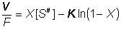 (5.15)
Reversible reaction in a CSTR:
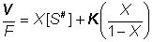 (5.16)
X in equations (5.15) and (5.16) is the fractional conversion for a reversible reaction.
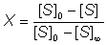 (5.17)
The meaning of other symbols used in equations (5.11)-(5.17) are given Chapter 1. These equations may be used to compare the size of PBR and CSTR necessary to achieve the same conversion under various conditions (Figure 5.7). Another useful parameter for comparing these reactors is the productivity. This can be derived for each reactor assuming a first-order inactivation of the enzyme (equation (1.26)). Combined with equation (5.6) for PBR, or (5.10) for CSTR, the following relationships are obtained on integration:
PBR: 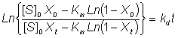 (5.18)

CSTR: 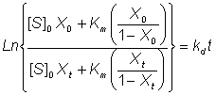 (5.19)
where k_{d} is the first -order inactivation constant (i.e. k_{d1}, in equation (1.25)) and the fractional conversion subscripts refer to time = 0 or t. The change in productivity (Figure 5.8) and fractional conversion (Figure 5.9) of these reactors with time can be compared using these equations.
These reactors may be operated for considerably longer periods than that determined by the inactivation of their contained immobilised enzyme, particularly if they are capable of high conversion at low substrate concentrations (Figure 5.9). This is independent of any enzyme stabilisation and is simply due to such reactors initially containing large amounts of redundant enzyme.

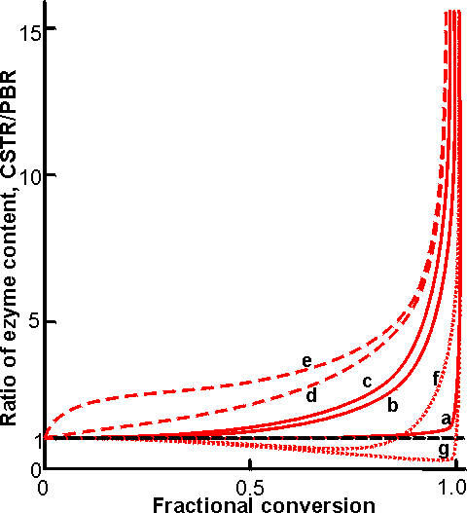
Figure 5.7. Comparison of the ratio, of the enzyme content in a CSTR to that in a PBR, necessary to achieve various degrees of conversion for a range of process conditions. The actual size of the CSTR will be five to ten times greater than indicated due to the necessity of maintaining stirring within the vessel. ———Uninhibited reaction; ············ product inhibited; ---------substrate inhibited. (curve a) [S]₀/K_{m} = 100; (curve b) [S]₀/K_{m} = 1; (curve c) [S]₀/K_{m} < 0.01; (curve d) [S]₀/K_{m} = 1, product inhibited K_{P}/K_{m} = 0.1 ; (curve e) [S]₀/K_{m} = 1, product inhibited K_{P}/K_{m} = 0.01; (curve f) [S]₀/K_{m} = 1, substrate inhibited [S]₀/K_{S} = 10; (curve g) [S]₀/K_{m} = 100; substrate inhibited [S]₀/K_{S} = 10. The size of a CSTR becomes prohibitively large at high conversions (e.g. using curve b, a CSTR contains three times the enzyme in a PBR to achieve a 90% conversion, but this increases to 18 times for 99% conversion. The difference between the two types of reactor is increased if the effectiveness factor (η) is less than one due to diffusional effects.

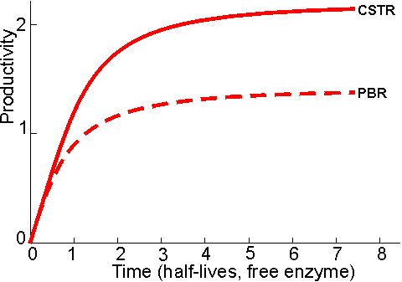
Figure 5.8. The change in productivity of a PBR (---------) and CSTR (——— ) with time, assuming an initial fractional conversion (X₀) = 0.99 and [S]₀/K_{m} = 100. The units of time are half -lives of the free enzyme ( ) and the productivity is given in terms of (FXt_{1/2}). Although the overall productivity is 1.6 times greater for a CSTR than a PBR, it should be noted that the CSTR contains 1.9 times more enzyme.

In general, there is little or no back -pressure to increased flow rate through the CSTR. Such reactors may be started up as batch reactors until the required degree of conversion is reached, when the process may be made continuous. CSTRs are not generally used in processes involving high conversions but a train of CSTRs may approach the PBR performance. This train may be a number (greater than three) of reactors connected in series or a single vessel divided into compartments, in order to minimise back-mixing CSTRs may be used with soluble rather than immobilised enzyme if an ultrafiltration membrane is used to separate the reactor output stream from the reactor contents. This causes a number of process difficulties, including concentration polarization or inactivation of the enzyme on the membrane but may be preferable in order to achieve a combined reaction and separation process or where a suitable immobilised enzyme is not readily available.

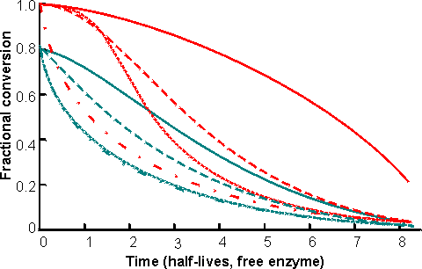
Figure 5.9. The change in fractional conversion of PBRs and CSTRs with time, assuming initial fractional conversion (X₀) of 0.99 or 0.80. ————CSTR, [S]o/K_{m} = 0.01; - - - - - - CSTR, [S]₀/K_{m} = 100; ············ PBR [S]₀/K_{m} = 0.01; ·-·-·-·-·-·-·-· PBR [S]₀/K_{m} = 100. The time is given in terms of the half -life of the free enzyme (). Although the CSTR maintains its fractional conversion for a longer period than the PBR, particularly at high X₀. It should be noted that a CSTR capable of X₀ = 0.99 at a substrate feed concentration of [S]₀/K_{m} = 0.01 contains 22 times more enzyme than an equivalent PBR, but yields only 2.2 times more product. The initial stability in the fractional conversion over a considerable period of time, due to the enzyme redundancy, should not be confused with any effect due to stabilisation of the immobilised enzyme.

Fluidised bed reactors

These reactors generally behave in a manner intermediate between CSTRs and PBRs. They consist of a bed of immobilised enzyme which is fluidised by the rapid upwards flow of the substrate stream alone or in combination with a gas or secondary liquid stream, either of which may be inert or contain material relevant to the reaction. A gas stream is usually preferred as it does not dilute the product stream. There is a minimum fluidisation velocity needed to achieve bed expansion, which depends upon the size, shape, porosity and density of the particles and the density and viscosity of the liquid. This minimum fluidisation velocity is generally fairly low (about 0.2 -I.0 cm s⁻¹) as most immobilised-enzyme particles have densities close to that of the bulk liquid. In this case the relative bed expansion is proportional to the superficial gas velocity and inversely proportional to the square root of the reactor diameter. Fluidising the bed requires a large power input but, once fluidised, there is little further energetic input needed to increase the flow rate of the substrate stream through the reactor (Figure 5.3). At high flow rates and low reactor diameters almost ideal plug -flow characteristics may be achieved. However, the kinetic performance of the FBR normally lies between that of the PBR and the CSTR, as the small fluid linear velocities allowed by most biocatalytic particles causes a degree of back-mixing that is often substantial, although never total. The actual design of the FBR will determine whether it behaves in a manner that is closer to that of a PBR or CSTR (see Figures 5.5 -5.9). It can, for example, be made to behave in a manner very similar to that of a PBR, if it is baffled in such a way that substantial backmixing is avoided. FBRs are chosen when these intermediate characteristics are required, e.g. where a high conversion is needed but the substrate stream is colloidal or the reaction produces a substantial pH change or heat output. They are particularly useful if the reaction involves the utilisation or release of gaseous material.
The FBR is normally used with fairly small immobilised enzyme particles (20-40 μm diameter) in order to achieve a high catalytic surface area. These particles must be sufficiently dense, relative to the substrate stream, that they are not swept out of the reactor. Less-dense particles must be somewhat larger. For efficient operation the particles should be of nearly uniform size otherwise a non-uniform biocatalytic concentration gradient will be formed up the reactor. FBRs are usually tapered outwards at the exit to allow for a wide range of flow rates. Very high flow rates are avoided as they cause channelling and catalyst loss. The major disadvantage of development of FBR process is the difficulty in scaling-up these reactors. PBRs allow scale-up factors of greater than 50000 but, because of the markedly different fluidisation characteristics of different sized reactors, FBRs can only be scaled-up by a factor of 10 -100 each time. In addition, changes in the flow rate of the substrate stream causes complex changes in the flow pattern within these reactors that may have consequent unexpected effects upon the conversion rate.

Immobilised-enzyme processes

Immobilise -enzyme systems are used where they offer cost advantages to users on the basis of total manufacturing costs. The plant size needed for continuous processes is two orders of magnitude smaller than that required for batch processes using free enzymes. The capital costs are, therefore, considerably smaller and the plant may be prefabricated cheaply off-site Immobilised enzymes offer greatly increased productivity on an enzyme weight basis and also often provide process advantages (see Chapter 3) Currently used immobilised-enzyme processes are given in Table 5.1.

Table 5.1 Some of the more important industrial uses of immobilised enzymes
Enzyme | EC number | Product
Aminoacylase | 3.5.1.14 | L-Amino acids
Aspartate ammonia-lyase | 4.3.1.1 | L-Aspartic acid
Aspartate 4-decarboxylase | 4.1.1.12 | L-Alanine
Cyanidase | 3.5.5.x | Formic acid (from waste cyanide)
Glucoamylase | 3.2.1.3 | D-Glucose
Glucose isomerase | 5.3.1.5 | High -fructose corn syrup
Histidine ammonia-lyase | 4.3.1.3 | Urocanic acid
Hydantoinaseª | 3.5.2.2 | D- and L-amino acids
Invertase | 3.2.1.26 | Invert sugar
Lactase | 3.2.1.23 | Lactose-free milk and whey
Lipase | 3.1.1.3 | Cocoa butter substitutes
Nitrile hydratase | 4.2.I.x | Acrylamide
Penicillin amidases | 3.5.1.11 | Penicillins
Raffinase | 3.2.1.22 | Raffinose-free solutions
Thermolysin | 3.2.24.4 | Aspartame
ª Dihydropyrimidinase.

High-fructose corn syrups (HFCS)

With the development of glucoamylase in the 1940s and 1950s it became a straightforward matter to produce high DE glucose syrups. However, these have shortcomings as objects of commerce: D-glucose has only about 70% of the sweetness of sucrose, on a weight basis, and is comparatively insoluble. Batches of 97 DE glucose syrup at the final commercial concentration (71% (w/w)) must be kept warm to prevent crystallisation or diluted to concentrations that are microbiologically insecure. Fructose is 30% sweeter than sucrose, on a weight basis, and twice as soluble as glucose at low temperatures so a 50% conversion of glucose to fructose overcomes both problems giving a stable syrup that is as sweet as a sucrose solution of the same concentration (see Table 4.3). The isomerisation is possible by chemical means but not economical, giving tiny yields and many by-products (e.g. 0.1 M glucose 'isomerised' with 1.22 M KOH at 5°C under nitrogen for 3.5 months gives a 5% yield of fructose but only 7% of the glucose remains unchanged, the majority being converted to various hydroxy acids).
One of the triumphs of enzyme technology so far has been the development of 'glucose isomerase'. Glucose is normally isomerised to fructose during glycolysis but both sugars are phosphorylated. The use of this phosphohexose isomerase may be ruled out as a commercial enzyme because of the cost of the ATP needed to activate the glucose and because two other enzymes (hexokinase and fructose-6-phosphatase) would be needed to complete the conversion. Only an isomerase that would use underivatised glucose as its substrate would be commercially useful but, until the late 1950s, the existence of such an enzyme was not suspected. At about this time, enzymes were found that catalyse the conversion of D-xylose to an equilibrium mixture of D-xylulose and D-xylose in bacteria. When supplied with cobalt ions, these xylose isomerases were found to isomerise α-D-glucopyranose to α-D -fructofuranose (see reaction scheme [1.5]), equilibration from the more abundant β-D-glucopyranose and to the major product β-D-fructopyranose occurring naturally and non-enzymically. Now it is known that several genera of microbes, mainly bacteria, can produce such glucose isomerases: The commercial enzymes are produced by Actinoplanes missouriensis, Bacillus coagulans and various Streptomyces species; as they have specificities for glucose and fructose which are not much different from that for xylose and ways are being found to avoid the necessity of xylose as inducer, these should perhaps now no longer be considered as xylose isomerases. They are remarkably amenable enzymes in that they are resistant to thermal denaturation and will act at very high substrate concentrations, which have the additional benefit of substantially stabilising the enzymes at higher operational temperatures. The vast majority of glucose isomerases are retained within the cells that produce them but need not be separated and purified before use.
All glucose isomerases are used in immobilised forms. Although differerent immobilisation methods have been used for enzymes from differerent organisms, the principles of use are very similar. Immobilisation is generally by cross-linking with glutaraldehyde, plus in some cases a protein diluent, after cell lysis or homogenisation.
Originally, immobilised glucose isomerase was used in a batch process. This proved to be costly as the relative reactivity of fructose during the long residence times gave rise to significant by -product production. Also, difficulties were encountered in the removal of the added Mg²⁺ and Co²⁺ and the recovery of the catalyst. Nowadays most isomerisation is performed in PBRs (Table 5.2). They are used with high substrate concentration (35-45% dry solids, 93-97% glucose) at 55-60°C. The pH is adjusted to 7.5-8.0 using sodium carbonate and magnesium sulphate is added to maintain enzyme activity (Mg²⁺ and Co²⁺ are cofactors). The Ca²⁺ concentration of the glucose feedstock is usually about 25 μm, left from previous processing, and this presents a problem. Ca²⁺ competes successfully for the Mg²⁺ binding site on the enzyme, causing inhibition. At this level the substrate stream is normally made 3 mM with respect to Mg²⁺. At higher concentrations of calcium a Mg²⁺ : Ca²⁺ ratio of 12 is recommended. Excess Mg²⁺ is uneconomic as it adds to the purification as well as the isomerisation costs. The need for Co²⁺ has not been eliminated altogether, but the immobilisation methods now used fix the cobalt ions so that none needs to be added to the substrate streams.

Table 5.2. Comparison of glucose isomerisation methods
Parameter | Batch  (soluble GI) | Batch  (immobilised Gl) | Continuous  (PBR)
Reactor volume (m³) | 1100 | 1100 | 15
Enzyme consumption (tonnes) | 180 | 11 | 2
Activity, half-life (h) | 30 | 300 | 1500
Active life, half-lives | 0.7 | 2 | 3
Residence time (h) | 20 | 20 | 0.5
Co²⁺ (tonnes) | 2 | 1 | 0
Mg²⁺ (tonnes) | 40 | 40 | 7
Temperature (°C) | 65 | 65 | 60
pH | 6.8 | 6.8 | 7.6
Colour formation (A₄₂₀) | 0.7 | 0.2 | < 0.1
Product refining | Filtration  C-treatmentª  Cation exchange  Anion exchange | -  C-treatment  Cation exchange  Anion exchange | -  C -treatment  -  -
Capital, labour and  energy costs, £ tonne⁻¹ | 5 | 5 | 1
Conversion cost, £ tonne⁻¹ | 500 | 30 | 5
All processes start with 45% (w/w) glucose syrup DE 97 and produce 10000 tonnes per month of 42% fructose dry syrup. Some of the improvement that may be seen for PBR productivity is due to the substantial development of this process.
ª Treatment with activated carbon.

It is essential for efficient use of immobilised glucose isomerase that the substrate solution is adequately purified so that it is free of insoluble material and other impurities that might inactivate the enzyme by chemical (inhibitory) or physical (pore-blocking) means. In effect, this means that glucose produced by acid hydrolysis cannot be used, as its low quality necessitates extensive and costly purification. Insoluble material is removed by filtration, sometimes after treatment with flocculants, and soluble materials are removed by ion exchange resins and activated carbon beads. This done, there still remains the possibility of inhibition due to oxidised by-products caused by molecular oxygen. This may be removed by vacuum de-aeration of the substrate at the isomerisation temperature or by the addition of low concentrations (< 50 ppm) of sulphite.
At equilibrium at 60°C about 51 % of the glucose in the reaction mixture is converted to fructose (see Chapter 1 for a full discussion of such reversible reactions). However, because of the excessive time taken for equilibrium to be attained and the presence of oligosaccharides in the substrate stream, most manufacturers adjust flow rates so as to produce 42-46% (w/w) fructose (leaving 47-51 % (w/w) glucose). To produce 100 tonnes (dry substance) of 42% HFCS per day, an enzyme bed volume of about 4 m³ is needed. Activity decreases, following a first-order decay equation. The half-life of most enzyme preparations is between 50 and 100 days at 55°C. Typically a batch of enzyme is discarded when the activity has fallen to an eighth of the initial value (i.e. after three half -lives). To maintain a constant fructose content in the product, the feed flow rate is adjusted according to the enzyme activity. Several reactors containing enzyme preparations of different ages are needed to maintain overall uniform production by the plant (Figure 5.10). In its lifetime 1 kg of immobilised glucose isomerase (exemplified by Novo's Sweetzyme T) will produce 10 -11 tonnes of 42% fructose syrup (dry substance).

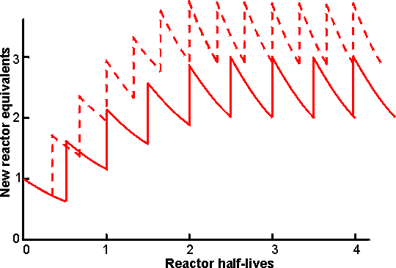
Figure 5.10. Diagram showing the production rate of a seven-column PBR facility on start -up, assuming exponential decay of reactor activity. The columns are brought into use one at a time. At any time a maximum of six PBRs are operating in parallel, whilst the seventh, exhausted, reactor is being refilled with fresh biocatalyst. ——— PBR activities allowed to decay through three half-lives (to 12.5% initial activity) before replacement. The final average productivity is 2.51 times the initial productivity of one column. - - -- - - - PBR activities allowed to decay through two half-lives (to 25% initial activity) before replacement. The final average productivity is 3.23 times the initial productivity of one column. It may be seen that the final average production rate is higher when the PBRs are individually operated for shorter periods but this 29% increase in productivity is achieved at a cost of 50% more enzyme, due to the more rapid replacement of the biocatalyst in the PBRs. A shorter PBR operating time also results in a briefer start-up period and a more uniform productivity.

After isomerisation, the pH of the syrup is lowered to 4 - 5 and it is purified by ion-exchange chromatography and treatment with activated carbon. Then, it is normally concentrated by evaporation to about 70% dry solids.
For many purposes a 42% fructose syrup is perfectly satisfactory for use but it does not match the exacting criteria of the quality soft drink manufacturers as a replacement for sucrose in acidic soft drinks. For use in the better colas, 55% fructose is required. This is produced by using vast chromatographic columns of zeolites or the calcium salts of cation exchange resins to adsorb and separate the fructose from the other components. The fractionation process, although basically very simple, is only economic if run continuously. The fructose stream (90% (w/w) fructose, 9% glucose) is blended with 42% fructose syrups to give the 55% fructose (42% glucose) product required. The glucose-rich 'raffinate' stream may be recycled but if this is done undesirable oligosaccharides build up in the system. Immobilised glucoamylase is used in some plants to hydrolyse oligosaccharides in the raffinate; here the substrate concentration is comparatively low (around 20% dry solids) so the formation of isomaltose by the enzyme is insignificant.
Clearly the need for a second large fructose enrichment plant in addition to the glucose isomerase plant is undesirable and attention is being paid to means of producing 55% fructose syrups using only the enzyme. The thermodynamics of the system favour fructose production at higher temperatures and 55% fructose syrups could be produced directly if the enzyme reactors were operated at around 95°C. The use of miscible organic co -solvents may also produce the desired effect. Both these alternatives present a more than considerable challenge to enzyme technology!
The present world market for HFCS is over 5 million tonnes of which about 60% is for 55% fructose syrup with most of the remainder for 42% fructose syrup. This market is still expanding and ensures that HFCS production is the major application for immobilised-enzyme technology.
The high-fructose syrups can be used to replace sucrose where sucrose is used in solution but they are inadequate to replace crystalline sucrose. Another ambition of the corn syrup industry is to produce sucrose from starch. This can be done using a combination of the enzymes phosphorylase (EC 2.4.1.1), glucose isomerase and sucrose phosphorylase (EC 2.4.1.7), but the thermodynamics do not favour the conversion so means must be found of removing sucrose from the system as soon as it is formed. This will not be easy but is achievable if the commercial pull (i.e. money available) is sufficient:
phosphorylase
starch (G_{n}) + orthophosphate starch (G_{n-1}) + α-glucose-1-phosphate [5.1]
glucose isomerase
glucose fructose [5.2]
sucrose phosphorylase
α-glucose-1 -phosphate + fructose sucrose + orthophosphate [5.3]
A further possible approach to producing sucrose from glucose is to supply glucose at high concentrations to microbes whose response to osmotic stress is to accumulate sucrose intracellularly. Provided they are able to release sucrose without hydrolysis when the stress is released, such microbes may be the basis of totally novel processes.

Use of immobilised raffinase

The development of a raffinase (α-D-galactosidase) suitable for commercial use is another triumph of enzyme technology. Plainly, it would be totally unacceptable to use an enzyme preparation containing invertase to remove this material during sucrose production (see Chapter 4). It has been necessary to find an organism capable of producing an α-galactosidase but not an invertase. A mould, Mortierella vinacea var. raffinoseutilizer, fills the requirements. This is grown in a particulate form and the particles harvested, dried and used directly as the immobilised-enzyme preparation. It is stirred with the sugar beet juice in batch stirred tank reactors. When the removal of raffinose is complete, stirring is stopped and the juice pumped off the settled bed of enzyme. Enzyme, lost by physical attrition, is replaced by new enzyme added with the next batch of juice. The galactose released is destroyed in the alkaline conditions of the first stages of juice purification and does not cause any further problems while the sucrose is recovered. This process results in a 3% increase in productivity and a significant reduction in the costs of the disposal of waste molasses.
Immobilised raffinase may also be used to remove the raffinose and stachyose from soybean milk. These sugars are responsible for the flatulence that may be caused when soybean milk is used as a milk substitute in special diets.

Use of immobilised invertase

Invertase was probably the first enzyme to be used on a large scale in an immobilised form (by Tate & Lyle). In the period 1941 -1946 the acid, previously used in the manufacture of Golden Syrup, was unavailable, so yeast invertase was used instead. Yeast cells were autolysed and the autolysate clarified by adjustment to pH 4.7, followed by filtration through a bed of calcium sulphate and adsorption into bone char. A layer of the bone char containing invertase was included in the bed of bone char already used for decolourising the syrup. The scale used was large, the bed of invertase-char being 2 ft (60 cm) deep in a bed of char 20 ft (610 cm) deep. The preparation was very stable, the limiting factors being microbial contamination or loss of decolourising power rather than loss of enzymic activity. The process was cost-effective but, not surprisingly, the product did not have the subtlety of flavour of the acid-hydrolysed material and the immobilised enzyme process was abandoned when the acid became available once again. Recently, however, it has been relaunched using BrimacTM, where the invertase -char mix is stabilised by cross-linking and has a half-life of 90 days in use (pH 5.5, 50°C). The revival is due, in part, to the success of HFCS as a high-quality low-colour sweetener. It is impossible to produce inverted syrups of equivalent quality by acid hydrolysis. Enzymic inversion avoids the high-colour, high salt-ash, relatively low conversion and batch variability problems of acid hydrolysis. Although free invertase may be used (with residence times of about a day), the use of immobilised enzymes in a PBR (with residence time of about 15 min) makes the process competitive; the cost of 95% inversion (at 50% (w/w)) being no more than the final evaporation costs (to 75% (w/w)). A productivity of 16 tonnes of inverted syrup (dry weight) may be achieved using one litre of the granular enzyme.

Production of amino acids

Another early application of an immobilised enzyme was the use of the aminoacylase from Aspergillus oryzae to resolve racemic mixtures of amino acids.
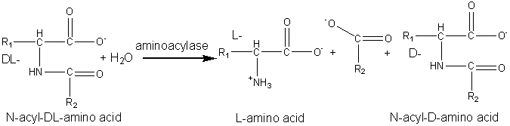 [5.4]
Chemically synthesised racemic N-acyl-DL-amino acids are hydrolysed at pH 8.5 to give the free L-amino acids plus the unhydrolysed N-acyl-D-amino acids. These products are easily separated by differential crystallisation and the N-acyl-D-amino acids racemised chemically (or enzymically) and reprocessed. The enzyme is immobilised by adsorption to anion exchange resins (e.g. DEAE-Sephadex) and has an operational half-life of about 65 days at 50°C in PBRs with residence times of about 30 min. The reactors may be re-activated in situ by simply adding more enzyme. The immobilised enzyme has proved a more economical process than the use of free enzyme mainly due to the more efficient use of the substrate and reductions in the cost of enzyme and labour.
Novel and natural L-amino acids can be produced by the chemical conversion of aldehydes through DL-amino nitrites to racemic DL-hydantoins (reaction scheme [5.5]) followed by enzymic hydrolysis with hydantoinase and a carbamoylase (reaction scheme [5.6]) at pH 8.5. Both enzymes may be obtained from Arthrobacter species.
D -Amino acids are important constituents in antibiotics and insecticides. They may be produced in a manner similar to the L-amino acids but using hydantoinases of differing specificity. The Pseudomonas striata enzyme is specific for D-hydantoins, allowing their specific hydrolysis to D-carbamoyl amino acids which can be converted to the D-amino acids by chemical treatment with nitrous acid. They remaining L-hydantoin may be simply racemised by base and the process repeated.
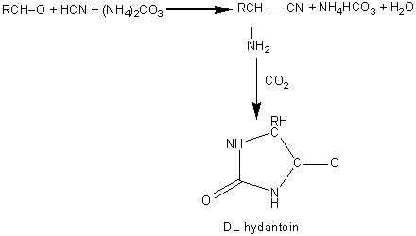 [5.5]
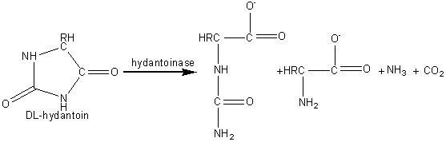 [5.6]
L -Aspartic acid is widely used in the food and pharmaceutical industries and is needed for the production of the low -calorific sweetener aspartame. It may be produced from fumaric acid by the use of the aspartate ammonia-lyase (aspartase) from Escherichia coli.
aspartate ammonia-lyase
⁻OOCCH=CHCOO⁻ + NH₄⁺ ⁻OOCCH₂CH(NH₃⁺)COO⁻ [5.7]
fumaric acid L-aspartic acid
A crude immobilised aspartate ammonia-lyase (50000 U g⁻¹) may be prepared by entrapping Escherichia coli cells in a κ -carageenan gel crosslinked with glutaraldehyde and hexamethylenediamine. The process is operated in a PBR at pH 8.5 using ammonium fumarate as the substrate, with a reported operational half-life of 680 days at 37°C.
Urocanic acid is a sun-screening agent which may be produced from L-histidine by the histidine ammonia -lyase (histidase) from Achromobacter liquidum (see reaction scheme [1.4]). The organism cannot be used directly as it has urocanate hydratase activity, which removes the urocanic acid. However, a brief heat treatment (70°C, 30 min) inactivates this unwanted activity but has little effect on the histidine ammonia-lyase. A crude immobilised-enzyme preparation consisting of heat -treated cells entrapped in a polyacrylamide gel has been used to effect this conversion, showing a half-life of 180 days at 37°C.

Use of immobilised lactase
Lactase is one of relatively few enzymes that have been used both free and immobilised in large-scale processes. The reasons for its utility has been given earlier (see Chapter 4), but the relatively high cost of the enzyme is an added incentive for its use in an immobilised state.
Immobilised lactases are important mainly in the treatment of whey, as the fats and proteins in the milk emulsion tend to coat the biocatalysts. This both reduces their apparent activity and increases the probability of microbial colonisation.
Yeast lactase has been immobilised by incorporation into cellulose triacetate fibres during wet spinning, a process developed by Snamprogetti S.p.A. in Italy. The fibres are cut up and used in a batchwise STR process at 5°C (Kluyveromyces lactis, pH optimum 6.4 -6.8, 90 U g⁻¹). Fungal lactases have been immobilised on 0.5 mm diameter porous silica (35 nm mean pore diameter) using glutaraldehyde and γ-aminopropyltriethoxysilane (Asperigillus niger, pH optimum 3.0 -3.5, 500 U g⁻¹; A. oryzae, pH optimum 4.0 -1.5, 400 U g⁻¹). They are used in PBRs. Due to the different pH optima of fungal and yeast lactases, the yeast enzymes are useful at the neutral pH of both milk and sweet whey, whereas fungal enzymes are more useful with acid whey.
Immobilised lactases are particularly affected by two inherent short-comings. Product inhibition by galactose and unwanted oligosaccharide formation are both noticeable under the diffusion-controlled conditions usually prevalent. Both problems may be reduced by an increase in the effectiveness factor and a reduction in the degree of hydrolysis or initial lactose concentration, but such conditions also lead to a reduction in the economic return. The control of microbial contamination within the bioreactors is the most critical practical problem in these processes. To some extent, this may be overcome by the use of regular sanitation with basic detergent and a dilute protease solution.

Production of antibiotics
Benzylpenicillins and phenoxymethylpenicillins (penicillins G and V, respectively) are produced by fermentation and are the basic precursors of a wide range of semi-synthetic antibiotics, e.g. ampicillin. The amide link may be hydrolysed conventionally but the conditions necessary for its specific hydrolysis, whilst causing no hydrolysis of the intrinsically more labile but pharmacologically essential β-lactam ring, are difficult to attain. Such specific hydrolysis may be simply achieved by use of penicillin amidases (also called penicillin acylases). Different enzyme preparations are generally used for the hydrolysis of the penicillins G and V, pencillin-V-amidase being much more specific than pencillin-G-amidase.
Penicillin amidase may be obtained from E. coli and has been immobilised on a number of supports including cyanogen bromide-activated Sephadex G200. It represents one of the earliest successful processes involving immobilised enzymes and is generally used in batch or semicontinuous STR processes (40,000 Ukg⁻¹penicillin G, 35°C, pH 7.8, 2 h) where it may be reused over 100 times. It has also been used in PBRs, where it has an active life of over 100 days, producing about two tonnes of 6-aminopenicillanic acid kg⁻¹of immobolised enzyme.
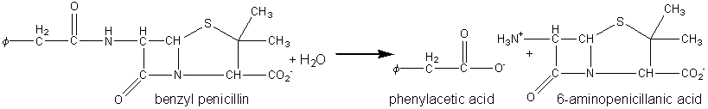 [5.8]
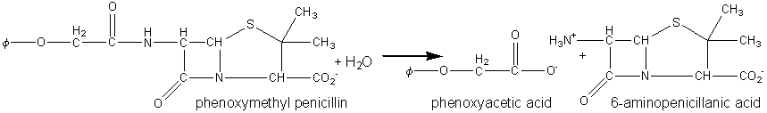 [5.9]
The penicillin-G-amidases may be used 'in reverse' to synthesise penicillin and cephalosporin antibiotics by non -equilibrium kinetically controlled reactions (see also Chapter 7). Ampicillin has been produced by the use of penicillin-G-amidase immobilised by adsorption to DEAE -cellulose in a packed bed column:
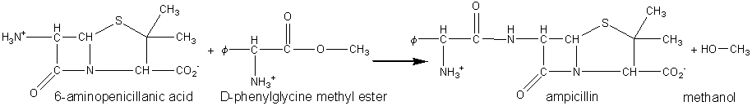 [5.10]
Many other potential and proven antibiotics have been synthesised in this manner, using a variety of synthetic β-lactams and activated carboxylic acids.

Preparation of acrylamide
Acrylamide is an important monomer needed for the production of a range of economically useful polymeric materials. It may be produced by the addition of water to acrylonitrile.
CH₂=CHCN + H₂O CH₂=CHCONH₂ ^{[5.11]}
This process may be achieved by the use of a reduced copper catalyst (Cu⁺); however, the yield is poor, unwanted polymerisation or conversion to acrylic acid (CH₂=CHCOOH) may occur at the relatively high temperatures involved (80 -140°C) and the catalyst is difficult to regenerate. These problems may be overcome by the use of immobilised nitrile hydratase (often erroneously called a nitrilase). The enzyme from Rhodococcus has been used by the Nitto Chemical Industry Co. Ltd, as it contains only very low amidase activity which otherwise would produce unwanted acrylic acid from the acrylamide.
Immobilised nitrile hydratase is simply prepared by entrapping the intact cells in a cross-linked 10% (w/v) polyacrylamide/dimethylaminoethylmethacrylate gel and granulating the product. It is used at 10°C and pH 8.0-8.5 in a semibatchwise process, keeping the substrate acrylonitrile concentration below 3% (w/v). Using 1% (w/v) immobilised-enzyme concentration (about 50,000 U l⁻¹) the process takes about a day. Product concentrations of up to 20% (w/v) acrylamide have been achieved, containing negligible substrate and less than 0.02% (w/w) acrylic acid. Acrylamide production using this method is about 4000 tonnes per year.
The closely related enzymes cyanidase and cyanide hydratase (see schemes [5.12] and [5.13], respectively) are used to remove cyanide from industrial waste and in the detoxification of feeds and foodstuffs containing amygdalin (see equation [6.12]).
HCN + 2H₂O HCOO⁻ + NH₄⁺ [5.12]
HCN + H₂O HCONH₂ [5.13]

Summary and Bibliography of Chapter 5
- Enzymes may be used in batch or continuous reactors. The choice of reactor for specific applications depends upon the physical forms of the substrate(s), enzymes) and products) in addition to the process economics.
- The PBR generally makes the most efficient use of immobilised enzymes. The CSTR is preferred mainly where pH control is essential or where the physical properties of the substrate stream are incompatible with PBR operation. The FBR has properties between those of a PBR and a CSTR but is more difficult to scale -up. Membrane reactors are versatile but expensive.
- Immobilised enzymes are used in an increasing number o economically viable bioconversions, the most important of which is the isomerisation of glucose.

References and Bibliography
- Baret, J. L. (1987). Large -scale production and application of immobilised lactase. Methods in Enzymology, 136, 411 -23.
- Chen, W. -P. (1980). Glucose isomerase (a review). Process Biochemistry, 15, 30 -41.
- Daniels, M. J. (1986). Immobilised enzymes in carbohydrate food processing. In Biotechnology in the food industry, pp. 29 -35. Pinner: Online Publications.
- Daniels, M. J. (1987). Industrial operation of immobilised enzymes. Methods in Enzymology, 136, 356 -70. Howaldt, M. W., Kulbe, K. D. & Chmiel, H. (1986). Choice of reactor to minimise enzyme requirement. 1. Mathematical model for one -substrate Michaelis-Menten type kinetics in continuous reactors. Enzyme and Microbial Technology, 8, 627 -31
- Jensen, V. J. & Rugh, S. (1987). Industrial -scale production and application of immobilised glucose isomerase. Methods in Enzymology, 136, 356 -70.
- Kleinstreuer, C. & Agarwal, S. S. (1986). Analysis and simulation of hollow -fiber bioreactor dynamics. Biotechnology and Bioengineering, 28, 1233 -40.
- Soda, K. & Yonaha, K. (1987). Application of free enzymes in pharmaceutical and chemical industries. In Biotechnology, vol. 7a Enzyme technology, ed. J. F. Kennedy, pp. 605 -52. Weinheim: VCH Verlagsgesellschaft mbH.
- Van Tilburg (1984). Enzymic isomerisation of corn starch -based glucose syrups. In Starch conversion technology, ed. G. M. A. Van Beynum & J. A. Roels, pp. 175 -236. New York: Marcel Dekker Inc.
- Vieth, W. R., Venkatasubramanian, K., Constantinides, A. & Davidson, B. (1976). Design and analysis of immobilized -enzyme flow reactors. In Applied biochemistry and bioengineering, vol. I Immobilised enzyme principles, ed. L. B. Wingard & E. Katchalski -Katzir, pp. 221 -327. London: Academic Press.
- Watanabe, I. (1987). Acrylamide production method using immobilised nitrilase -containing microbial cells. Methods in Enzymology, 136, 523 -30.

