Chapter 3: The preparation and kinetics of immobilised enzymes

The economic argument for immobilisation

An important factor determining the use of enzymes in a technological process is their expense. Several hundred enzymes are commercially available at prices of about £1 mg⁻¹, although some are much cheaper and many are much more expensive. As enzymes are catalytic molecules, they are not directly used up by the processes in which they are used. Their high initial cost, therefore, should only be incidental to their use. However due to denaturation, they do lose activity with time. If possible, they should be stabilised against denaturation and utilised in an efficient manner. When they are used in a soluble form, they retain some activity after the reaction which cannot be economically recovered for re-use and is generally wasted. This activity residue remains to contaminate the product and its removal may involve extra purification costs. In order to eliminate this wastage, and give an improved productivity, simple and economic methods must be used which enable the separation of the enzyme from the reaction product. The easiest way of achieving this is by separating the enzyme and product during the reaction using a two-phase system; one phase containing the enzyme and the other phase containing the product. The enzyme is imprisoned within its phase allowing its re-use or continuous use but preventing it from contaminating the product; other molecules, including the reactants, are able to move freely between the two phases. This is known as immobilisation and may be achieved by fixing the enzyme to, or within, some other material. The term 'immobilisation' does not necessarily mean that the enzyme cannot move freely within its particular phase, although this is often the case. A wide variety of insoluble materials, also known as substrates (not to be confused with the enzymes' reactants), may be used to immobilise the enzymes by making them insoluble. These are usually inert polymeric or inorganic matrices.
Immobilisation of enzymes often incurs an additional expense and is only undertaken if there is a sound economic or process advantage in the use of the immobilised, rather than free (soluble), enzymes. The most important benefit derived from immobilisation is the easy separation of the enzyme from the products of the catalysed reaction. This prevents the enzyme contaminating the product, minimising downstream processing costs and possible effluent handling problems, particularly if the enzyme is noticeably toxic or antigenic. It also allows continuous processes to be practicable, with a considerable saving in enzyme, labour and overhead costs. Immobilisation often affects the stability and activity of the enzyme, but conditions are usually available where these properties are little changed or even enhanced. The productivity of an enzyme, so immobilised, is greatly increased as it may be more fully used at higher substrate concentrations for longer periods than the free enzyme. Insoluble immobilised enzymes are of little use, however, where any of the reactants are also insoluble, due to steric difficulties.

Methods of immobilisation

There are four principal methods available for immobilising enzymes (Figure 3.1):
- adsorption
- covalent binding
- entrapment
- membrane confinement

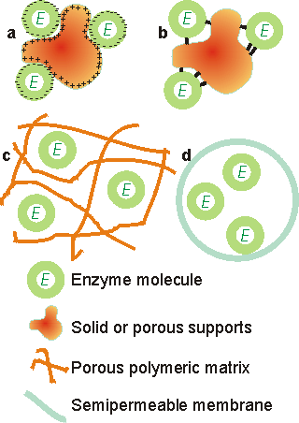
Figure 3.1. Immobilised enzyme systems. (a) enzyme non-covalently adsorbed to an insoluble particle; (b) enzyme covalently attached to an insoluble particle; (c) enzyme entrapped within an insoluble particle by a cross-linked polymer; (d) enzyme confined within a semipermeable membrane.

Carrier matrices for enzyme immobilisation by adsorption and covalent binding must be chosen with care. Of particular relevance to their use in industrial processes is their cost relative to the overall process costs; ideally they should be cheap enough to discard. The manufacture of high-valued products on a small scale may allow the use of relatively expensive supports and immobilisation techniques whereas these would not be economical in the large-scale production of low added-value materials. A substantial saving in costs occurs where the carrier may be regenerated after the useful lifetime of the immobilised enzyme. The surface density of binding sites together with the volumetric surface area sterically available to the enzyme, determine the maximum binding capacity. The actual capacity will be affected by the number of potential coupling sites in the enzyme molecules and the electrostatic charge distribution and surface polarity (i.e. the hydrophobic-hydrophilic balance) on both the enzyme and support. The nature of the support will also have a considerable affect on an enzyme's expressed activity and apparent kinetics. The form, shape, density, porosity, pore size distribution, operational stability and particle size distribution of the supporting matrix will influence the reactor configuration in which the immobilised biocatalyst may be used. The ideal support is cheap, inert, physically strong and stable. It will increase the enzyme specificity (k_{cat}/K_{m}) whilst reducing product inhibition, shift the pH optimum to the desired value for the process, and discourage microbial growth and non-specific adsorption. Some matrices possess other properties which are useful for particular purposes such as ferromagnetism (e.g. magnetic iron oxide, enabling transfer of the biocatalyst by means of magnetic fields), a catalytic surface (e.g. manganese dioxide, which catalytically removes the inactivating hydrogen peroxide produced by most oxidases), or a reductive surface environment (e.g. titania, for enzymes inactivated by oxidation). Clearly most supports possess only some of these features, but a thorough understanding of the properties of immobilised enzymes does allow suitable engineering of the system to approach these optimal qualities.
Adsorption of enzymes onto insoluble supports is a very simple method of wide applicability and capable of high enzyme loading (about one gram per gram of matrix). Simply mixing the enzyme with a suitable adsorbent, under appropriate conditions of pH and ionic strength, followed, after a sufficient incubation period, by washing off loosely bound and unbound enzyme will produce the immobilised enzyme in a directly usable form (Figure 3.2). The driving force causing this binding is usually due to a combination of hydrophobic effects and the formation of several salt links per enzyme molecule. The particular choice of adsorbent depends principally upon minimising leakage of the enzyme during use. Although the physical links between the enzyme molecules and the support are often very strong, they may be reduced by many factors including the introduction of the substrate. Care must be taken that the binding forces are not weakened during use by inappropriate changes in pH or ionic strength. Examples of suitable adsorbents are ion-exchange matrices (Table 3.1), porous carbon, clays, hydrous metal oxides, glasses and polymeric aromatic resins. Ion-exchange matrices, although more expensive than these other supports, may be used economically due to the ease with which they may be regenerated when their bound enzyme has come to the end of its active life; a process which may simply involve washing off the used enzyme with concentrated salt solutions and re-suspending the ion exchanger in a solution of active enzyme.

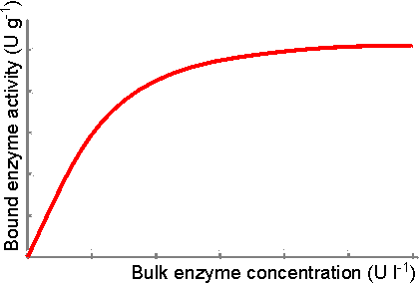
Figure 3.2. Schematic diagram showing the effect of soluble enzyme concentration on the activity of enzyme immobilised by adsorption to a suitable matrix. The amount adsorbed depends on the incubation time, pH, ionic strength, surface area, porosity, and the physical characteristics of both the enzyme and the support.

Table 3.1 Preparation of immobilised invertase by adsorption (Woodward 1985)
 | Support type
% bound at | DEAE-Sephadex  anion exchanger | CM-Sephadex  cation exchanger
pH 2.5 | 0 | 100
pH 4.7 | 100 | 75
pH 7.0 | 100 | 34

Immobilisation of enzymes by their covalent coupling to insoluble matrices is an extensively researched technique. Only small amounts of enzymes may be immobilised by this method (about 0.02 gram per gram of matrix) although in exceptional cases as much as 0.3 gram per gram of matrix has been reported. The strength of binding is very strong, however, and very little leakage of enzyme from the support occurs. The relative usefulness of various groups, found in enzymes, for covalent link formation depends upon their availability and reactivity (nucleophilicity), in addition to the stability of the covalent link, once formed (Table 3.2). The reactivity of the protein side-chain nucleophiles is determined by their state of protonation (i.e. charged status) and roughly follows the relationship -S⁻ > -SH > -O⁻ > -NH₂ > -COO⁻ > -OH >> -NH₃⁺where the charges may be estimated from a knowledge of the pK_{a} values of the ionising groups (Table 1.1) and the pH of the solution. Lysine residues are found to be the most generally useful groups for covalent bonding of enzymes to insoluble supports due to their widespread surface exposure and high reactivity, especially in slightly alkaline solutions. They also appear to be only very rarely involved in the active sites of enzymes.

Table 3.2 Relative usefulness of enzyme residues for covalent coupling
Residue | Content | Exposure | Reactivity | Stability  of couple | Use
Aspartate | + | ++ | + | + | +
Arginine | + | ++ | - | ± | -
Cysteine | - | ± | ++ | - | -
Cystine | + | - | ± | ± | -
Glutamate | + | ++ | + | + | +
Histidine | ± | ++ | + | + | +
Lysine | ++ | ++ | ++ | ++ | ++
Methionine | - | - | ± | - | -
Serine | ++ | + | ± | + | ±
Threonine | ++ | ± | ± | + | ±
Tryptophan | - | - | - | ± | -
Tyrosine | + | - | + | _+ | +
C terminus | - | ++ | + | + | +
N terminus | - | ++ | ++ | ++ | +
Carbohydrate | - ~ ++ | ++ | + | + | ±
Others | - ~ ++ | - | - | - ~ ++ | -

The most commonly used method for immobilising enzymes on the research scale (i.e. using less than a gram of enzyme) involves Sepharose, activated by cyanogen bromide. This is a simple, mild and often successful method of wide applicability. Sepharose is a commercially available beaded polymer which is highly hydrophilic and generally inert to microbiological attack. Chemically it is an agarose (poly-{β-1,3-D-galactose-α-1,4-(3,6-anhydro)-L-galactose}) gel. The hydroxyl groups of this polysaccharide combine with cyanogen bromide to give the reactive cyclic imido-carbonate. This reacts with primary amino groups (i.e. mainly lysine residues) on the enzyme under mildly basic conditions (pH 9 - 11.5, Figure 3.3a). The high toxicity of cyanogen bromide has led to the commercial, if rather expensive, production of ready-activated Sepharose and the investigation of alternative methods, often involving chloroformates, to produce similar intermediates (Figure 3.3b). Carbodiimides (Figure 3.3c) are very useful bifunctional reagents as they allow the coupling of amines to carboxylic acids. Careful control of the reaction conditions and choice of carbodiimide allow a great degree of selectivity in this reaction. Glutaraldehyde is another bifunctional reagent which may be used to cross-link enzymes or link them to supports (Figure 3.3d). It is particularly useful for producing immobilised enzyme membranes, for use in biosensors, by cross-linking the enzyme plus a non-catalytic diluent protein within a porous sheet (e.g. lens tissue paper or nylon net fabric). The use of trialkoxysilanes allows even such apparently inert materials as glass to be coupled to enzymes (Figure 3.3e). There are numerous other methods available for the covalent attachment of enzymes (e.g. the attachment of tyrosine groups through diazo-linkages, and lysine groups through amide formation with acyl chlorides or anhydrides).

(a) cyanogen bromide
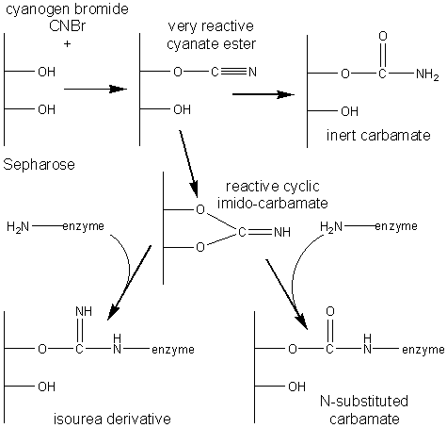 [3.1]
(b) ethyl chloroformate
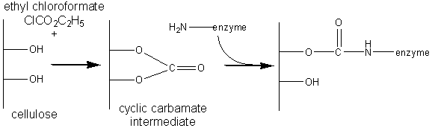 [3.2]
(c) carbodiimide
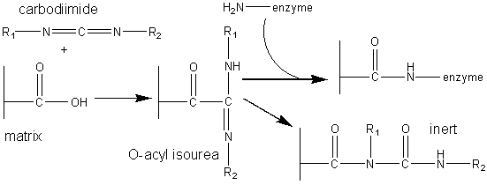 [3.3]
(d) glutaraldehyde
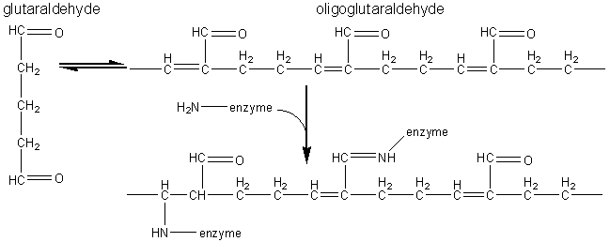 [3.4]
(e) 3-aminopropyltriethoxysilane
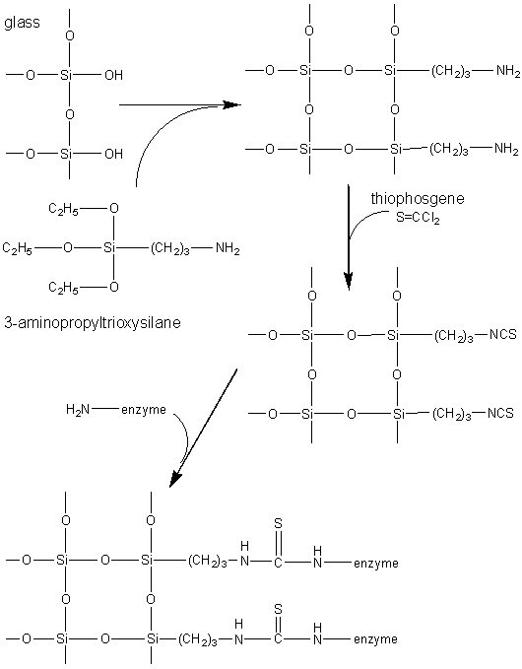 [3.5]
Figure 3.3. Commonly used methods for the covalent immobilisation of enzymes. (a) Activation of Sepharose by cyanogen bromide. Conditions are chosen to minimise the formation of the inert carbamate. (b) Chloroformates may be used to produce similar intermediates to those produced by cyanogen bromide but without its inherent toxicity. (c) Carbodiimides may be used to attach amino groups on the enzyme to carboxylate groups on the support or carboxylate groups on the enzyme to amino groups on the support. Conditions are chosen to minimise the formation of the inert substituted urea. (d) Glutaraldehyde is used to cross-link enzymes or link them to supports. It usually consists of an equilibrium mixture of monomer and oligomers. The product of the condensation of enzyme and glutaraldehyde may be stabilised against dissociation by reduction with sodium borohydride. (e) The use of trialkoxysilane to derivatise glass. The reactive glass may be linked to enzymes by a number of methods including the use thiophosgene, as shown.

It is clearly important that the immobilised enzyme retains as much catalytic activity as possible after reaction. This can, in part, be ensured by reducing the amount of enzyme bound in non-catalytic conformations (Figure 3.4). Immobilisation of the enzyme in the presence of saturating concentrations of substrate, product or a competitive inhibitor ensures that the active site remains unreacted during the covalent coupling and reduces the occurrence of binding in unproductive conformations. The activity of the immobilised enzyme is then simply restored by washing the immobilised enzyme to remove these molecules.

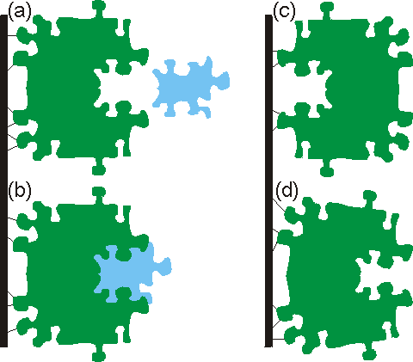
Figure 3.4. The effect of covalent coupling on the expressed activity of an immobilised enzyme. (a) Immobilised enzyme (E) with its active site unchanged and ready to accept the substrate molecule (S), as shown in (b). (c) Enzyme bound in a non-productive mode due to the inaccessibility of the active site. (d) Distortion of the active site produces an inactive immobilised enzyme. Non-productive modes are best prevented by the use of large molecules reversibly bound in or near the active site. Distortion can be prevented by use of molecules which can sit in the active site during the coupling process, or by the use of a freely reversible method for the coupling which encourages binding to the most energetically stable (i.e. native) form of the enzyme. Both (c) and (d) may be reduced by use of 'spacer' groups between the enzyme and support, effectively displacing the enzyme away from the steric influence of the surface.

Entrapment of enzymes within gels or fibres is a convenient method for use in processes involving low molecular weight substrates and products. Amounts in excess of 1 g of enzyme per gram of gel or fibre may be entrapped. However, the difficulty which large molecules have in approaching the catalytic sites of entrapped enzymes precludes the use of entrapped enzymes with high molecular weight substrates. The entrapment process may be a purely physical caging or involve covalent binding. As an example of this latter method, the enzymes' surface lysine residues may be derivatised by reaction with acryloyl chloride (CH₂=CH-CO-Cl) to give the acryloyl amides. This product may then be copolymerised and cross-linked with acrylamide (CH₂=CH-CO-NH₂) and bisacrylamide (H₂N-CO-CH=CH-CH=CH-CO-NH₂) to form a gel. Enzymes may be entrapped in cellulose acetate fibres by, for example, making up an emulsion of the enzyme plus cellulose acetate in methylene chloride, followed by extrusion through a spinneret into a solution of an aqueous precipitant. Entrapment is the method of choice for the immobilisation of microbial, animal and plant cells, where calcium alginate is widely used.
Membrane confinement of enzymes may be achieved by a number of quite different methods, all of which depend for their utility on the semipermeable nature of the membrane. This must confine the enzyme whilst allowing free passage for the reaction products and, in most configurations, the substrates. The simplest of these methods is achieved by placing the enzyme on one side of the semipermeable membrane whilst the reactant and product stream is present on the other side. Hollow fibre membrane units are available commercially with large surface areas relative to their contained volumes (> 20 m² l⁻¹) and permeable only to substances of molecular weight substantially less than the enzymes. Although costly, these are very easy to use for a wide variety of enzymes (including regenerating coenzyme systems, see Chapter 8) without the additional research and development costs associated with other immobilisation methods. Enzymes, encapsulated within small membrane-bound droplets or liposomes (see Chapter 7), may also be used within such reactors. As an example of the former, the enzyme is dissolved in an aqueous solution of 1,6-diaminohexane. This is then dispersed in a solution of hexanedioic acid in the immiscible solvent, chloroform. The resultant reaction forms a thin polymeric (Nylon-6,6) shell around the aqueous droplets which traps the enzyme. Liposomes are concentric spheres of lipid membranes, surrounding the soluble enzyme. They are formed by the addition of phospholipid to enzyme solutions. The micro-capsules and liposomes are washed free of non-confined enzyme and transferred back to aqueous solution before use.
Table 3.3 presents a comparison of the more important general characteristics of these methods.

Table 3.3 Generalised comparison of different enzyme immobilisation techniques.
Characteristics | Adsorption | Covalent  binding | Entrapment | Membrane confinement
Preparation | Simple | Difficult | Difficult | Simple
Cost | Low | High | Moderate | High
Binding force | Variable | Strong | Weak | Strong
Enzyme leakage | Yes | No | Yes | No
Applicability | Wide | Selective | Wide | Very wide
Running Problems | High | Low | High | High
Matrix effects | Yes | Yes | Yes | No
Large diffusional barriers | No | No | Yes | Yes
Microbial protection | No | No | Yes | Yes

Kinetics of immobilised enzymes

The kinetic behaviour of a bound enzyme can differ significantly from that of the same enzyme in free solution. The properties of an enzyme can be modified by suitable choice of the immobilisation protocol, whereas the same method may have appreciably different effects on different enzymes. These changes may be due to conformational alterations within the enzyme due to the immobilisation procedure, or the presence and nature of the immobilisation support.
Immobilisation can greatly effect the stability of an enzyme. If the immobilisation process introduces any strain into the enzyme, this is likely to encourage the inactivation of the enzymes under denaturing conditions (e.g. higher temperatures or extremes of pH). However where there is an unstrained multipoint binding between the enzyme and the support, substantial stabilisation may occur (Figure 3.5). This is primarily due to the physical prevention of the large conformational changes within the protein structure which generally precede its inactivation. Many successful covalent immobilisation processes involve an initial freely-reversible stage, where the covalent links are allowed to form, break and re-form until an unstrained covalently-linked structure is created, in order to stabilise the resultant immobilised enzyme. Additional stabilisation is derived by preventing the enzyme molecules from interacting with each other, and the protection that immobilisation affords towards proteolytic and microbiological attack. This latter effect is due to a combination of diffusional difficulties and the camouflage to enzymic attack produced by the structural alterations. In order to achieve maximum stabilisation of the enzymes, the surfaces of the enzyme and support should be complementary with the formation of many unstrained covalent or non-covalent interactions. Often, however, this factor must be balanced against others, such as the cost of the process, the need for a specific support material, and ensuring that the substrates are not sterically hindered from diffusing to the active site of the immobilised enzyme in order to react at a sufficient rate.

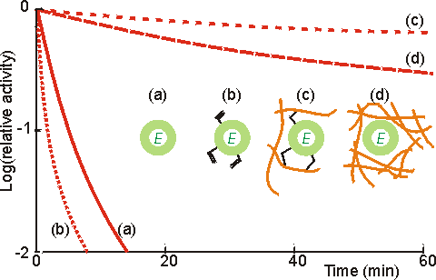
Figure 3.5. Illustration of the use of multipoint interactions for the stabilisation of enzymes (Martinek et al, 1977a,b). (a) ——— activity of free underivatised chymotrypsin. (b) ········· activity of chymotrypsin derivatised with acryloyl chloride. (c) -------- activity of acryloyl chymotrypsin copolymerised within a polymethacrylate gel. Up to 12 residues are covalently bound per enzyme molecule. Lower derivatisation leads to lower stabilisation. (d) ----- activity of chymotrypsin non-covalently entrapped within a polymethacrylate gel. The degree of stabilisation is determined by strength of the gel, and hence the number of non-covalent interactions. All reactions were performed at 60°C using low molecular weight artificial substrates. The immobilised chymotrypsin preparations showed stabilisation of up to 100,000 fold, most of which is due to their multipoint nature although the consequent prevention of autolytic loss of enzyme activity must be a significant contributory factor.

The kinetic constants (e.g. K_{m}, V_{max}) of enzymes may be altered by the process of immobilisation due to internal structural changes and restricted access to the active site. Thus, the intrinsic specificity (k./K_{m}) of such enzymes may well be changed relative to the soluble enzyme. An example of this involves trypsin where the freely soluble enzyme hydrolyses fifteen peptide bonds in the protein pepsinogen but the immobilised enzyme hydrolyses only ten. The apparent value of these kinetic parameters, when determined experimentally, may differ from the intrinsic values. This may be due to changes in the properties of the solution in the immediate vicinity of the immobilised enzyme, or the effects of molecular diffusion within the local environment (Figure 3.6). The relationship between these parameters is shown below.
Intrinsic parameters of the soluble enzyme
Intrinsic parameters of the immobilised enzyme
Apparent parameters due to partition and diffusion

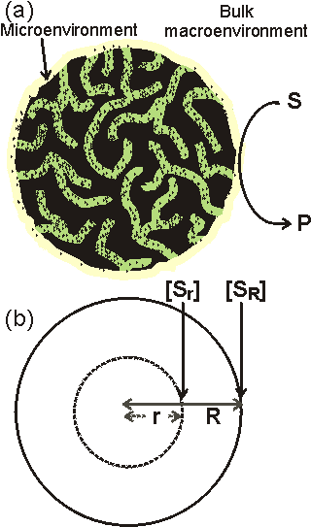
Figure 3.6. A schematic cross-section of an immobilised enzyme particle (a) shows the macroenvironment and microenvironment. triangular dots represent the enzyme molecules. The microenvironment consists of the internal solution plus that part of the surrounding solution which is influenced by the surface characteristics of the immobilised enzyme. Partitioning of substances will occur between these two environments. Substrate molecules (S) must diffuse through the surrounding layer (external transport) in order to reach the catalytic surface and be converted to product (P). In order for all the enzyme to be utilised, substrate must also diffuse within the pores in the surface of the immobilised enzyme particle (internal transport). The porosity (ε) of the particle is the ratio of the volume of solution contained within the particle to the total volume of the particle. The tortuosity (τ) is the average ratio of the path length, via the pores, between any points within the particle to their absolute distance apart. The tortuosity, which is always greater than or equal to unity, clearly depends on the pore geometry. The diagram exaggerates dimensions for the purpose of clarity. Typically, the diameter of enzyme molecules (2 - 10 nm) are 1 - 2 decades smaller than the pore diameters which are 2 - 4 decades smaller than the particle diameters (10 - 2000 μm); the microenvironment consisting of a diffusion layer (~ 10 μm thick) and a thinner partition layer (~ 20 nm thick). (b) The concentration of the substrate at the surface of the particles (radius R) is [S_{R}] whereas the internal concentration at any smaller radius (r) is the lower value represented by [S_{r}].

Effect of solute partition on the kinetics of immobilised enzymes

The solution lying within a few molecular diameters (λ 10 nm) from the surface of an immobilised enzyme will be influenced by both the charge and hydrophobicity of the surface. Charges are always present on the surface of immobilised enzyme particles due to the amphoteric nature of enzymes. Where these positive and negative charges are not equally balanced, the net charge on the surface exerts a considerable effect over the properties of the microenvironment. This surface charge, easily produced by the use of ion-exchange or similar charged matrices for the immobilisation, repels molecules of similar charge whilst attracting those possessing opposite charge. The force of attraction or repulsion due to this charge is significant over molecular distances but decays rapidly with the square of the distance from the surface. A partitioning of charged molecules (e.g. substrates and products) occurs between the bulk solution and the microenvironment; molecules of opposite charge to the immobilised enzyme surface being partitioned into the microenvironment, whereas molecules possessing similar charge to the immobilised enzyme surface are expelled, with equal effect, into the bulk solution. The solute partition may be quantified by introduction of the electrostatic partition coefficient (Λ) defined by,
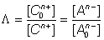 (3.1)
where [C₀^{n+}] and [A₀^{n-}] represent each cation and anion bulk concentration, [C^{n+}] and [A^{n-}] represent their concentration within the microenvironment and n is the number of charges on each ion. Λ has been found to vary within the range of about 0.01 to 100; Λ being greater than unity for positively charged enzymic surfaces and less than unity for negatively charged surfaces. The effect of partition on positively and negatively charged molecules is equal but opposite. For a positively charged support, cations are partitioned away from the microenvironment whereas the concentration of anions is greater within this volume compared with that in the bathing solution. ϕ depends on the density of charge on and within the immobilised enzyme particle. It is greatly influenced by the ionic strength of the solution. At high ionic strength the raised concentration of charged solute molecules counteracts the charge on the particles, reducing the electrostatic forces and causing ϕ to approach unity. Assuming Michaelis-Menten kinetics, the rate of reaction catalysed by an immobilised enzyme is given by equation 1.9 where the substrate concentration is the concentration within the microenvironment.
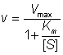 (3.2)
If the substrate is positively charged, it follows from equation 3.1 that
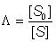 (3.3)
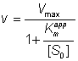 (3.4)
where
(3.5)
K_{m}^{app} is the apparent Michaelis constant that would be determined experimentally using the known bulk substrate concentrations. If the substrate is negatively charged, the following relationships hold:
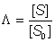 (3.6)
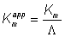 (3.7)
The K_{m} of an enzyme for a substrate is apparently reduced if the substrate concentration in the vicinity of the enzyme's active site is higher than that measured in the bulk of the solution (Figure 3.7). This is because a lower bulk concentration of the substrate is necessary in order to provide the higher localised substrate concentration needed to half-saturate the enzyme with substrate. Similar effects on the local concentration of products, inhibitors, cofactors and activators may change the apparent kinetic constants involving these molecules. For example, the apparent inhibition constant of a positively-charged competitive inhibitor is given by,
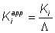 (3.8)

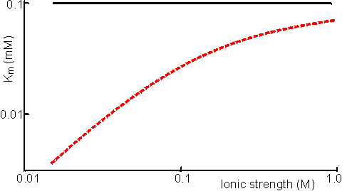
Figure 3.7. The effect of immobilisation and ionic strength on the K_{m} of bromelain for its positively-charged substrate, N-α-benzoyl-L-arginine ethyl ester. The support is the negatively-charged poly-anionic polymer, carboxymethyl cellulose (Engasser & Horvath, 1976). ——— free enzyme; ------ immobilised enzyme.

If the immobilised enzyme contains a number of groups capable of chelating cations the partition of such cations into the microenvironment is far greater than that described by the electrostatic partition coefficient (ϕ). For example, soluble glucose isomerase needs a higher concentration of magnesium ions, than those required by the immobilised enzyme. It also requires the presence of cobalt ions which do not need to be added to processes involving the immobilised enzyme due to their strong chelation by the immobilised matrix. A high concentration of ionising groups may cause a partitioning of gases away from the microenvironment with consequent effects on their apparent kinetic parameters. It is also a useful method for protecting oxygen-labile enzymes by 'salting out' the oxygen from the vicinity of the enzyme.
Differential partitioning of the components of redox couples may have a significant effect on the activity and stability of certain enzymes. For example, papain is stabilised by the presence of thiols, which act as effective reducing agents. However, thiols possess partial negative charges at neutral pHs which causes their expulsion from the microenvironment of papain if it is immobilised on the negatively charged clay, kaolinite. In effect, the redox couple involving thiol and uncharged disulphide, which is not partitioned, becomes more oxidising around this immobilised enzyme. The net effect is a destabilisation of the immobilised papain relative to the free enzyme.
pK_{a} ~ 8
2H⁺ + 2R-S⁻ 2R-SH R-S-S-R + 2H⁺ + 2e⁻ [3.6]
reduced oxidised
(stabilised enzyme) (destabilised enzyme)
Partition of hydrogen ions represents an important case of solute partition. The pH of the microenvironment may differ considerably from the pH of the bulk solution if hydrogen ions are partitioned into or out of the immobilised enzyme matrix. The binding of substrate and the activity of the immobilised enzyme both depend on the local microenvironmental pH whereas the pH, as measured by a pH meter, always reflects the pH of the bathing solution. This causes apparent shifts in the behaviour of the kinetic constants with respect to the solution pH (Figure 3.8). It is quite a simple process to alter the optimum pH of an immobilised enzyme by 1 - 2 pH units giving important technological benefits (e.g. allowing operation of a process away from the optimum pH of the soluble enzyme but at a pH more suited to the solubility or stability of reactants or products).

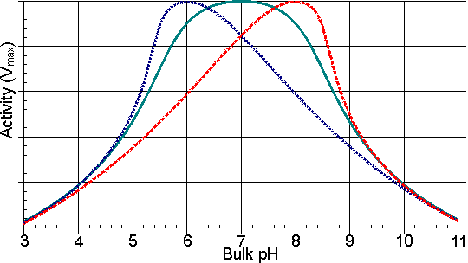
Figure 3.8. Schematic diagram of the variation in the profiles of activity of an enzyme, immobilised on charged supports, with the pH of the solution.——— free enzyme. ------- enzyme bound to a positively charged cationic support; a bulk pH of 5 is needed to produce a pH of 7 within the microenvironment. ------- enzyme bound to a negatively charged anionic support; a pH of 7 within the microenvironment is produced by a bulk pH of 9.

In addition to its affect on solute partition, the localised electrostatic gradient may affect both the K_{m} and V_{max} by encouraging or discouraging the intramolecular approach of charged groups within the enzyme, or enzyme-substrate complex, during binding and catalysis. A large number of small energetic gains and losses may complicate the analysis of such overall effects (Table 3.4). As the resultant changes are also reduced by increases in the ionic strength of the solution, these electrostatic effects may be difficult to distinguish from the effects of partition.

Table 3.4 The effect of covalent attachment to a charged matrix on the kinetic constants of chymotrypsin for N-acetyl-L-tyrosine ethyl ester (Goldstein 1972)
 | Ionic strength  (M) | k_{cat}  (s⁻¹) | Km  (mM | specificity  (k_{cat}/K_{m})
Free enzyme | 0.05 | 184 | 0.74 | 249
Free enzyme | 1.00 | 230 | 0.55 | 418
Enzyme attached to a  negatively charged support | 0.05 | 300 | 2.50 | 120
Enzyme attached to a  negatively charged support | 1.00 | 280 | 1.93 | 145
Enzyme attached to a  positively charged support | 0.05 | 119 | 7.10 | 17
Enzyme attached to a  positively charged support | 1.00 | 1.65 | 5.82 | 28
The changes in k_{cat} may be due to the approach of two positively charged groups during the rate-controlling step in the catalysis

Hydrophobic interactions play a central role in the structure of lipid membranes and the conformation of macromolecules including enzymes. They are responsible for the relative solubility of organic molecules in aqueous and organic solvents. These interactions involve an ordered rearrangement of water molecules at the approach of hydrophobic surfaces. The force of attraction between hydrophobic surfaces decays exponentially with their distance apart, halving every nanometer separation. These hydrophobic interactions effectively reduce the dielectric constant of the microenvironment with consequent modification of the acidity constants of acid and basic groups on the enzymes, substrates, products and buffers (Figure 3.9). Similar effects may alter the acidity constants of key substrate binding groups, so affecting the K_{m} of the immobilised enzyme for its substrates. Hydrophobic interactions are unaffected by the ionic strength or pH of the solution but may be neutralised by the presence of neighbouring hydrophilic groups where they are sufficient to dominate the localised structure of the water molecules. Hydrophobic interactions may, therefore, cause the partition of molecules between the bulk phase and the microenvironment. If the surface of the immobilised enzyme particles is predominantly hydrophobic, hydrophobic molecules will partition into the microenvironment of the enzyme and hydrophilic molecules will be partitioned out into the bathing solution. The reverse case holds if the biocatalytic surface is hydrophilic. Partition causes changes in the local concentration of the molecules which, in turn, affects the apparent kinetic constants of the enzyme in a similar manner to that described for immobilised enzyme particles possessing a net charge. An example of this effect is the reduction in the K_{m} of immobilised alcohol dehydrogenase for butanol. If the support is polyacrylamide the K_{m} is 0.1 mM but if the more hydrophobic copolymer of methacrylate with acrylamide is used as the support, the K_{m} is reduced to 0.025 mM. In this example, no difference is noticed in the apparent values for K_{m} using ethanol, a more hydrophilic substrate. A similar effect may be seen in the case of competitive inhibitors (Table 3.5). Gases partitioned out from the microenvironment by the presence of a charged support (e.g. oxygen) are generally partitioned into the microenvironment by hydrophobic supports

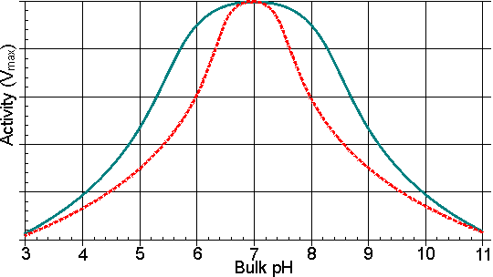
Figure 3.9. Schematic diagram showing the effect of a hydrophobic support on the pH-activity profile of immobilised enzymes in solutions of low ionic strength. ——— free enzyme; -------enzyme immobilised on a hydrophobic support. The effective decrease in the dielectric constant for the microenvironment reduces the dissociation of charged groups, increasing the pK_{a} of carboxylic acids and reducing the pK_{a} of some basic groups.

Table 3.5 The effect of immobilisation using a hydrophobic support on the relative competitive inhibition of invertase
 | Invertase
Inhibition constant (k_{i}, mM) | Soluble | Bound to polystyrene  (hydrophobic)
Aniline (hydrophobic) | 0.94 | 0.39
Tris-(hydroxymethyl)-aminomethane  (hydrophilic) | 0.45 | 1.10
The K_{i} is reduced where both the inhibitor and support are hydrophobic.

Other specific partition effects are associated with particular immobilisation supports. As examples: (a) The apparent K_{m} of glucoamylase for maltose is considerably reduced when the enzyme is immobilised on titanium activated supports; such supports having a specific affinity for some poly-alcohols. (b) Some polyphenolic resins have specific affinities for polysaccharides which assist their partition into the microenvironment.

Effects of solute diffusion on the kinetics of immobilised enzymes

In order for an immobilised enzyme to catalyse a reaction, the substrates must be able to diffuse through the solution to the catalytically active sites and the products diffuse away into the bulk solution. The driving force for the net diffusive process is due to the concentration gradients, solutes moving in the direction of higher to lower concentration. The substrates approach the surface of the enzyme particles through the surrounding thin stagnant unstirred layer of solution and then diffuse into any pores where they may encounter active enzyme. The net movement of the solutes is described in terms of these two steps;
- external diffusion where the transport of substrates towards the surface, and products away, is in series with the catalytic conversion of substrates to products occurring at the surface (the processes being consecutive)
- internal diffusion where the transport of the substrates and products, within the pores of immobilised enzyme particles, is in parallel with the catalysed reaction (the processes being simultaneous).
The concentration gradients caused by diffusion and partition are shown diagrammatically in Figure 3.10. The rate of a reaction catalysed by an immobilised enzyme (v) is normally lower than the rate due to the same amount of free enzyme in solution (v_{free}). This is due to the controlling necessity for the substrate to diffuse from the bulk phase to the catalytic surface. The substrate concentration within the microenvironment ([S]) is lower than that in the bulk ([S₀]) due to its depletion by the reaction. The change in reaction rate can be expressed quantitatively by introducing the effectiveness factor (η), where:
η= v/v_{free} (3.9)
The effectiveness factor generally lies between 0 and 1 and is dependent on the bulk substrate concentration, amongst other factors (see later). It may sometimes be greater than unity due to non-isothermal operation, because of partition or inhibitory effects, or if the immobilised enzyme is stabilised relative to the free enzyme over the time course of its assay.

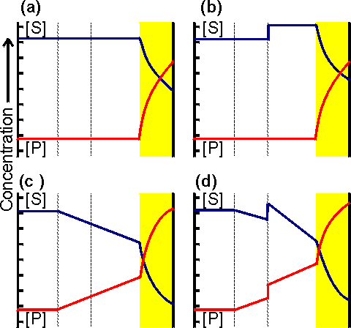
Figure 3.10. Schematic diagram showing the concentration gradients of substrate and product that may be produced around a porous particle of an immobilised enzyme. (a) concentration gradient due solely to reaction and internal diffusion within the particle; (b) as (a) but with additional concentration gradients due to partition of substrate and product into the microenvironment; (c) as (a) but with an additional concentration gradients due to external diffusion to the surface of the particle; (d) concentration gradients due to the combined effects of partition and diffusion. The partition boundary layer is normally about a thousand-fold thinner than the diffusive boundary layer. The actual concentration gradients will not show the sharp discontinuities which are shown here for simplicity.

The effect of external diffusion on the rate of an enzyme catalysed reaction may be simply derived, assuming (1) Michaelis-Menten kinetics, (2) the enzyme is immobilised to a flat impervious support, and (3) the absence of any partitioning or electrostatic effects. If the reaction is occurring under steady state conditions, the rate of increase of product within the bulk of the solution must equal the rates of three consecutive processes; the rate at which substrate diffuses to the surface, the rate of enzymic catalysis, and the rate at which the product diffuses away from the surface. The steady state assumption is generally valid if the volume of the bulk of the solution is sufficiently large such that the variation in [S₀] with time may be ignored. Immobilised enzymes are open systems, where both energy and material are exchanged through the boundary with the environment. This allows steady state operation even at very high enzyme loading. In any circumstances, it is clear that the substrate concentration at the catalytic surface cannot continuously increase or decrease at a substantial rate compared with the rate of reaction.
Therefore, from equation 1.8,
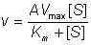 (3.10)
where A is the total surface area and V_{max} is the maximum rate of reaction catalysed by unit area of surface. Combining equations 1.8 and 3.10 gives,
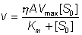 (3.11)
As ε varies with [S₀], the immobilised enzyme will no longer show hyperbolic kinetics. Eadie-Hofstee plots (see Figure 3.18) derived from the relationship 3.11 are not linear because they obey the transformation equation,
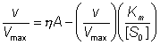 (3.12)
As this also involves a term in ε which varies, equalling unity when v equals V_{max} at the intercept with the vertical v axis but which may be much lower when v is much less than V_{max} at the intercept with the horizontal v/[S₀] axis.
Assuming that all of the surface is equally accessible, the rate of flow of substrate to the surface has been found to be proportional both to the surface area and the difference in substrate concentration between the bulk of the solution and the microenvironment next to the surface. It is given by the relationship,
(3.13)
The proportionality constant (k_{L}) is known as the (local liquid phase) mass transfer coefficient (with units of m s⁻¹) which depends upon the diffusivity of the substrate and the effective distance between the surface and the bulk phase.
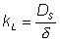 (3.14)
where DS is the substrate diffusivity (diffusion coefficient) in free solution (with units of m² s⁻¹) and δ is the effective thickness of the unstirred layer through which the substrate must diffuse. The diffusivity is defined by Fick's law as the rate at which unit mass of the compound (m) travels through a unit surface area (A) due to a concentration gradient of unit density (ρ) change.
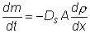 (3.15)
depends upon the molecular weight and dimensions of the substrate, and the temperature, viscosity and composition of the liquid phase (Table 3.6). In general terms, the higher the molecular weight and the solution viscosity, the lower will be the diffusivity. δ may be effectively regarded as a distance although it is not precisely defined by the thickness of the unstirred stagnant layer as liquid motion may be detectable at distances less than δ from the surface. Under stagnant flow conditions δ is equal to the particle radius for spherical particles. It depends on the hydrodynamic conditions, being reduced by increases in the rate of stirring and consequent increasing particle-fluid relative velocity.; this reduction in δ causing an increase in the mass transfer coefficient (k_{L}). For example, using particles of 400 μm diameter, δ has been found to be 5 μm when used in a packed bed reactor (see Chapter 5) at a reactant stream flow rate of 1 m s⁻¹. Dependent upon the conditions, δ also may vary with the diffusivity, and the density and viscosity of the liquid; increasing with increasing diffusivity and viscosity but reducing with increasing density difference between the immobilised biocatalyst and the medium. It may be halved by the use of ultrasound, which may be particularly useful for larger particles. For the small biocatalytic particles normally used, the maximum reduction in δ that is achievable by increasing the turbulence of the solution around the immobilised enzyme is about ten fold.
The rate of diffusion is significantly affected where partitioning occurs. For charged molecules, this will depend on the electrostatic potential gradient in addition to the concentration gradient. The electrostatic potential gradient causes apparent changes in both δ and D_{S} within the immediate vicinity of the surface (i.e. at distances very much smaller than δ). This may be particularly relevant in the case of hydrogen ion diffusion (see later) as hydrogen ions move rapidly through solutions across electrostatic gradients due to their ability to rapidly change their association with water molecules.

Table 3.6 Diffusivity of molecules in aqueous solution at 20°C
Substance | Molecular weight | Diffusivity  (m² s⁻¹)
Oxygen | 32 | 21.0 x10⁻¹⁰
Glucose | 180 | 6.7 x10⁻¹⁰
Sucrose | 342 | 4.5 x10⁻¹⁰
Inulin | 5,200 | 2.3 x10⁻¹⁰
Albumin | 67,000 | 0.7 x10⁻¹⁰
Urease | 480,000 | 0.3 x10⁻¹⁰
Bushy stunt virus | 10,700,000 | 0.1 x10⁻¹⁰

Due to the consecutive nature of the process the rate of enzymic reaction (given by v in equation 3.10) must equal the rate of diffusion of the substrate to the catalytic surface (given by v in equation 3.13); the terms in A cancelling out.
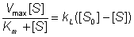 (3.16)
This equation is quadratic with respect to the microenvironmental substrate concentration ([S]), the value of which is very difficult to establish by independent means. It may be simplified under extreme values of [S] relative to the K_{m} of the enzyme for the substrate.If [S] is much greater than K_{m}, the left-hand side of equation 3.16 simplifies to give just V_{max}
(3.17)
where v_{A} is the rate of reaction catalysed by unit area of the immobilised enzyme surface. It follows that the rate of the reaction is equal to the maximum rate of reaction of the non-immobilised enzyme when [S], and hence [S₀], is much greater than the K_{m}. Often, however, it is found that [S] is much less than K_{m}. Under such conditions, equation 3.16 gives
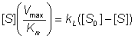 (3.18)
collecting terms in [S],
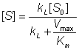 (3.19)
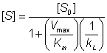 (3.20)
From equation 3.10, when [S] is much less than K_{m},
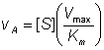 (3.21)
Substituting for [S] from equation 3.20,
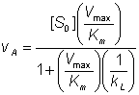 (3.22)
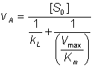 (3.23)
The relative values of the two components of the denominator, in equation 3.23, determine whether the reaction is controlled primarily by the diffusion of the substrate (the k_{L} term) or by the catalytic ability of the immobilised enzyme (the V_{max}/K_{m} term). The comparison may be made by means of the introduction of a substrate modulus (μ, also known as the Damköhler number and is the dimensionless ratio of reaction velocity to transport velocity) defined by,
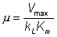 (3.24)
where V_{max} is the maximum rate of reaction catalysed by unit surface area. Substituting this in equation 3.22,
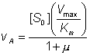 (3.25)

The relationships between the rates of reaction and the immobilised enzyme and bulk substrate concentrations are shown in Figures 3.11 and 3.12. When k_{L} is much greater than V_{max}/K_{m} (i.e. at zero μ, when mass transport is capable of a much faster rate than that of the enzyme catalysed reaction), the overall rate of the process is under the kinetic control of the enzyme, which is then as effective as the free enzyme (i.e. μ = 1). This allows the simplification of equation 3.23 to yield
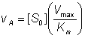 (3.26)
However, when k_{L} is much less than V_{max}/K_{m}, (i.e. at high substrate modulus, when mass transport is much slower than the intrinsic rate of the enzyme catalysed reaction), the overall rate of the process is under the control of the rate of diffusion of the substrate. Equation 3.23 then simplifies to give:
(3.27)
This last relationship, apart from its obvious utility as a method for determining mass transport coefficients, is very important for the proper understanding of the behaviour of immobilised enzymes under the diffusional control of external transport of the substrate. The rate of reaction is shown to be independent of the activity of the enzyme. This means that it is not affected by changes in the pH, temperature (except as it may affect viscosity) or ionic strength of the solution, nor is it affected by the presence of inhibitors or activators. If, however, the ratio V_{max}/K_{m} is reduced substantially by changes in these conditions to approach the value of k_{L}, the relationship shown in equation 3.27 will no longer hold true. As diffusional limitations approach a total controlling influence, the behaviour of the enzyme with respect to these factors gradually changes from that of a free enzyme in solution to the state of being unaffected. For example, increasing diffusional control causes a broadening of the pH-activity profile and a lowering of the activation energy (and the related Q₁₀), both of which will be more apparent at lower substrate concentrations. Under such conditions, the bulk substrate concentration that gives half the maximum rate of reaction ([S_{1/2}], equivalent to the apparent K_{m}, K_{m}^{app}) is higher than the K_{m} of the free enzyme (see Figure 3.12). This is in contrast to the case of the free enzyme where [S_{1/2}] is identical to the K_{m}. The equivalent microenvironmental substrate concentration giving half-maximal reaction rate remains equal to the K_{m}.

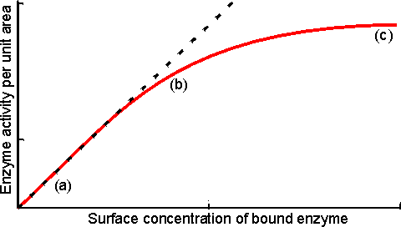
Figure 3.11. Variation in the rate of reaction catalysed by an immobilised enzyme with its concentration. The relationship shows three phases; (a) kinetic control by the enzyme, extrapolated (-----) to show the activity of equivalent amounts of free enzyme; (b) mixed intermediate control; (c) control by the rate of external transport of substrate.

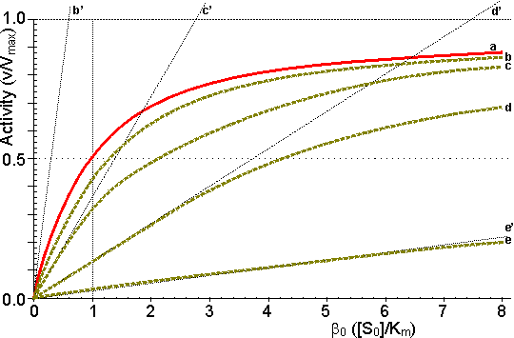
Figure 3.12. This shows the variation in the rate of reaction catalysed by an immobilised enzyme and the dimensionless bulk substrate concentration (β₀, which equals [S₀]/K_{m}) with the substrate modulus (μ, defined by equation 3.24). (a) free enzyme; (b) μ = 1; (c) μ = 3; (d) μ = 10; (e) μ = 100. Also drawn are the maximum rates of substrate diffusion to the surface, given by v_{A}/V_{max} = k_{L}β₀ (b', c', d' and e', showing the effect of decreasing mass transfer coefficients, k_{L} = 1.00, 0.33, 0.10 and 0.01, corresponding to curves b, c, d and e respectively). It should be noticed that curves b, c, d and e are bounded both by curve a and by the lines b', c', d' and e' respectively. Increased diffusional control extends the range of linearity at lower substrate concentrations, but the same V_{max} is reached in all cases if a sufficiently high substrate concentration can be achieved (see Figure 3.27a).

v_{A} may be substituted by V_{max}/2 in equation 3.13 when [S] equals K_{m}, giving:
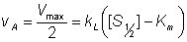 (3.28)
Therefore:
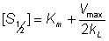 (3.29)
Therefore:
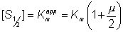 (3.30)
The K_{m} apparently increases with the substrate modulus. This causes a reduction in the apparent specificity. The introduction of the dimensionless substrate concentrations β (= [S]/K_{m}) and β₀ (= [S₀]/K_{m}) into equation 3.16 gives,
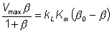 (3.31)
Substituting μ from equation 3.24,
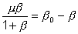 (3.32)
This may be simplified at low β0, when β approaches zero,
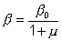 (3.33)
and,
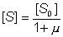 (3.34)
Therefore, if the value of μ is known, the concentration of the substrate at the surface of the immobilised enzyme may be obtained.
The most important factors to arise from this analysis concern the consequences of immobilisation on the effective catalytic ability of the enzyme. It is clear that the effectiveness factor (ε) must vary with both β₀ and μ, being reduced by low β₀ and high μ; this relationship being illustrated in Figure 3.13. The conditions that produce an increased probability of external diffusional control over the rate of an immobilised enzyme catalysed reaction may be summarised as follows:
- High enzyme loading on the surface.
- Low bulk substrate concentration.
- Low substrate diffusivity.
- Low K_{m}.
- High enzymic specificity.
- Low rate of stirring or mixing.
- Flat surfaces (e.g. large average particle diameter; see Figure 3.14).

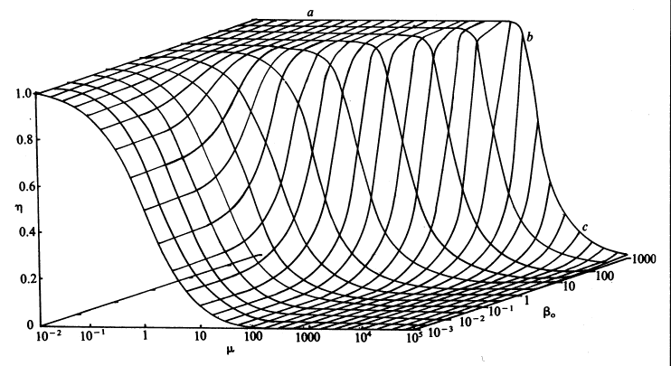
Figure 3.13. The combined effect of the bulk substrate concentration (β₀) and substrate modulus (μ) on the effectiveness factor (η). The plateau (a) is an area of kinetic control, the surface dropping through an area of intermediate control (b) to an area of diffusional control (c).

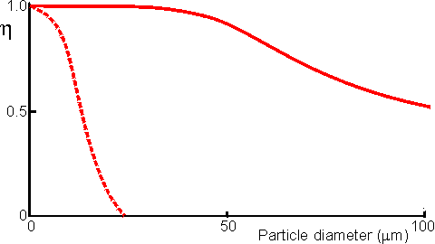
Figure 3.14. Schematic diagram showing the effect of particle diameter on the effectiveness factor (ε) of immobilised enzymes. ——— small surface concentration of enzyme; --------- high surface concentration of enzyme.

Diffusion-free enzyme kinetics can be simply determined by decreasing the loading of enzyme on the immobilisation support or by lowering the temperature. It is often necessary to determine the kinetic parameters of an immobilised enzyme in the presence of external diffusional effects. This may be in order to investigate the effect of immobilisation on the intrinsic stability or activity of the enzyme. The intrinsic V_{max} can be determined if sufficiently high microenvironmental substrate concentrations can be achieved (see Figure 3.27a) but determination of the intrinsic K_{m} depends upon knowledge of the microenvironmental substrate concentration. This may be graphically determined if the mass transfer coefficient is known (Figure 3.15).

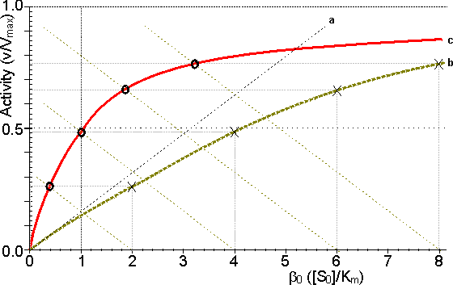
Figure 3.15. Diagram illustrating a method for the determination of the intrinsic kinetic parameters (V_{max} and K_{m}). The value of k_{L} may be determined from the tangent of the experimental curve at the origin (line a). For each experimentally determined (rate : bulk substrate concentration) data point (x, on curve b) a line is drawn of gradient -k_{L} from the appropriate position on the horizontal axis. The microenvironmental substrate concentration is given by the intercept of this line with the vertical position representing the reaction rate. These graphically determined (rate : microenvironmental substrate concentration) data points (o, on curve c) may be used to calculate the intrinsic kinetic parameters.

The substrate concentration gradient, within the microenvironment, is only perfectly linear next to flat surfaces (see equation 3.13). The more usual situation is that of enzymes attached to curved surfaces (e.g. spherical particles, the inside of cylindrical tubes or the outside of cylindrical fibres). These are found to produce non-linear concentration profiles (Figure 3.16). This is due to the substrate molecules approaching the surface through convergent or divergent pathways (e.g. substrate molecules diffusing towards the surface of a spherical particle pass through successively decreasing volumes and areas, the concentration gradient increasing with decreasing radius, in order to retain the same flux of molecules throughout).

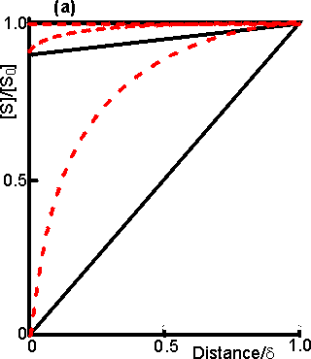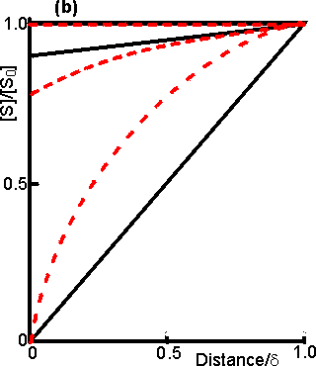
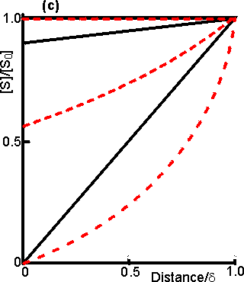
Figure 3.16. Concentration profiles of substrate molecules approaching the curved surface of immobilised enzymes, where r is the radius of curvature. (a) enzyme attached to spherical particles; (b) enzyme attached to the outside of cylindrical fibres; (c) enzyme attached to the inside of cylindrical tubes. ——— r/δ = 9; ---------- r/δ = 0.11. In each case, μ = 10⁻³, 1 and 10³ for the top, middle and bottom pair of curves, respectively.

Inhibitors may affect the rate of an immobilised enzyme catalysed reaction in a different manner than that in which they affect the free enzyme. The relative affects of reversible competitive, uncompetitive and noncompetitive inhibitors can be understood by consideration of the resultant changes in the apparent kinetic constants K_{m}^{app} and V_{max}^{app}. If μi represents the value of the substrate modulus (μ) in the presence of the inhibitor and using equation 3.24,for competitive inhibition, from equation 1.84,
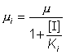 (3.35)
for uncompetitive inhibition, from equations 1.93 and 1.94,
(3.36)
for noncompetitive inhibition, from equation 1.98,
(3.37)
Competitive and noncompetitive inhibition both show a reduction in μ_{i} relative to μ. Substrate diffusional resistance will, therefore, have less affect on these inhibited processes than on the uninhibited immobilised enzyme. This is because such inhibited reactions are inherently slower and less likely to be controlled by the rate of substrate diffusion. No affect is noticed in the case of uncompetitive inhibition as this has negligible affect on the rate of reaction at low substrate concentrations. Even in the former two cases the affect of the degree of inhibition becomes negligible at high substrate modulus (μ > 50), when equation 3.27 holds.
Product inhibition may be more severe in the case of immobilised enzymes due to product having to diffuse away from the site of reaction. Its concentration is likely to be much higher within the microenvironment than in the bulk of the solution (Figure 3.10). At the beginning of the reaction, this product concentration will build up until the concentration gradient to the bulk macroenvironment is sufficient to allow it to diffuse away at an equal rate to its production by the reaction. If k_{L}^{S} and k_{L}^{P} represent the substrate and product mass transfer coefficients, and [P] and [P₀] represent the product concentrations in the microenvironment and bulk respectively, then from equation 3.13,
(3.38)
Under diffusional control, [P] and [S₀] are much greater than [P₀] and [S] respectively.
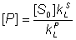 (3.39)
Substituting for [P] in equation 1.85 and assuming that K_{m} is much greater than [S],
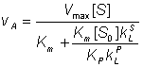 (3.40)
The effect of product inhibition (the second term in the denominator) depends on the bulk substrate concentration and the ratio K_{m}k_{L}^{S}/(K_{P}k_{L}^{P}) which expresses the competition between the substrate and the product for the enzymic surface. The build-up of the product at the surface increases with this ratio causing a reduction in both the rate of reaction and the effectiveness factor. The effect is greater when K_{m}/K_{P} or k_{L}^{S}/k_{L}^{P} are large and μ is small (< 50). k_{L}^{S} is usually approximately equal to k_{L}^{P} but may be higher where the reaction involved produces a higher molecular weight product from more than one substrate molecule, or substantially lower in a depolymerisation (e.g. hydrolysis) reaction.
Substrate inhibition presents a somewhat more complex scenario. Equations 1.96 and 3.13 may be combined to give,
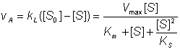 (3.41)
This equation is third order with respect to the microenvironmental substrate concentration ([S]). For this reason, it is not surprising that multiple steady states are possible, provided that diffusion of the substrate to the enzyme is sufficiently slow (Figure 3.17). The same bulk substrate concentration may give two different stable concentrations within the microenvironment; (1) a low concentration which gives a relatively fast rate of reaction, without much substrate inhibition, and equally fast rate of inward diffusion of substrate due to the steep concentration gradient, and (2) a much higher concentration which gives a relatively slow rate of reaction, due to the substrate inhibition, and equally slow rate of inward diffusion of substrate down the relatively slight concentration gradient. A third possibility exists of an intermediate concentration representing an unstable state which is not naturally established and is of no practical consequence (Figure 3.17). The choice of which stable state exists depends on the start-up conditions. Addition of the substrate under conditions of low substrate modulus (e.g. at a low temperature or with vigorous stirring) allowing an initially high microenvironmental substrate concentration to be achieved and favouring the stable state involving higher [S] as the temperature and substrate modulus are raised. The alternative stable state may be reached by addition of the substrate under conditions of high substrate modulus where the microenvironmental substrate concentration is initially zero and kept low.

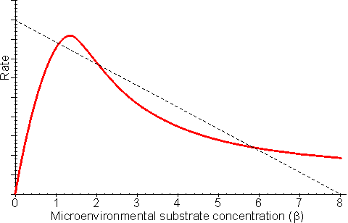
Figure 3.17. The effect of substrate inhibition on the rate of immobilised enzyme reactions. ——— immobilised enzyme vs microenvironmental substrate concentration (or free enzyme vs bulk substrate concentration). The line ---------- represents the rate of diffusion of the substrate from the bulk (β0 = 8) to the microenvironment (i.e. rate = k_{L}(β₀ - β); lower microenvironmental substrate concentration, relative to the bulk concentration, giving the higher rate.

Reversible reactions catalysed by immobilised enzymes may be severely affected by the slow diffusion of the product away from the catalytic surface. Even a slight build-up in the microenvironmental product concentration will increase the reverse rate of reaction, severely reducing the productivity of the enzyme. An analysis of the effect of this diffusional resistance may be made by combining equations 1.68 and 3.38, which then describe the resultant lowering of the rates of reaction and effectiveness factor. Figure 3.18 shows Eadie-Hofstee plots comparing the effect of reaction reversibility at increasing external substrate modulus.

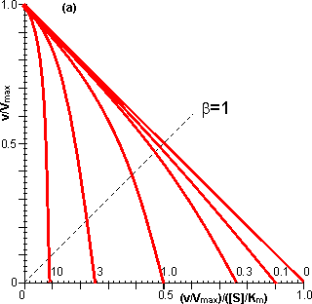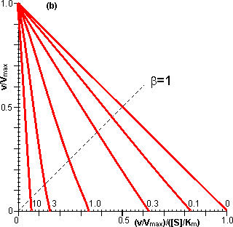
Figure 3.18. Eadie-Hofstee plots illustrating the effect of external diffusional resistance on the kinetics of an immobilised enzyme. Essentially non-reversible (a) and reversible (b) reactions are shown. The reversible situation has been modelled on the glucose isomerase reaction using values of 1.14 for the K_{eq} and 42% and 51% (w/w, of carbohydrate present) for the initial bulk concentration of fructose and glucose, respectively. The lines represent the kinetically controlled reaction and increasing substrate modulus (μ), as shown. (a) corresponds to Figure 3.12.

Diffusional resistance can lead to an apparent increase in the stability of immobilised enzymes. The reason for this is the ceiling that the diffusional resistance imposes upon the activity. At a high loading of active enzyme, the activity obeys equation 3.27 and is independent of the inherent activity of the immobilised enzyme. Under these circumstances, there is always sufficient reaction occurring to remove the substrate as it arrives from the bulk solution, most of the enzyme molecules being effectively redundant (effectiveness factor close to zero). The productivity of the immobilised biocatalyst remains constant until the specific activity of the enzyme has decayed sufficiently that the reaction is no longer diffusionally controlled (Figure 3.19). Some of the early researchers in this field who used data collected only during the initial diffusionally controlled period were misled into believing that the immobilisation process was more likely to stabilise an enzyme than is now realised.

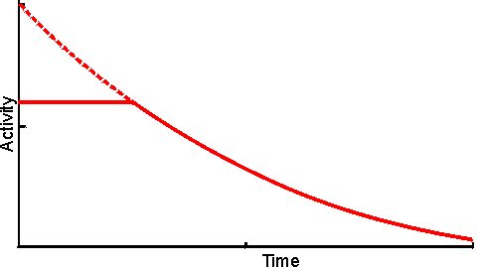
Figure 3.19. The apparent stabilisation of an immobilised enzyme, when diffusionally controlled. ——— utilisable activity; ---------- intrinsic activity, not realised above the activity ceiling imposed by the slower (rate-controlling) diffusion of the substrate to the enzyme.

A special case of diffusional control of immobilised enzyme reactions concerns hydrogen ions. Many enzyme catalysed reactions involve the release or consumption of H⁺ (e.g. dehydrogenases, peptidases and esterases). This may include any reaction involving molecules containing ionisable groups as the pK_{a}s of such groups on the substrates and products may differ. Sometimes the reaction may produce or consume hydrogen ions dependent on the pH of the reaction (e.g. urease, see Table 6.2). Hydrogen ions diffuse relatively slowly, similar to other monovalent ions, in the absence of an electrical field. This is due to four main causes, (1) H⁺ is normally hydrated (H₃0⁺ , H₉0₄⁺) increasing its apparent molecular weight and hence reducing its diffusion coefficient, (2) the need for localised electroneutrality necessitates the co-diffusion of positively and negatively charged species, again causing an increase in the effective molecular weight (i.e. each H⁺ diffuses with an anionic counterion), (3) hydrogen ions are buffered by histidine and other groups on the immobilised enzyme particles which reduce their ability to diffuse into the bulk liquid phase, (4) normally the H⁺ concentration in the bulk of the solution is low (e.g. pH 7 is equivalent to 10⁻⁷ M H⁺) which only allows the production of very small concentration gradients even at pH differences of 1 or 2. The shallowness of H⁺ concentration gradients are especially noticeable when compared with those normally encountered for other substrates or products (greater than mM). For these reasons many reactions may be controlled by the diffusion of hydrogen ions to, or away from, immobilised enzyme surfaces. The effect of this diffusional control may be examined by combining equations 1.17 and 3.13 for a reaction involving the production of H⁺.
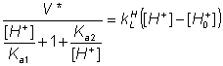 (3.42)
where V* is the maximum rate of reaction if pK_{a1} and pK_{a2} are well separated, k_{L}^{H} is the mass transfer coefficient of H⁺, [H⁺] is the microenvironmental concentration of H⁺, and [H⁺,80] is the bulk concentration of H⁺. If the reaction involves the consumption of hydrogen ions, the reaction obeys the following related equation
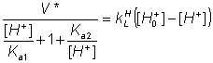 (3.43)
The magnitude of the diffusional resistance is given by the proton modulus (μH), where
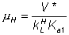 (3.44)
Note the similarity in the definitions of the proton and substrate moduli (equation 3.24).

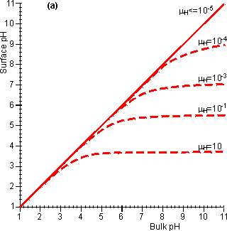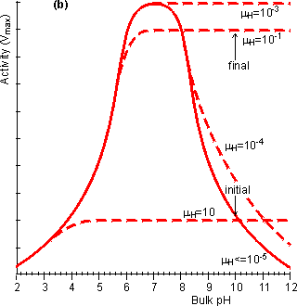
Figure 3.20. The effect of diffusional control on the local pH and pH-activity profile of an immobilised enzyme catalysed reaction. (a) the variation of surface pH with bulk pH at various proton moduli (μH); ——— H <= 10⁻⁵ ; -------- μH = 10⁻⁴, μH = 10⁻³, μH = 10⁻¹ and μH = 10. The reduction in microenvironmental pH is most noticeable at high pH due to the much lower hydrogen ion concentration gradients, and hydrogen ion diffusion rates, present (e.g. a pH difference of 1 at pH 12 produces a concentration gradient only a millionth of that produced at pH 6). (b) the effect of the surface pH on the pH-activity profile. Note that μH and hence the pH-activity profile will vary with the flow rate and degree of turbulence. If the reaction is started at pH = 10 and μH = 0.1, the rate of hydrogen ion production is initially low (initial rate shown) but faster than the rate that the hydrogen ions can diffuse away. This causes a drop in the microenvironmental pH towards the optimal pH, increasing the rate of reaction. This process continues until the concentration gradient between the microenvironmental and bulk phases is sufficient that the rate of diffusion equals the rate of reaction (final rate shown).

It is found that hydrogen ions accumulate at the surface when the proton modulus is greater than about 10,000 (Figure 3.20). Such reactions may be operated at a significant rate, well away from the pH optimum of the free enzyme. This may be very useful in cases where such a pH allows higher substrate solubilities or a more favourable process environment for the reaction. The diffusion of hydrogen ions may be facilitated by conjugate acid-base pairs, even at concentrations appreciably lower than those needed for their conventional buffering action. The reason for this is that the 'buffers' are capable of far greater concentration gradients than hydrogen ions, without necessarily affecting the bulk pH (Figure 3.21). In this case, equation 3.42 must be extended to include the diffusional transport of hydrogen ions by the conjugate acid. For a reaction producing H⁺ this becomes,
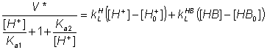 (3.45)
where k_{L}^{HB} is the mass transfer coefficient of HB, [HB] is the micro-environmental concentration of the conjugate acid (HB) and [HB₀] is the bulk concentration of HB. At a bulk pH of 7 about a thousand times more hydrogen ions are transported by a millimolar buffer with a pK_{a} of 7 than as free hydrogen ion. The presence of these buffering ions can significantly affect the pH-activity profile of reactions limited by hydrogen ion diffusion (Figure 3.22).

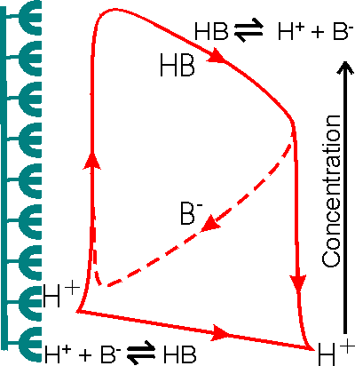
Figure 3.21. Schematic diagram showing the facilitated transport of hydrogen ions away from an immobilised enzyme catalysing a reaction producing hydrogen ions. The hydrogen ion concentration gradient is small due to the low concentration of hydrogen ions in the bulk and the inability to produce a substantial hydrogen ion concentration (e.g. pH < 3) in the microenvironment. The buffer, represented by the conjugate pair HB/B⁻, removes protons from the surface down much steeper concentration gradients, dependent on its concentration and pK_{a} relative to the pH of the microenvironmental and bulk phases. The proton removal and delivery reactions occurring in these microenvironmental and bulk phases, respectively, are shown at the bottom.

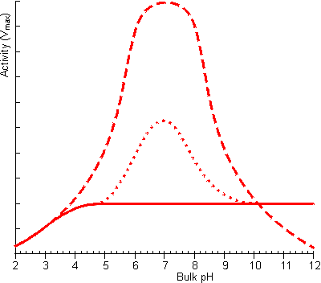
Figure 3.22. The effect of facilitated transport of hydrogen ions away from an immobilised enzyme catalysing a reaction producing hydrogen ions on the pH-activity profile (under conditions when μ is 10). ——— no buffer; ---------- high buffer concentration, pK_{a} = 7; ········· low buffer concentration, pK_{a} = 7. The buffer is only effective, at facilitating transport, close to its pk_{a} as at low pH there is insufficient base present which binds the hydrogen ions and at high pH very little binding can occur due to the unfavourable equilibria.

Analysis of diffusional effects in porous supports

So far, only external diffusional control of immobilised enzyme catalysed reactions has been described. This has been more due to the ease of the analysis rather than the scale of its application. Although it is undoubtedly extremely important, most immobilised enzyme catalysts are porous to some extent which necessitates the examination of the effect of internal diffusional resistance. Porous particles generally have very large surface areas of up to several hundred square metres per gram enabling very high immobilised enzyme loading. Where such biocatalysts operate under total external diffusional control (i.e. equation 3.27 holds) then the surface substrate concentration is effectively zero, no substrate is available for penetration into any pores and internal diffusion may be safely ignored as being of no importance. However, in all other cases it may well be relevant. This is because the pathways through which the substrate travel internally within the particles are generally much greater than those involved in external diffusional control (i.e. the pore length is several orders of magnitude greater than the depth of the surrounding stagnant layer, δ). It should be noted that the effect of external diffusional limitations can be moderated, and sometimes removed completely, by changing the flow rate of the substrate solution over the biocatalytic surface, but such changes have no influence on the diffusion of the substrate within the protected environment of the interior of the particles.
Diffusion of the substrate and product inside a porous biocatalyst occurs in parallel with the catalysed reaction. The more the enzyme catalysed reaction reduces the substrate concentration within the particles, the greater will be the substrate concentration gradient created between the internal microenvironment and the bulk of the solution. This, in turn, will increase the rate at which the substrate is delivered to the enzyme molecules towards the outside of the particles, increasing their effectiveness. The productivity of the reaction is, therefore, reduced considerably by the serious depletion of the substrate deep within the particle and the consequent high concentrations of product to be found there, possibly causing inhibition or reversing the reaction. To a certain extent, however, this is compensated by the increased flow of substrate to the outer portion of the immobilised enzyme particles due to the increased substrate concentration gradient.
Analysis of the effect of internal diffusion is complicated by such factors as the shape of the particles, the distribution in size and shape of the pores, the total volume of the pores with respect to the particle volume (porosity, η), the depth to which the pores penetrate the particles (e.g. pellicular particles have only a thin layer of enzyme-containing pores at their surface), the tortuosity (τ) of the route through the pores that the substrate encounters, the effective diffusivity of the reactants and products within the pores and the degree of uniformity of the enzyme's distribution within the particles (many immobilisation methods produce a higher volumetric concentration of enzyme towards the exterior of the immobilised enzyme particles, due to the rapid nature of the immobilisation reaction which immobilises the enzyme before it fully penetrates the pores). In order to examine the effect of these factors on a real system, it is useful to start with an analysis of the effect of internal diffusional resistance on the productivity of a 'model' porous biocatalytic particle. Beaded pellets are the most commonly encountered porous biocatalysts and may be considered as perfectly spherical for this purpose. The kinetics of other types of porous biocatalyst (e.g. flat membranous sheets, cylindrical pellets and fibres) may be analysed using a similar approach to that outlined here.
A porous spherical particle of immobilised enzyme may be represented as shown in Figure 3.6. The simplified model used in this analysis also requires that
- the immobilised enzyme is uniformly distributed throughout the totally porous particle (i.e. η and τ are both unity),
- the Michaelis-Menten model describes the enzyme's kinetics,
- the system is operating under steady-state conditions and is isothermal,
- the diffusion of substrate and product obeys Fick's law (i.e. they are proportional to their concentration gradients), and the effective diffusivities are constant throughout the particle,
- there is no external diffusional resistance (i.e. the substrate concentration at the particle surface ([S_{R}]) equals that in the bulk of the solution ([S₀]), and
- neither partition nor inhibition occur.
Under steady state conditions, the net rate of diffusion of the substrate through a concentric slice of width δr into a 'model' spherical immobilised enzyme particle at the radial position r from its centre must equal the rate of reaction of the substrate within that slice. The rate of substrate diffusion into the slice from the outside equals the flux (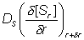) times the area of the outside of the slice (). The rate of substrate diffusion out of that slice towards the interior of the particle equals the flux (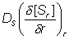) times the area of the inside of the slice (4πr²). The rate of substrate reaction within the slice equals the volumetric activity (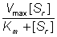) times the volume (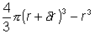). Therefore, by combining these processes and ignoring the negligibly small terms in δr² and δr³:
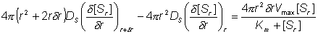 (3.46)
Simplifying and using the identity between (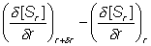 and 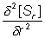
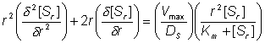 (3.47)
This may be further simplified by substitution with the dimensionless units; ρ for r/R, S for [S_{r}]/[S_{R}], and β for [S_{R}]/K_{m}.
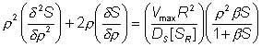 (3.48)
The relative effects of internal diffusion and the kinetic rate of reaction can be described by use of a substrate modulus for internal diffusion (φ) which is conceptually similar to μ for external diffusion. φ, however is defined differently for each type of porous biocatalyst (e.g. porous spheres, flat porous membranes, pellicular particles). Substituting θ for (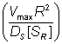) and combining the left hand terms in equation 3.48 gives,
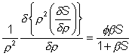 (3.49)
Therefore, as the slice width δρ tends to zero
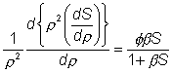 (3.50)
An alternative definition of φ (φ#) which is linear with respect to the characteristic length of the system (in this case this is the ratio of the volume to surface area (R/3)) is sometimes used, where:
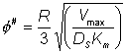 (3.51)
and, therefore, the two moduli are related by the expression:
(3.52)
This definition corresponds closer to that of μ, the substrate modulus for external diffusion, in that it is linear with respect to length. Thus, increases in the radius of porous particles are shown to be an additional factor which may cause diffusional control in an immobilised enzyme catalysed reaction. The equation 3.50 cannot be solved analytically but may be solved by numerical methods using the boundary conditions that S and ρ are unity at the exterior surface of the particle, and ρ and dS/dρ are zero at the centre of the particle. This latter condition is necessary for reasons of symmetry through the centre of the particle. The solution is achieved by an iterative choice of the substrate concentration at the centre of the particle and using the relationship 3.49 to describe the changes in the substrate concentration, in small steps, from the centre outwards to the surface of the particle until the first boundary condition is met to within the accuracy required. The resultant concentration profile, which can be rapidly obtained using a fairly simple microcomputer, enables the overall rate and effectiveness of reaction, catalysed by the particle, to be calculated. Clearly, only if the substrate concentration is unchanged throughout the particle will the effectiveness of the enzyme be unchanged relative to freely soluble enzyme (i.e. η = 1). This is unlikely to be approached except in the case of very low enzyme loading or very small particles. The substrate modulus (φ) indicates the importance of these factors, being proportional to the enzyme loading and the square of the particle diameter and inversely proportional to the diffusion coefficient. In this example, it is also inversely proportional to the bulk substrate concentration as this governs the extreme value obtainable by the concentration gradient.

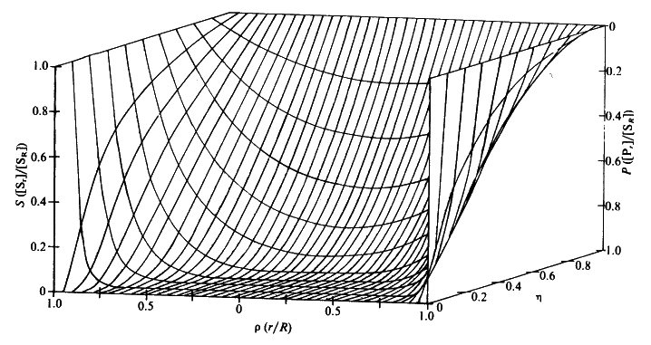
Figure 3.23. Substrate concentration profiles across spherical porous biocatalytic particles. The axes depict the substrate concentration relative to the external substrate concentration (S, which represents [S_{r}]/[S_{R}]), the dimensionless radial position (ρ, representing r/R) and the effectiveness factor (η). The profiles were derived by changing the substrate modulus (φ) whilst keeping β ([S_{R}]/K_{m}) constant (and equal to 0.1). Product concentration profiles are also shown; calculated assuming zero bulk product concentration and that the diffusion coefficients of substrate and product are equal.

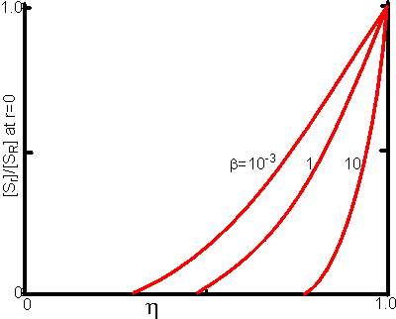
Figure 3.24. This shows the variation of the substrate concentration in the centre of immobilised enzyme particles with the effectiveness factor (η). Values for β (representing [S_{R}]/K_{m}) of 10, 1 and 10⁻³ are illustrated.

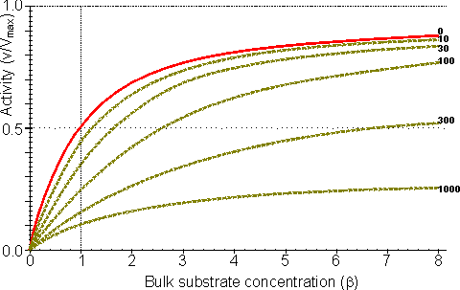
Figure 3.25. The variation in the rate of reaction catalysed by porous spherical particles containing immobilised enzyme with the dimensionless surface concentration of substrate, β (representing [S_{R}]/K_{m}). The top curve represents the case where there is no diffusional control (i.e. zero φ') whereas the lower curves show the effect of progressively greater normalised substrate modulus for internal diffusion, φ' (equalling 10, 30, 100, 300 and 1000). φ' is the substrate modulus for internal diffusion (θ) normalised with respect to the K_{m} (i.e. φ' = βφ) in order to make it independent of the absolute value of the exterior substrate concentration. The shapes of the curves displayed should be compared with those encountered under conditions of external diffusional control (Figure 3.12). Particularly note the absence here of the significant linear portion at low β and high substrate modulus.

The substrate concentration profiles across the particles at various effectiveness factors are shown in Figure 3.23. It can be seen that even at high η the substrate concentration drops significantly towards the centre of the particles and at low η this drop is so severe that the centres of the particles encounter very little substrate (Figure 3.24). This is particularly apparent at high β ([S_{R}]/K_{m}) as the reaction rate is close to V_{max} and small changes in the substrate concentration do not significantly lower the effectiveness factor. The variation in the rate of reaction with substrate concentration and substrate modulus is shown in Figure 3.25. At low effectiveness factors, only the outer layer of the biocatalytic particle is utilised causing the particles to show an impressive apparent stability with time; relatively unused enzyme within the particle core only being brought into use as the surface immobilised enzyme inactivates due to denaturation.
The variation of the effectiveness factor with the substrate modulus and the dimensionless substrate concentration is shown in Figure 3.26, which should be compared with the equivalent relationship for external diffusion shown in Figure 3.13. From this it can be seen that values of the substrate modulus below unity have little effect on the productivity of the immobilised enzyme particles, but higher values result in a considerable reduction in the effectiveness of the enzyme especially at low substrate concentrations.

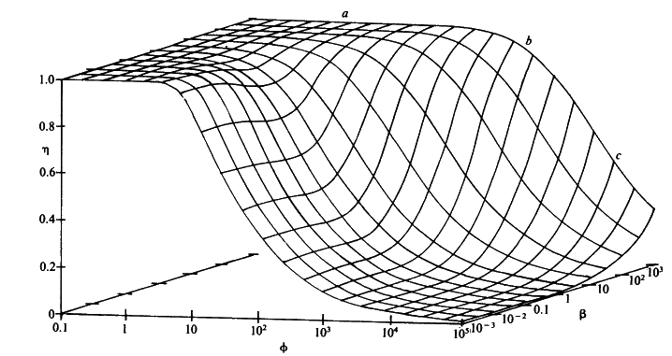
Figure 3.26. The combined effect of the bulk substrate concentration β (representing [S_{R}]/K_{m}) and substrate modulus for internal diffusion (φ) on the effectiveness factor (η) of porous spherical biocatalytic particles. The plateau (a) is an area of kinetic control, the graphical surface dropping through an area of intermediate control (b) to an area of diffusional control (c).

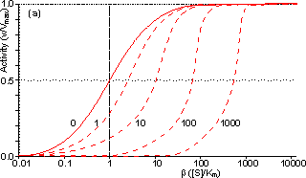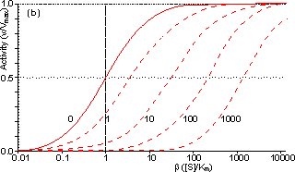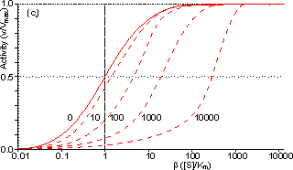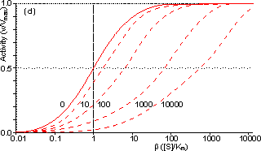
Figure 3.27. Semi-logarithmic plots for externally (a, b; μ = 0, 0.1, 0.3, 1, 3 and 10) and internally (c, d; φ' = βφ = 0, 1, 3, 10, 30, 100, 300 and 1000) controlled reactions involving immobilised biocatalysts. (a) and (c) show non-reversible reactions whereas (b) and (d) have been calculated for the reversible reaction involving glucose isomerase (K_{eq} = 1.14, bulk concentration of glucose (S) and fructose (P) being 51% and 42% (w/w), respectively, of the total carbohydrate).

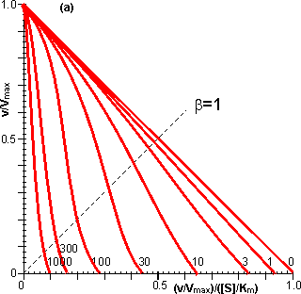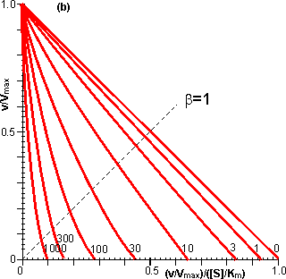
Figure 3.28. Eadie-Hofstee plots for internally (φ' = βφ = 0, 1, 3, 10, 30, 100, 300 and 1000) controlled reactions involving immobilised biocatalysts. (a) non-reversible reaction, (b) reversible reaction involving glucose isomerase (K_{eq} = 1.14, bulk concentration of glucose (S) and fructose (P) being 51% and 42%, respectively, of the total carbohydrate). These plots correspond to those shown in Figure 3.27 (c, d). Figure 3.18 (a, b) shows equivalent plots for Figure 3.27 (a, b).

In real systems, the effectiveness factor is further reduced by steric effects which have been ignored in the above analysis. Where the substrate is large compared with the pore diameter, the effective diffusivity of the substrate within the pores will be significantly reduced, increasing φ. This reduction is generally proportional to the tortuosity of the pore geometry (τ) and inversely proportional to the particle porosity (η; see Figure 3.6 for definitions of τ and η). The effective diffusion coefficient is additionally reduced as the ratio of the effective diameter of the substrate increases relative to the pore diameter, particularly where this ratio exceeds 0.02. This relationship usually causes a decrease in the effective diffusivity with the depth penetrated by the substrate. The active site of the enzyme may additionally be masked from binding the substrate by the difficulty with which the substrate can rotate within the confined space of the pores to give the correct effective conformation. The effectiveness factor may be increased by non-isothermal conditions where the reaction generates heat within the particles which is then unable to escape rapidly to the bulk phase. Non-isothermal operation is only rarely encountered as most enzyme catalysed reactions generate little heat and the catalytic particles are fairly small having large surface areas, through which the heat may escape, for their volume.
Under circumstances where both external and internal diffusion gradients are found, the flux of substrate through the stagnant layer (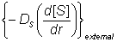) must equal the flux entering the surface of the particles (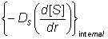),
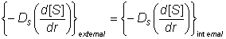 (3.53)
As the effective diffusion coefficient of the substrate within the particles (D_{S}) is usually less than that in free solution, the substrate concentration gradient (d[S]/dr) within the particles must be greater than that occurring outside.
Determination of the intrinsic kinetic constant (K_{m}) is more complex in the case of internal than external diffusional control due to the added complexity concerning variation in the effective substrate diffusivity. It is best determined under conditions where θ is less than unity, when little diffusional effect is apparent. Such conditions can be achieved by use of sufficiently small particles or low enzyme loading. Knowledge of the intrinsic K_{m} value(s) and V_{max} (obtained at high substrate concentrations, see Figure 3.27) allows the effective diffusion coefficients to be calculated.
The effect of internal diffusional control on reversible or inhibited reactions is similar to that encountered under external diffusional control. It may be analysed as outlined earlier for uninhibited non-reversible reactions, but replacing the equation for the volumetric activity by one involving reversibility or inhibition. For example, in the case of the reversible glucose isomerase reaction, the Michaelis-Menten volumetric activity term in equation 3.46 may be replaced by that from equation 1.56. This gives the following relationship, after a similar derivation to that shown in equations 3.46 to 3.49,
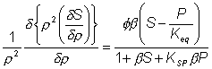 (3.54)
where P represents [P_{r}]/[S_{R}], [P_{r}] represents the product concentration at radial position r and K_{SP} replaces K_{m}^{S}/K_{m}^{P}. Under steady state conditions, the diffusion of substrate inwards, and product outwards are linked by the relationship
(3.55)
where D_{P} is the diffusion coefficient of the product.
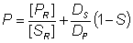 (3.56)
This value for P may be substituted into equation 3.54 and the resultant equation solved by an iterative numerical method as outlined previously.
A comparison of the rates of reaction for non-reversible and reversible reactions under both internal and external diffusion control are shown in Figures 3.27 and 3.28. Figure 3.27 emphasises the fact that diffusional control of a reaction can be overcome at sufficiently high substrate concentrations whatever the type of control or substrate modulus (so long as the substrate remains soluble and no substrate inhibition occurs). The two types of diffusional control may be distinguished at the higher values of substrate modulus by the pronounced differences in the steepness of the sigmoidal curve in the intermediary range of reaction rates (e.g. between 10% and 90% of V_{max}). This is because the rate of internally diffusion controlled reactions at low substrate concentrations are increased somewhat by the higher substrate flux through the outer layers of the porous biocatalysts. This effect can also be seen in the Eadie-Hofstee plots (Figure 3.28) at low rates of reaction. In practice, these graphs suffer from drawbacks if they are to be used to distinguish internal from external diffusional control. The semi-logarithmic plots need high substrate concentrations to be possible without these adversely affecting the reaction, whereas the Eadie-Hofstee plots are most prone to error within the area of interest.
The difference between internal and external diffusional control is most noticeable in the variation in the rate of reaction with temperature. Reactions catalysed under conditions of external diffusional control obey equation 3.27. Their rates are independent of the activity of the enzyme and are, therefore, also almost independent of the temperature. Clearly, violent changes in temperature may affect the enzyme sufficiently that the rate of reaction is reduced below the rate at which the substrate can diffuse from the bulk of the solution, but then the reaction is no longer diffusionally controlled. Reactions catalysed under conditions of internal diffusional control do not obey equation 3.27. Increasing temperatures increase the rate at which the immobilised enzymes catalyse the reaction. This increases the substrate concentration gradient causing an increase in the flux of the substrate through the outer layer of the biocatalytic particles. Effectively, this halves the standard free energy of activation for the reaction relative to that catalysed by the free enzyme in solution. It should be noted that any such reduction in activation energy will reduce the effect of increased temperature on the reaction rates of immobilised enzymes. The relationship between the rate of reaction and temperature is shown schematically in Figure 3.29.

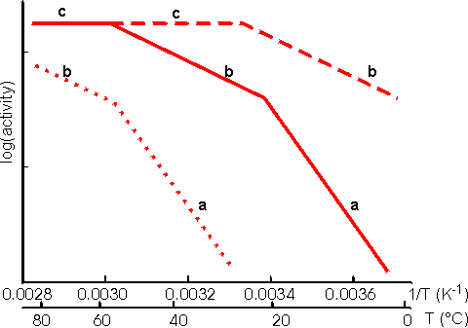
Figure 3.29. Schematic Arrhenius plots showing the progressive effect of diffusional limitations on the rate of reaction catalysed by porous particles containing immobilised enzyme. As the temperature increases the activity progresses through three phases (a), (b) and (c), in that order. (a) represents enzyme kinetic control of the reaction. The rate of reaction is sufficiently slow that no diffusional limitations are noticeable. The standard free energy of activation may be obtained from the gradient of this line. (b) represents control of the reaction rate by the internal diffusion of the substrate (i.e. the intrinsic rate of reaction has increased to greater than the rate at which substrate can diffuse into the particles). (c) represents control of the reaction rate by the diffusion of the substrate to the surface (i.e. the intrinsic rate of reaction has increased to greater than the rate at which substrate can diffuse through the stagnant layer surrounding the particles). No substrate is available for penetration into the pores. ----------- low enzyme loading, ——— intermediate enzyme loading,·········high enzyme loading. An Arrhenius plot using real data for an immobilised enzyme would show pronounced curvature between the three phases. The transition between the linear sections would not be readily discernible, over the range of temperatures normally encountered for the use of immobilised enzymes, unless the standard free energy of activation for the reaction was unusually high (e.g. above 75,000 J mole⁻¹ for one of the transitions or above 100,000 J mole⁻¹ for both transitions).

Enzymic depolymerisation (including hydrolysis) of macromolecules may be affected by diffusional control. Large molecules only diffuse fairly slowly. After reaction, catalysed by the biocatalyst, the cleaved fragments normally retain their ability to act as substrates for the enzyme. They may diffuse away but are likely to be cleaved several times whilst in the vicinity of the immobilised enzyme. This causes a significant difference in the molecular weight profiles of the fragments produced by the use of free and immobilised enzymes. After a small degree of hydrolysis, most substrate molecules are cleaved by free soluble enzyme, whereas immobilised enzyme produces a small quantity of well-hydrolysed low molecular weight product with the majority of the substrate molecules unchanged. This process is exacerbated by the use of porous biocatalysts where there is some further restriction to the internal diffusion of large molecules. Use of immobilised enzyme is, therefore, indicated under circumstances where only a minimal proportion of partially hydrolysed product is required as it generally produces a mixture of almost fully hydrolysed moieties and unchanged polymer.
The increase in the product concentration within the micro-environment may result in an increase in by-products caused by side reactions, especially where the reverse reaction catalysed by enzyme does not show complete specificity for the re-formation of the substrates. This is particularly apparent in the action of some carbohydrases. The increased microenvironmental product concentration may be utilised, however, where a reaction pathway is required. Co-immobilisation of the necessary enzymes for the pathway results in a rapid conversion through the pathway due to the localised high concentrations of the intermediates (Figure 30).

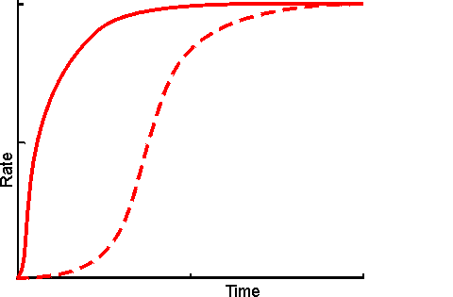
Figure 3.30. Schematic diagram showing the effect of co-immobilisation on the rate of production through a short reaction pathway. ---------- mixture of free enzymes, in solution; ——— co-immobilised enzymes showing a much reduced lag phase. The reduction in the apparent lag phase is most noticeable when there are more enzymes in the pathway. It is least pronounced where the flux through the pathway is controlled by the first step as the microenvironmental concentration of the initial substrate cannot be higher than its bulk concentration but those of all intermediates may be raised due to diffusional restriction on their rate of efflux.

A logical extension of the use of immobilised multi-enzyme systems is the use of immobilised cell systems. These may be in a form which still allows respiration and reproduction or, in a restricted form, which cannot manage these functions but does retain catalytic activity. Sometimes they are treated with inhibitors or by physical means (e.g. heat) to ensure that only a sub-set of their natural enzymes remain active. Compared with immobilised multi-enzyme systems, immobilised cells are generally cheaper, easier to prepare with high activity, show little change in performance, on immobilisation, with respect to pH, ionic strength and temperature, and are generally preferred for use with metabolic pathways involving intracellular enzymes or dissociable cofactors or coenzymes. However they do suffer from a number of practical disadvantages. They are more prone to microbial contamination, less efficient with respect to substrate conversion to product, much more difficult to control and present diffusional problems due to their cell membranes.

Summary and Bibliography of Chapter 3

- Immobilisation of enzymes enables their efficient and continuous use. The rationale behind immobilisation is the easy separation of product from the biocatalyst.
- Enzymes may be immobilised by adsorption, covalent binding, entrapment and membrane confinement, each method having its pros and cons. Adsorption is quick, simple and cheap but may be reversible. Covalent binding is permanent but expensive. Entrapment is generally applicable but may cause diffusional problems. Membrane confinement is a flexible method but expensive to set up.
- Immobilisation of enzymes may have a considerable effect on their kinetics. This may be due to structural changes to the enzyme and the creation of a distinct microenvironment around the enzyme. The activity of an immobilised enzyme is governed by the physical conditions within this microenvironment not those prevalent in the bulk phase. The immobilisation matrix affects the partition of material between the product phase and the enzyme phase and imposes restrictions on the rate of diffusion of material.
- Some effects of enzyme immobilisation are seen to be beneficial whilst others are detrimental to the economics of their use.

References and Bibliography
- Bodálo, A., Gómez, J.L., Gómez, E., Bastida, J., Iborra, J.L. & Manjón, A. (1986). Analysis of diffusion effects on immobilized enzymes on porous supports with reversible Michaelis-Menten kinetics. Enzyme and Microbial Technology8, 433-8.
- Engasser, J-M. & Coulet, P.R. (1977). Comparison of intrinsic stabilities of free and bound enzymes by graphical removal of diffusional effects. Biochimica et Biophysica Acta 485, 29-36.
- Engasser, J-M. & Horvath, C. (1973). Effect of internal diffusion in heterogeneous enzyme systems: Evaluation of true kinetic parameters and substrate diffusivity. Journal of Theoretical Biology 42, 137-55.
- Engasser, J-M. & Horvath, C. (1974). Buffer-facilitated proton transport pH profile of bound enzymes. Biochimica et Biophysica Acta 358 178-92.
- Engasser, J-M. & Horvath, C. (1976). Diffusion and kinetics with immobilised enzymes. In Applied biochemistry and bioengineering, vol. 1 Immobilised enzyme principles. ed. L.B.Wingard,
- E.Katchalski-Katzir & L.Goldstein, pp 127-220, New York: Academic Press.European Federation of Biotechnology (1983). Guidelines for the characterization of immobilised biocatalysts. Enzyme and Microbial Technology 5, 304-7.
- Goldstein, L. (1972). Microenvironmental effects on enzyme catalysis. A kinetic study of polyanionic and polycationic derivatives of chymotrypsin. Biochemistry, 11, 4072-84.
- Israelachvili, J. & Pashley, R. (1982). The hydrophobic interaction is long range, decaying exponentially with distance. Nature, 300 341-2.
- Kennedy, J.F. & Cabral, J.M.S., (1987). Enzyme immobilisation. In Biotechnology, vol. 7a, Enzyme Technology, ed. J.F.Kennedy, pp 347-404. Weinheim: VCH Verlagsgesellschaft mbH.
- Martinek, K., Klibanov, A.M., Goldmacher, V.S. & Berezin, I.V. (1977a). The principles of enzyme stabilization 1. Increase in thermostability of enzymes covalently bound to a complementary surface of a polymer support in a multipoint fashion. Biochimica et Biophysica Acta, 485, 1-12.
- Martinek, K., Klibanov, A.M., Goldmacher, V.S., Tchernysheva, A.V., Mozhaev, V.V., Berezin, I.V. & Glotov, B.O. (1977b). The principles of enzyme stabilization 2. Increase in the thermostability of enzymes as a result of multipoint noncovalent interaction with a polymeric support. Biochimica et Biophysica Acta 485, 13-28.
- Woodward, J. (1985). Immobilised enzymes: Adsorption and covalent coupling. In Immobilised cells and enzymes A practical approach, ed. J.Woodward, pp 3-17. Oxford: IRL Press Ltd.
- Working party on immobilised biocatalysts. (1983). Guidelines for the characterization of immobilised biocatalysts. Enzyme and Microbial Technology, 5, 304-307.

