Chpetr 6 Biosensors

The use of enzymes in analysis

Enzymes make excellent analytical reagents due to their specificity, selectivity and efficiency. They are often used to determine the concentration of their substrates (as analytes) by means of the resultant initial reaction rates. If the reaction conditions and enzyme concentrations are kept constant, these rates of reaction (v) are proportional to the substrate concentrations ([S]) at low substrate concentrations. When [S] < 0.1 K_{m}, equation 1.8 simplifies to give
v = (V_{max}/K_{m})[S] (6.1)
The rates of reaction are commonly determined from the difference in optical absorbance between the reactants and products. An example of this is the β-D-galactose dehydrogenase (EC 1.1.1.48) assay for galactose which involves the oxidation of galactose by the redox coenzyme, nicotine-adenine dinucleotide (NAD⁺).
β-D-galactose + NAD⁺ D-galactono-1,4-lactone + NADH + H⁺ [6.1]
A 0.1 mM solution of NADH has an absorbance at 340nm, in a 1 cm path-length cuvette, of 0.622, whereas the NAD⁺ from which it is derived has effectively zero absorbance at this wavelength. The conversion (NAD⁺ NADH) is, therefore, accompanied by a large increase in absorption of light at this wavelength. For the reaction to be linear with respect to the galactose concentration, the galactose is kept within a concentration range well below the K_{m} of the enzyme for galactose. In contrast, the NAD⁺ concentration is kept within a concentration range well above the K_{m} of the enzyme for NAD⁺, in order to avoid limiting the reaction rate. Such assays are commonly used in analytical laboratories and are, indeed, excellent where a wide variety of analyses need to be undertaken on a relatively small number of samples. The drawbacks to this type of analysis become apparent when a large number of repetitive assays need to be performed. Then, they are seen to be costly in terms of expensive enzyme and coenzyme usage, time consuming, labour intensive and in need of skilled and reproducible operation within properly equipped analytical laboratories. For routine or on-site operation, these disadvantages must be overcome. This is being achieved by the production of biosensors which exploit biological systems in association with advances in micro-electronic technology.

What are biosensors?

A biosensor is an analytical device which converts a biological response into an electrical signal (Figure 6.1). The term 'biosensor' is often used to cover sensor devices used in order to determine the concentration of substances and other parameters of biological interest even where they do not utilise a biological system directly. This very broad definition is used by some scientific journals (e.g. Biosensors, Elsevier Applied Science) but will not be applied to the coverage here. The emphasis of this Chapter concerns enzymes as the biologically responsive material, but it should be recognised that other biological systems may be utilised by biosensors, for example, whole cell metabolism, ligand binding and the antibody-antigen reaction. Biosensors represent a rapidly expanding field, at the present time, with an estimated 60% annual growth rate; the major impetus coming from the health-care industry (e.g. 6% of the western world are diabetic and would benefit from the availability of a rapid, accurate and simple biosensor for glucose) but with some pressure from other areas, such as food quality appraisal and environmental monitoring. The estimated world analytical market is about £12,000,000,000 year⁻¹ of which 30% is in the health care area. There is clearly a vast market expansion potential as less than 0.1% of this market is currently using biosensors. Research and development in this field is wide and multidisciplinary, spanning biochemistry, bioreactor science, physical chemistry, electrochemistry, electronics and software engineering. Most of this current endeavour concerns potentiometric and amperometric biosensors and colorimetric paper enzyme strips. However, all the main transducer types are likely to be thoroughly examined, for use in biosensors, over the next few years.
A successful biosensor must possess at least some of the following beneficial features:
- The biocatalyst must be highly specific for the purpose of the analyses, be stable under normal storage conditions and, except in the case of colorimetric enzyme strips and dipsticks (see later), show good stability over a large number of assays (i.e. much greater than 100).
- The reaction should be as independent of such physical parameters as stirring, pH and temperature as is manageable. This would allow the analysis of samples with minimal pre-treatment. If the reaction involves cofactors or coenzymes these should, preferably, also be co-immobilised with the enzyme (see Chapter 8).
- The response should be accurate, precise, reproducible and linear over the useful analytical range, without dilution or concentration. It should also be free from electrical noise.
- If the biosensor is to be used for invasive monitoring in clinical situations, the probe must be tiny and biocompatible, having no toxic or antigenic effects. If it is to be used in fermenters it should be sterilisable. This is preferably performed by autoclaving but no biosensor enzymes can presently withstand such drastic wet-heat treatment. In either case, the biosensor should not be prone to fouling or proteolysis.
- The complete biosensor should be cheap, small, portable and capable of being used by semi-skilled operators.
- There should be a market for the biosensor. There is clearly little purpose developing a biosensor if other factors (e.g. government subsidies, the continued employment of skilled analysts, or poor customer perception) encourage the use of traditional methods and discourage the decentralisation of laboratory testing.
The biological response of the biosensor is determined by the biocatalytic membrane which accomplishes the conversion of reactant to product. Immobilised enzymes possess a number of advantageous features which makes them particularly applicable for use in such systems. They may be re-used, which ensures that the same catalytic activity is present for a series of analyses. This is an important factor in securing reproducible results and avoids the pitfalls associated with the replicate pipetting of free enzyme otherwise necessary in analytical protocols. Many enzymes are intrinsically stabilised by the immobilisation process (see Chapter 3), but even where this does not occur there is usually considerable apparent stabilisation. It is normal to use an excess of the enzyme within the immobilised sensor system. This gives a catalytic redundancy (i.e. η << 1) which is sufficient to ensure an increase in the apparent stabilisation of the immobilised enzyme (see, for example, Figures 3.11, 3.19 and 5.8). Even where there is some inactivation of the immobilised enzyme over a period of time, this inactivation is usually steady and predictable. Any activity decay is easily incorporated into an analytical scheme by regularly interpolating standards between the analyses of unknown samples. For these reasons, many such immobilised enzyme systems are re-usable up to 10,000 times over a period of several months. Clearly, this results in a considerable saving in terms of the enzymes' cost relative to the analytical usage of free soluble enzymes.
When the reaction, occurring at the immobilised enzyme membrane of a biosensor, is limited by the rate of external diffusion, the reaction process will possess a number of valuable analytical assets. In particular, it will obey the relationship shown in equation 3.27. It follows that the biocatalyst gives a proportional change in reaction rate in response to the reactant (substrate) concentration over a substantial linear range, several times the intrinsic K_{m} (see Figure 3.12 line e). This is very useful as analyte concentrations are often approximately equal to the K_{m}s of their appropriate enzymes which is roughly 10 times more concentrated than can be normally determined, without dilution, by use of the free enzyme in solution. Also following from equation 3.27 is the independence of the reaction rate with respect to pH, ionic strength, temperature and inhibitors. This simply avoids the tricky problems often encountered due to the variability of real analytical samples (e.g, fermentation broth, blood and urine) and external conditions. Control of biosensor response by the external diffusion of the analyte can be encouraged by the use of permeable membranes between the enzyme and the bulk solution. The thickness of these can be varied with associated effects on the proportionality constant between the substrate concentration and the rate of reaction (i.e. increasing membrane thickness increases the unstirred layer (δ) which, in turn, decreases the proportionality constant, k_{L}, in equation 3.27). Even if total dependence on the external diffusional rate is not achieved (or achievable), any increase in the dependence of the reaction rate on external or internal diffusion will cause a reduction in the dependence on the pH, ionic strength, temperature and inhibitor concentrations.

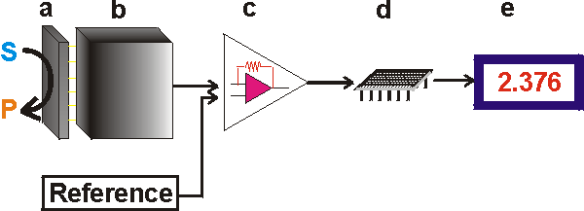
Figure 6.1. Schematic diagram showing the main components of a biosensor. The biocatalyst (a) converts the substrate to product. This reaction is determined by the transducer (b) which converts it to an electrical signal. The output from the transducer is amplified (c), processed (d) and displayed (e).

The key part of a biosensor is the transducer (shown as the 'black box' in Figure 6.1) which makes use of a physical change accompanying the reaction. This may be
- the heat output (or absorbed) by the reaction (calorimetric biosensors),
- changes in the distribution of charges causing an electrical potential to be produced (potentiometric biosensors),
- movement of electrons produced in a redox reaction (amperometric biosensors),
- light output during the reaction or a light absorbance difference between the reactants and products (optical biosensors), or
- effects due to the mass of the reactants or products (piezo-electric biosensors).
There are three so-called 'generations' of biosensors; First generation biosensors where the normal product of the reaction diffuses to the transducer and causes the electrical response, second generation biosensors which involve specific 'mediators' between the reaction and the transducer in order to generate improved response, and third generation biosensors where the reaction itself causes the response and no product or mediator diffusion is directly involved.
The electrical signal from the transducer is often low and superimposed upon a relatively high and noisy (i.e. containing a high frequency signal component of an apparently random nature, due to electrical interference or generated within the electronic components of the transducer) baseline. The signal processing normally involves subtracting a 'reference' baseline signal, derived from a similar transducer without any biocatalytic membrane, from the sample signal, amplifying the resultant signal difference and electronically filtering (smoothing) out the unwanted signal noise. The relatively slow nature of the biosensor response considerably eases the problem of electrical noise filtration. The analogue signal produced at this stage may be output directly but is usually converted to a digital signal and passed to a microprocessor stage where the data is processed, converted to concentration units and output to a display device or data store.

Calorimetric biosensors

Many enzyme catalysed reactions are exothermic, generating heat (Table 6.1) which may be used as a basis for measuring the rate of reaction and, hence, the analyte concentration. This represents the most generally applicable type of biosensor. The temperature changes are usually determined by means of thermistors at the entrance and exit of small packed bed columns containing immobilised enzymes within a constant temperature environment (Figure 6.2). Under such closely controlled conditions, up to 80% of the heat generated in the reaction may be registered as a temperature change in the sample stream. This may be simply calculated from the enthalpy change and the amount reacted. If a 1 mM reactant is completely converted to product in a reaction generating 100 kJ mole⁻¹ then each ml of solution generates 0.1 J of heat. At 80% efficiency, this will cause a change in temperature of the solution amounting to approximately 0.02°C. This is about the temperature change commonly encountered and necessitates a temperature resolution of 0.0001°C for the biosensor to be generally useful.

Table 6.1. Heat output (molar enthalpies) of enzyme catalysed reactions.
Reactant | Enzyme | Heat output  -ΔH (kJ mole⁻¹)
Cholesterol | Cholesterol oxidase | 53
Esters | Chymotrypsin | 4 - 16
Glucose | Glucose oxidase | 80
Hydrogen peroxide | Catalase | 100
Penicillin G | Penicillinase | 67
Peptides | Trypsin | 10 - 30
Starch | Amylase | 8
Sucrose | Invertase | 20
Urea | Urease | 61
Uric acid | Uricase | 49

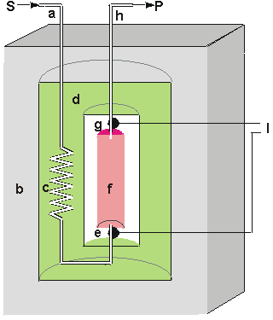
Figure 6.2. Schematic diagram of a calorimetric biosensor. The sample stream (a) passes through the outer insulated box (b) to the heat exchanger (c) within an aluminium block (d). From there, it flows past the reference thermistor (e) and into the packed bed bioreactor (f, 1ml volume), containing the biocatalyst, where the reaction occurs. The change in temperature is determined by the thermistor (g) and the solution passed to waste (h). External electronics (l) determines the difference in the resistance, and hence temperature, between the thermistors.

The thermistors, used to detect the temperature change, function by changing their electrical resistance with the temperature, obeying the relationship
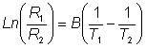 (6.2)
therefore:
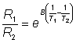 (6.2b)
where R₁ and R₂ are the resistances of the thermistors at absolute temperatures T₁ and T₂ respectively and B is a characteristic temperature constant for the thermistor. When the temperature change is very small, as in the present case, B(1/T₁) - (1/T₂) is very much smaller than one and this relationship may be substantially simplified using the approximation when x<<1 that e^{x}≈1 + x (x here being B(1/T₁) - (1/T₂),
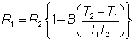 (6.3)
As T₁ ≈ T₂, they both may be replaced in the denominator by T₁.
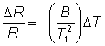 (6.4)
The relative decrease in the electrical resistance (ΔR/R) of the thermistor is proportional to the increase in temperature (ΔT). A typical proportionality constant (-B/T₁²) is -4%°C⁻¹. The resistance change is converted to a proportional voltage change, using a balanced Wheatstone bridge incorporating precision wire-wound resistors, before amplification. The expectation that there will be a linear correlation between the response and the enzyme activity has been found to be borne out in practice. A major problem with this biosensor is the difficulty encountered in closely matching the characteristic temperature constants of the measurement and reference thermistors. An equal movement of only 1°C in the background temperature of both thermistors commonly causes an apparent change in the relative resistances of the thermistors equivalent to 0.01°C and equal to the full-scale change due to the reaction. It is clearly of great importance that such environmental temperature changes are avoided, which accounts for inclusion of the well-insulated aluminium block in the biosensor design (see Figure 6.2).
The sensitivity (10⁻⁴ M) and range (10⁻⁴ - 10⁻² M) of thermistor biosensors are both quite low for the majority of applications although greater sensitivity is possible using the more exothermic reactions (e.g. catalase). The low sensitivity of the system can be increased substantially by increasing the heat output by the reaction. In the simplest case this can be achieved by linking together several reactions in a reaction pathway, all of which contribute to the heat output. Thus the sensitivity of the glucose analysis using glucose oxidase can be more than doubled by the co-immobilisation of catalase within the column reactor in order to disproportionate the hydrogen peroxide produced. An extreme case of this amplification is shown in the following recycle scheme for the detection of ADP.
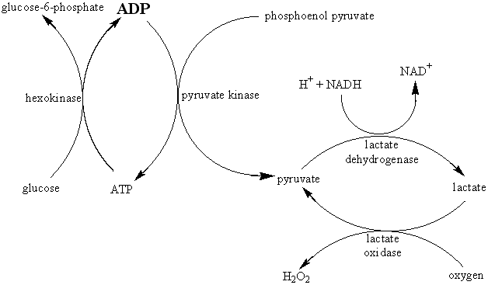 [6.2]
ADP is the added analyte and excess glucose, phosphoenol pyruvate, NADH and oxygen are present to ensure maximum reaction. Four enzymes (hexokinase, pyruvate kinase, lactate dehydrogenase and lactate oxidase) are co-immobilised within the packed bed reactor. In spite of the positive enthalpy of the pyruvate kinase reaction, the overall process results in a 1000 fold increase in sensitivity, primarily due to the recycling between pyruvate and lactate. Reaction limitation due to low oxygen solubility may be overcome by replacing it with benzoquinone, which is reduced to hydroquinone by flavo-enzymes. Such reaction systems do, however, have the serious disadvantage in that they increase the probability of the occurrence of interference in the determination of the analyte of interest. Reactions involving the generation of hydrogen ions can be made more sensitive by the inclusion of a base having a high heat of protonation. For example, the heat output by the penicillinase reaction may be almost doubled by the use of Tris (tris-(hydroxymethyl)aminomethane) as the buffer.In conclusion, the main advantages of the thermistor biosensor are its general applicability and the possibility for its use on turbid or strongly coloured solutions. The most important disadvantage is the difficulty in ensuring that the temperature of the sample stream remains constant (± 0.01°C).

Potentiometric biosensors

Potentiometric biosensors make use of ion-selective electrodes in order to transduce the biological reaction into an electrical signal. In the simplest terms this consists of an immobilised enzyme membrane surrounding the probe from a pH-meter (Figure 6.3), where the catalysed reaction generates or absorbs hydrogen ions (Table 6.2). The reaction occurring next to the thin sensing glass membrane causes a change in pH which may be read directly from the pH-meter's display. Typical of the use of such electrodes is that the electrical potential is determined at very high impedance allowing effectively zero current flow and causing no interference with the reaction.

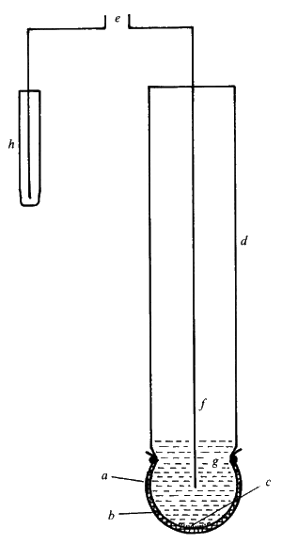
Figure 6.3. A simple potentiometric biosensor. A semi-permeable membrane (a) surrounds the biocatalyst (b) entrapped next to the active glass membrane (c) of a pH probe (d). The electrical potential (e) is generated between the internal Ag/AgCl electrode (f) bathed in dilute HCl (g) and an external reference electrode (h).

There are three types of ion-selective electrodes which are of use in biosensors:
- Glass electrodes for cations (e.g. normal pH electrodes) in which the sensing element is a very thin hydrated glass membrane which generates a transverse electrical potential due to the concentration-dependent competition between the cations for specific binding sites. The selectivity of this membrane is determined by the composition of the glass. The sensitivity to H⁺ is greater than that achievable for NH₄⁺,
- Glass pH electrodes coated with a gas-permeable membrane selective for CO₂, NH₃ or H₂S. The diffusion of the gas through this membrane causes a change in pH of a sensing solution between the membrane and the electrode which is then determined.
- Solid-state electrodes where the glass membrane is replaced by a thin membrane of a specific ion conductor made from a mixture of silver sulphide and a silver halide. The iodide electrode is useful for the determination of I⁻ in the peroxidase reaction (Table 6.2c) and also responds to cyanide ions.

Table 6.2. Reactions involving the release or absorption of ions that may be utilised by potentiometric biosensors.
(a) H⁺ cation,
glucose oxidase H₂O
D-glucose + O₂ D-glucono-1,5-lactone + H₂O₂ D-gluconate + H⁺ [6.3]
penicillinase
penicillin penicilloic acid + H⁺ [6.4]
urease (pH 6.0)ª
H₂NCONH₂ + H₂O + 2H⁺ 2NH₄⁺ + CO₂ [6.5]
urease (pH 9.5)^{b}
H₂NCONH₂ + 2H₂O 2NH₃ + HCO₃⁻ + H⁺ [6.6]
lipase
neutral lipids + H₂O glycerol + fatty acids + H⁺ [6.7]
(b) NH₄⁺ cation,
L-amino acid oxidase
L-amino acid + O₂ + H₂O keto acid + NH₄⁺ + H₂O₂ [6.8]
asparaginase `
L-asparagine + H₂O L-aspartate + NH₄⁺ [6.9]
urease (pH 7.5)
H₂NCONH₂ + 2H₂O + H⁺ 2NH₄⁺+ HCO₃⁻ [6.10]
(c) I⁻ anion,
peroxidase
H₂O₂ + 2H⁺ + 2I⁻ I₂ + 2H₂O [6.11]
(d) CN⁻anion,
β-glucosidase
amygdalin + 2H₂O 2glucose + benzaldehyde + H⁺ + CN⁻ [6.12]
ª Can also be used in NH₄⁺ and CO₂ (gas) potentiometric biosensors.
^{b} Can also be used in an NH₃ (gas) potentiometric biosensor.es80ll66bp

The response of an ion-selective electrode is given by
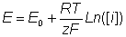 (6.5)
where E is the measured potential (in volts), E₀ is a characteristic constant for the ion-selective/external electrode system, R is the gas constant, T is the absolute temperature (K), z is the signed ionic charge, F is the Faraday, and [i] is the concentration of the free uncomplexed ionic species (strictly, [i] should be the activity of the ion but at the concentrations normally encountered in biosensors, this is effectively equal to the concentration). This means, for example, that there is an increase in the electrical potential of 59 mv for every decade increase in the concentration of H⁺ at 25°C. The logarithmic dependence of the potential on the ionic concentration is responsible both for the wide analytical range and the low accuracy and precision of these sensors. Their normal range of detection is 10⁻⁴ - 10⁻² M, although a minority are ten-fold more sensitive. Typical response time are between one and five minutes allowing up to 30 analyses every hour.
Biosensors which involve H⁺ release or utilisation necessitate the use of very weakly buffered solutions (i.e. < 5 mM) if a significant change in potential is to be determined. The relationship between pH change and substrate concentration is complex, including other such non-linear effects as pH-activity variation and protein buffering. However, conditions can often be found where there is a linear relationship between the apparent change in pH and the substrate concentration. A recent development from ion-selective electrodes is the production of ion-selective field effect transistors (ISFETs) and their biosensor use as enzyme-linked field effect transistors (ENFETs, Figure 6.4). Enzyme membranes are coated on the ion-selective gates of these electronic devices, the biosensor responding to the electrical potential change via the current output. Thus, these are potentiometric devices although they directly produce changes in the electric current. The main advantage of such devices is their extremely small size (<< 0.1 mm²) which allows cheap mass-produced fabrication using integrated circuit technology. As an example, a urea-sensitive FET (ENFET containing bound urease with a reference electrode containing bound glycine) has been shown to show only a 15% variation in response to urea (0.05 - 10.0 mg ml⁻¹) during its active lifetime of a month. Several analytes may be determined by miniaturised biosensors containing arrays of ISFETs and ENFETs. The sensitivity of FETs, however, may be affected by the composition, ionic strength and concentrations of the solutions analysed.

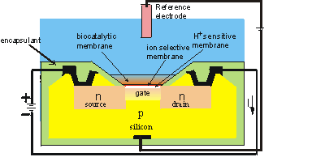
Figure 6.4. Schematic diagram of the section across the width of an ENFET. The actual dimensions of the active area is about 500 μm long by 50 μm wide by 300 μm thick. The main body of the biosensor is a p-type silicon chip with two n-type silicon areas; the negative source and the positive drain. The chip is insulated by a thin layer (0.1 μm thick) of silica (SiO₂) which forms the gate of the FET. Above this gate is an equally thin layer of H⁺-sensitive material (e.g. tantalum oxide), a protective ion selective membrane, the biocatalyst and the analyte solution, which is separated from sensitive parts of the FET by an inert encapsulating polyimide photopolymer. When a potential is applied between the electrodes, a current flows through the FET dependent upon the positive potential detected at the ion-selective gate and its consequent attraction of electrons into the depletion layer. This current (I) is compared with that from a similar, but non-catalytic ISFET immersed in the same solution. (Note that the electric current is, by convention, in the opposite direction to the flow of electrons).

Amperometric biosensors

Amperometric biosensors function by the production of a current when a potential is applied between two electrodes. They generally have response times, dynamic ranges and sensitivities similar to the potentiometric biosensors. The simplest amperometric biosensors in common usage involve the Clark oxygen electrode (Figure 6.5). This consists of a platinum cathode at which oxygen is reduced and a silver/silver chloride reference electrode. When a potential of -0.6 V, relative to the Ag/AgCl electrode is applied to the platinum cathode, a current proportional to the oxygen concentration is produced. Normally both electrodes are bathed in a solution of saturated potassium chloride and separated from the bulk solution by an oxygen-permeable plastic membrane (e.g. Teflon, polytetrafluoroethylene). The following reactions occur:
Ag anode 4Ag⁰ + 4Cl⁻ 4AgCl + 4e⁻ [6.13]
Pt cathode O₂ + 4H⁺ + 4e⁻ 2H₂O [6.14]
The efficient reduction of oxygen at the surface of the cathode causes the oxygen concentration there to be effectively zero. The rate of this electrochemical reduction therefore depends on the rate of diffusion of the oxygen from the bulk solution, which is dependent on the concentration gradient and hence the bulk oxygen concentration (see, for example, equation 3.13). It is clear that a small, but significant, proportion of the oxygen present in the bulk is consumed by this process; the oxygen electrode measuring the rate of a process which is far from equilibrium, whereas ion-selective electrodes are used close to equilibrium conditions. This causes the oxygen electrode to be much more sensitive to changes in the temperature than potentiometric sensors. A typical application for this simple type of biosensor is the determination of glucose concentrations by the use of an immobilised glucose oxidase membrane. The reaction (see reaction scheme [1.1]) results in a reduction of the oxygen concentration as it diffuses through the biocatalytic membrane to the cathode, this being detected by a reduction in the current between the electrodes (Figure 6.6). Other oxidases may be used in a similar manner for the analysis of their substrates (e.g. alcohol oxidase, D- and L-amino acid oxidases, cholesterol oxidase, galactose oxidase, and urate oxidase)

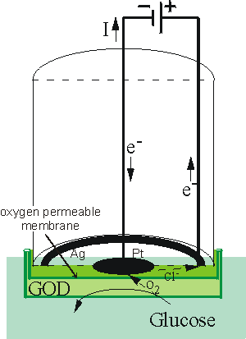
Figure 6.5. Schematic diagram of a simple amperometric biosensor. A potential is applied between the central platinum cathode and the annular silver anode. This generates a current (I) which is carried between the electrodes by means of a saturated solution of KCl. This electrode compartment is separated from the biocatalyst (here shown glucose oxidase, GOD) by a thin plastic membrane, permeable only to oxygen. The analyte solution is separated from the biocatalyst by another membrane, permeable to the substrate(s) and product(s). This biosensor is normally about 1 cm in diameter but has been scaled down to 0.25 mm diameter using a Pt wire cathode within a silver plated steel needle anode and utilising dip-coated membranes.

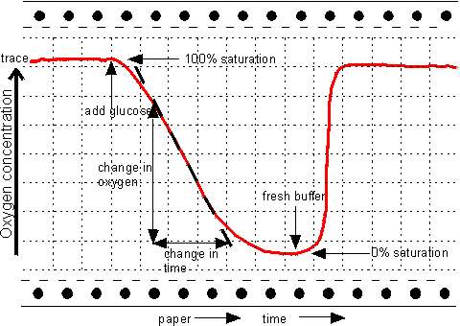
Figure 6.6. The response of an amperometric biosensor utilising glucose oxidase to the presence of glucose solutions. Between analyses the biosensor is placed in oxygenated buffer devoid of glucose. The steady rates of oxygen depletion may be used to generate standard response curves and determine unknown samples. The time required for an assay can be considerably reduced if only the initial transient (curved) part of the response need be used, via a suitable model and software. The wash-out time, which roughly equals the time the electrode spends in the sample solution, is also reduced significantly by this process.

An alternative method for determining the rate of this reaction is to measure the production of hydrogen peroxide directly by applying a potential of +0.68 V to the platinum electrode, relative to the Ag/AgCl electrode, and causing the reactions:
Pt anode H₂O₂ O₂ + 2H⁺ + 2e⁻ [6.15]
Ag cathode 2AgCl + 2e⁻ 2Ag⁰ + 2Cl⁻[6.16]
The major problem with these biosensors is their dependence on the dissolved oxygen concentration. This may be overcome by the use of 'mediators' which transfer the electrons directly to the electrode bypassing the reduction of the oxygen co-substrate. In order to be generally applicable these mediators must possess a number of useful properties.
- They must react rapidly with the reduced form of the enzyme.
- They must be sufficiently soluble, in both the oxidised and reduced forms, to be able to rapidly diffuse between the active site of the enzyme and the electrode surface. This solubility should, however, not be so great as to cause significant loss of the mediator from the biosensor's microenvironment to the bulk of the solution. However soluble, the mediator should generally be non-toxic.
- The overpotential for the regeneration of the oxidised mediator, at the electrode, should be low and independent of pH.
- The reduced form of the mediator should not readily react with oxygen.
The ferrocenes represent a commonly used family of mediators (Figure 6.7a). Their reactions may be represented as follows,
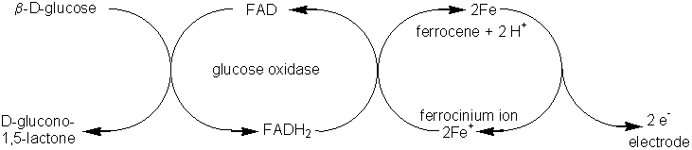 [6.17]
Electrodes have now been developed which can remove the electrons directly from the reduced enzymes, without the necessity for such mediators. They utilise a coating of electrically conducting organic salts, such as N-methylphenazinium cation (NMP⁺, Figure 6.7b) with tetracyanoquinodimethane radical anion (TCNQ^{.-} Figure 6.7c). Many flavo-enzymes are strongly adsorbed by such organic conductors due to the formation of salt links, utilising the alternate positive and negative charges, within their hydrophobic environment. Such enzyme electrodes can be prepared by simply dipping the electrode into a solution of the enzyme and they may remain stable for several months. These electrodes can also be used for reactions involving NAD(P)⁺-dependent dehydrogenases as they also allow the electrochemical oxidation of the reduced forms of these coenzymes. The three types of amperometric biosensor utilising product, mediator or organic conductors represent the three generations in biosensor development (Figure 6.8). The reduction in oxidation potential, found when mediators are used, greatly reduces the problem of interference by extraneous material.

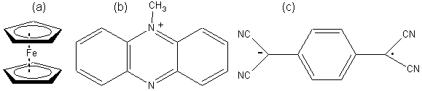
Figure 6.7. (a) Ferrocene (ε5-bis-cyclopentadienyl iron), the parent compound of a number of mediators. (b) TMP⁺, the cationic part of conducting organic crystals. (c) TCNQ^{.-}, the anionic part of conducting organic crystals. It is a resonance-stabilised radical formed by the one-electron oxidation of TCNQH₂.

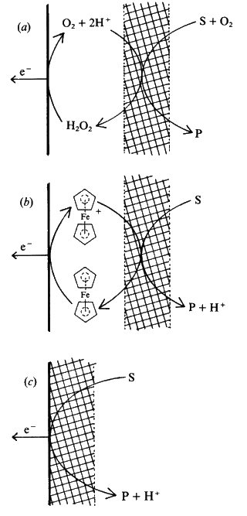
Figure 6.8. Amperometric biosensors for flavo-oxidase enzymes illustrating the three generations in the development of a biosensor. The biocatalyst is shown schematically by the cross-hatching. (a) First generation electrode utilising the H₂O₂ produced by the reaction. (E₀ = +0.68 V). (b) Second generation electrode utilising a mediator (ferrocene) to transfer the electrons, produced by the reaction, to the electrode. (E₀ = +0.19 V). (c) Third generation electrode directly utilising the electrons produced by the reaction. (E₀ = +0.10 V). All electrode potentials (E₀) are relative to the Cl⁻/AgCl,Ag⁰ electrode. The following reaction occurs at the enzyme in all three biosensors:
Substrate(2H) + FAD-oxidase Product + FADH₂-oxidasefi [6.18]
This is followed by the processes:
(a)
biocatalyst
FADH₂-oxidase + O₂ FAD-oxidase + H₂O₂ [6.19]
electrode
H₂O₂ O₂ + 2H⁺ + 2e⁻ [6.20]
(b)
biocatalyst
FADH₂-oxidase + 2 Ferricinium⁺ FAD-oxidase + 2 Ferrocene + 2H⁺ [6.21]
electrode
2 Ferrocene 2 Ferricinium⁺ + 2e⁻ [6.22]
(c)
biocatalyst/electrode
FADH₂-oxidase FAD-oxidase + 2H⁺ + 2e⁻ [6.23]

The current (i) produced by such amperometric biosensors is related to the rate of reaction (v_{A}) by the expression:
i = nFAv_{A} (6.6)
where n represents the number of electrons transferred, A is the electrode area, and F is the Faraday. Usually the rate of reaction is made diffusionally controlled (see equation 3.27) by use of external membranes. Under these circumstances the electric current produced is proportional to the analyte concentration and independent both of the enzyme and electrochemical kinetics.

Optical biosensors

There are two main areas of development in optical biosensors. These involve determining changes in light absorption between the reactants and products of a reaction, or measuring the light output by a luminescent process. The former usually involve the widely established, if rather low technology, use of colorimetric test strips. These are disposable single-use cellulose pads impregnated with enzyme and reagents. The most common use of this technology is for whole-blood monitoring in diabetes control. In this case, the strips include glucose oxidase, horseradish peroxidase (EC 1.11.1.7) and a chromogen (e.g. o-toluidine or 3,3',5,5'-tetramethylbenzidine). The hydrogen peroxide, produced by the aerobic oxidation of glucose (see reaction scheme [1.1]), oxidising the weakly coloured chromogen to a highly coloured dye.
peroxidase
chromogen(2H) + H₂O₂ dye + 2H₂O [6.24]
The evaluation of the dyed strips is best achieved by the use of portable reflectance meters, although direct visual comparison with a coloured chart is often used. A wide variety of test strips involving other enzymes are commercially available at the present time.A most promising biosensor involving luminescence uses firefly luciferase (Photinus-luciferin 4-monooxygenase (ATP-hydrolysing), EC 1.13.12.7) to detect the presence of bacteria in food or clinical samples. Bacteria are specifically lysed and the ATP released (roughly proportional to the number of bacteria present) reacted with D-luciferin and oxygen in a reaction which produces yellow light in high quantum yield.
luciferase
ATP + D-luciferin + O₂ oxyluciferin + AMP + pyrophosphate + CO₂ + light (562 nm) [6.25]
The light produced may be detected photometrically by use of high-voltage, and expensive, photomultiplier tubes or low-voltage cheap photodiode systems. The sensitivity of the photomultiplier-containing systems is, at present, somewhat greater (< 10⁴ cells ml⁻¹, < 10⁻¹² M ATP) than the simpler photon detectors which use photodiodes. Firefly luciferase is a very expensive enzyme, only obtainable from the tails of wild fireflies. Use of immobilised luciferase greatly reduces the cost of these analyses.

Piezo-electric biosensors

Piezo-electric crystals (e.g. quartz) vibrate under the influence of an electric field. The frequency of this oscillation (f) depends on their thickness and cut, each crystal having a characteristic resonant frequency. This resonant frequency changes as molecules adsorb or desorb from the surface of the crystal, obeying the relationshipes
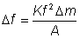 (6.7)
where Δf is the change in resonant frequency (Hz), Δm is the change in mass of adsorbed material (g), K is a constant for the particular crystal dependent on such factors as its density and cut, and A is the adsorbing surface area (cm²). For any piezo-electric crystal, the change in frequency is proportional to the mass of absorbed material, up to about a 2% change. This frequency change is easily detected by relatively unsophisticated electronic circuits. A simple use of such a transducer is a formaldehyde biosensor, utilising a formaldehyde dehydrogenase coating immobilised to a quartz crystal and sensitive to gaseous formaldehyde. The major drawback of these devices is the interference from atmospheric humidity and the difficulty in using them for the determination of material in solution. They are, however, inexpensive, small and robust, and capable of giving a rapid response.

Immunosensors

Biosensors may be used in conjunction with enzyme-linked immunosorbent assays (ELISA). The principles behind the ELISA technique is shown in Figure 6.9. ELISA is used to detect and amplify an antigen-antibody reaction; the amount of enzyme-linked antigen bound to the immobilised antibody being determined by the relative concentration of the free and conjugated antigen and quantified by the rate of enzymic reaction. Enzymes with high turnover numbers are used in order to achieve rapid response. The sensitivity of such assays may be further enhanced by utilising enzyme-catalysed reactions which give intrinsically greater response; for instance, those giving rise to highly coloured, fluorescent or bioluminescent products. Assay kits using this technique are now available for a vast range of analyses.

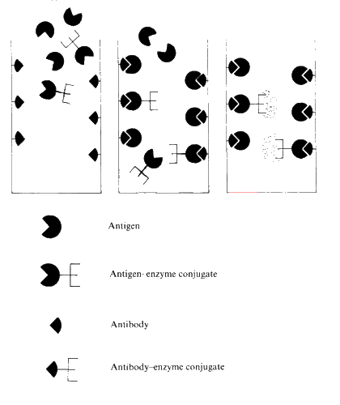
Figure 6.9. Principles of a direct competitive ELISA. (i) Antibody, specific for the antigen of interest is immobilised on the surface of a tube. A mixture of a known amount of antigen-enzyme conjugate plus unknown concentration of sample antigen is placed in the tube and allowed to equilibrate. (ii) After a suitable period the antigen and antigen-enzyme conjugate will be distributed between the bound and free states dependent upon their relative concentrations. (iii) Unbound material is washed off and discarded. The amount of antigen-enzyme conjugate that is bound may be determined by the rate of the subsequent enzymic reaction.

Recently ELISA techniques have been combined with biosensors, to form immunosensors, in order to increase their range, speed and sensitivity. A simple immunosensor configuration is shown in Figure 6.10 (a), where the biosensor merely replaces the traditional colorimetric detection system. However more advanced immunosensors are being developed (Figure 6.10 ( b)) which rely on the direct detection of antigen bound to the antibody-coated surface of the biosensor. Piezoelectric and FET-based biosensors are particularly suited to such applications.

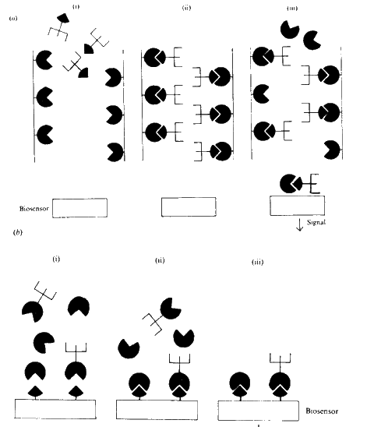
Figure 6.10. Principles of immunosensors. (a)(i) A tube is coated with (immobilised) antigen. An excess of specific antibody-enzyme conjugate is placed in the tube and allowed to bind. (a)(ii) After a suitable period any unbound material is washed off. (a)(iii) The analyte antigen solution is passed into the tube, binding and releasing some of the antibody-enzyme conjugate dependent upon the antigen's concentration. The amount of antibody-enzyme conjugate released is determined by the response from the biosensor. (b)(i) A transducer is coated with (immobilised) antibody, specific for the antigen of interest. The transducer is immersed in a solution containing a mixture of a known amount of antigen-enzyme conjugate plus unknown concentration of sample antigen. (b)(ii) After a suitable period the antigen and antigen-enzyme conjugate will be distributed between the bound and free states dependent upon their relative concentrations. (b)(iii) Unbound material is washed off and discarded. The amount of antigen-enzyme conjugate bound is determined directly from the transduced signal.

Summary and Bibliography of Chapter 6

- There is a vast potential market for biosensors which is only beginning to be expoited.
- Biosensors generally are easy to operate, analyse over a wide range of useful analyte concentrations and give reproducible results.
- The diffusional limitation of substrate(s) may be an asset to be encouraged in biosensor design due to the consequent reduction in the effects of analyte pH, temperature and inhibitors on biosensor response.

References and Bibliography
- Albery, J., Haggett, B. & Snook, D. (1986). You know it makes sensors. New Scientist 13th Feb., 38-41.
- Bergmeyer, H.U. ed. (1974). Methods of Enzymatic Analysis 3rd edn, New York: Verlag Chemie, Academic Press.
- Guilbault, G.G. & de Olivera Neto, G. (1985). Immobilised enzyme electrodes. In USES45,1Immobilised cells and enzymes A practical approach ed. J.Woodward, pp 55-74. Oxford: IRL Press Ltd.
- Hall, E.A.H. (1986). The developing biosensor arena. Enzyme and Microbial Technology 8, 651-657.
- Joachim, C. (1986). Biochips: dreams...and realities. International Industrial Biotechnology 79:7:12/1, 211-219.
- Kernevez, J.P., Konate, L. & Romette, J.L. (1983). Determination of substrate concentration by a computerized enzyme electrode. Biotechnology and Bioengineering 25, 845-855.
- Kricka, L.J. & Thorpe, G.H.G. (1986). Immobilised enzymes in analysis. Trends in Biotechnology4, 253-258.
- Lowe, C.R. (1984). Biosensors. Trends in Biotechnology 2, 59-64.
- North, J.R. (1985). Immunosensors: antibody-based biosensors. Trends in Biotechnology 3, 180-186.
- Russell, L.J. & Rawson, K.M. (1986). The commercialisation of sensor technology in clinical chemistry: An outline of the potential difficulties. Biosensors 2, 301-318.
- Scheller, F.W., Schubert, F., Renneberg, R. & Mes82,5~ller, H-G. (1985). Biosensors: Trends and commercialization. Biosensors 1, 135-160.
- Turner, A.P.F. (1987). Biosensors: Principles and potential. In Chemical aspects of food enzymes, ed. A.T.Andrews, pp 259-270, London: Royal Society of Chemistry.
- Turner, A.P.F., Karube, I. & Wilson, G.S. eds. (1987). Biosensors: Fundamentals and applications, Oxford, U.K: Oxford University Press.
- Vadgama, P. (1986). Urea pH electrodes: Characterisation and optimisation for plasma measurements. Analyst111, 875-878.bp

